**A Project Report on**

**GATE 2023 OFFICIAL SITE(CLONE)**

**USING HTML & CSS**

submitted by

**P. BHAVANA - GQT-S0152**

under the mentorship of

**KESHAV MURTHY**



**GLOBAL QUEST TECHNOLOGIES**

[info@gqtech.in](mailto:info@gqtech.in)

Yelahanka Satellite Town,

Bangalore, Karnataka - 560064.

[2023]

|  |  |
| --- | --- |
| **Signature of the mentor** | **Signature** |
|  |  |
| **Keshav Murthy** | **G.R.Narendra Reddy** |

**INTRODUCTION**

**HISTORY OF HTML:**

**HTML** stands for **Hyper Text Markup Language**.

* It is used to share the information over the internet.
* HTML id developed by Tim Berner’s Lee in 1991.But officially in 1993.
* The First version of HTML consists of “18 tags”
* HTML follows certain rules and regulations setup by “**ISO**”.
* International Organization for standardization is set of rules and regulation are present in ‘**SGML**’ document.

**Versions of HTML**

* **HTML-1** version in the year 1993.
* **Html-2** version in the year 1995.
* **HTML-3.02** version in the year 1997.
* **HTML-4.1** version in the year 1999.
* **HTML-5** version in the year 2014.

**Features of HTML**

* It is easy to Learn.
* It is a tag based language.
* HTML is supported by multiple browsers.
* First web browser is Netscape navigation which was developed by the “Mosiac”.
* It is a portable language.
* **WORA** stands for ‘write once run anywhere’

**Limitation of HTML**

* HTML has less designing capabilities.
* It is dependent on other technology such as CSS in order to develop well designed Webpages.
* HTML has no programming capabilities.
* Using HTML and CSS we can develop only static Web page.
* In order to write the HTML code required an editor such as VS Code, Notepad, Eclipse.
* In order to execute the HTML code we required Web browsers.Like Chrome, Firefox, edge, Opera Safari .

**CSS**

* **CSS** stands for **Cascading Style Sheets**.
* It was developed by W3C to add stylings to the HTML elements.
* W3C stands for World Wide Web.com

**Versions of CSS:**

* CSS-1 (level-1) in the year 1996.
* CSS-2 (level-2) in the year 1998.
* CSS-3 (level-3) in the year 1999.

**Why do we required CSS ?**

* Since HTML has less designing capabilities we cannot create well designed or most appealing Websites.
* Using HTML we cannot add style, animation and transitions to the Webpage.
* Therefore we require CSS to create well designed Webpages.

**Advantages of CSS**

* It allows to add styles, animation and variouses effects to the Webpage.
* It allows us to develop the Webpage rapidly. It is also know as RAD ( rapid application Developer).
* It allows us to separate from formatting develop page to the presentation of Webpage.
* It allows to create well designed Websites.

**Limitations of CSS**

* Using CSS we can perform static styles for the Webpages.
* In order to create dynamic styling for the Websites. We must make use of scripting language such as JavaScript and Libraries of JavaScript.

**Types of CSS:**

1. Inline CSS
2. Internal CSS
3. External CSS
4. Default Browser CSS

**Inline CSS:**

Defining all the CSS properties within the style attribute inside the opening of the tag is referred to as Inline CSS.

**Internal CSS:**

Defining all the CSS properties within <style> inside the HTML document is referred to as Internal CSS.

**External CSS:**

Defining all the CSS properties within as external Script or File with an extension CSS is referred to as External CSS.

* In order to link external CSS file within the HTML document we must use of <link>.
* The value for the ‘ref’ attribute should be ‘stylesheet’.

**GATE 2023 Official Site (Clone)**

**Scope of the document**

Creating a clone of a website like GATE (Graduate Aptitude Test in Engineering) for the year 2023 involves several components, features, and considerations. Here's a high-level scope for a GATE 2023 website clone:

**1. Website Overview:**

* Develop a user-friendly and responsive website that replicates the official GATE website's design and layout for the year 2023.

**2. User Registration and Authentication:**

* Implement a user registration and login system for applicants.
* Allow users to reset their passwords securely.

**3. User Dashboard:**

* Create a personalized dashboard for users to manage their profile, view application status, and access important information.

**4. Application Process:**

* Mirror the official GATE application process, allowing users to select their exam, enter personal details, upload documents, and pay the application fee.
* Include error checking and validation to ensure accurate data submission.
* Provide a confirmation email upon successful submission.

**5. Payment Integration:**

* Integrate secure payment gateways for application fee processing.
* Provide multiple payment options (credit/debit cards, net banking, etc.).

**6. Exam Information:**

* Display detailed information about the GATE 2023 exam, including eligibility criteria, syllabus, important dates, and guidelines.
* Allow users to download official brochures and documents.

**7. Mock Tests:**

* Offer mock tests to help users prepare for the GATE exam.
* Track and display users' progress and performance in these tests.

**8. Admit Cards:**

* Generate and allow users to download admit cards.
* Send notifications and reminders about the release of admit cards.

**9. Results and Scorecards:**

* Publish GATE 2023 results and scorecards on the website.
* Allow users to access their results by logging into their accounts.

**10. Frequently Asked Questions (FAQ):** - Include a comprehensive FAQ section to address common queries related to the GATE exam and application process.

**11. Notifications and Updates:** - Implement a notification system to inform users about important updates, announcements, and changes related to the exam.

**12. Contact and Support:** - Provide contact information and a support system (email, chat, or ticket system) for users to get assistance with their queries.

**13. Content Management System (CMS):** - Develop a CMS to easily update and manage website content, including news, announcements, and notifications.

**14. SEO and Analytics:** - Optimize the website for search engines (SEO) to improve visibility. - Implement analytics tools to track user engagement, traffic, and behavior on the website.

**15. Security:** - Implement robust security measures to protect user data and prevent cyber threats. - Regularly update and patch the website to address security vulnerabilities.

**16. Mobile Responsiveness:** - Ensure that the website is mobile-responsive, providing a seamless experience on various devices.

**17. Compliance:** - Comply with legal requirements, including data protection regulations and accessibility standards.

**18. Scalability:** - Design the website architecture to handle a high volume of users during peak registration periods.

**19. Testing and Quality Assurance:** - Thoroughly test the website for usability, functionality, and security. - Conduct load testing to ensure the site can handle heavy traffic.

**20. Deployment and Maintenance:** - Deploy the website on a reliable hosting infrastructure. - Provide ongoing maintenance and support to fix issues and keep the site up to date.

This scope provides a comprehensive outline for creating a GATE 2023 website clone. Be sure to adjust the specifics and prioritize features based on your resources, target audience, and goals. Additionally, consult with legal experts to ensure compliance with copyright and intellectual property laws when cloning a website.

Top of Form

**Technologies Used**

* HTML5
* CSS3

**Our Project**

**Root Structure:**

**GATE 2023 Official Website**

**→CODES**

**→HTML_Files**

→GATEHome.html

→GATElogin.html

→GATEViewall.html

→GATEView.html

→GATEMasterPapers.html

→GATEToppers.html

→GATEInformationalcities.html

→GATExaminationSchedule.html

→GATEDocuments.html

→GATEApplication.html

→GATEDownload.html

→GATEOpportunity.html

→GATEExamcity.html

→GATEFAQ.html

→Contact.html

**→CSS_Files**

→Contactus.css

→Downloadgate.css

→Examcities.css

→FAQS.css

→gate.css

→gatehome.css

→Gatelogin.css

→opportunity.css

**PROJECT REPORT**

→FRONT END PROJECT 2 GATE 2023 Official.DOC

**SCREENSHOTS**

→ALL THE CORRESPONDING SCREENSHOTS OF PAGES.

**CONTROL FLOW DIAGRAM:**

HOME.HTML IS OPENED

**Click**

Download.HTML IS OPENED

**Click**

Opportunities .HTML IS opend

**Click**

Examcities.HTML IS OPENED

**Click**

FAQS.HTML IS OPENED

**Click**

Contactus.HTML IS OPENED

**Click**

**Source Code:-**

GATE.html

<!DOCTYPE html>

<html lang="en">

<head>

    <meta charset="UTF-8">

    <meta name="viewport" content="width=device-width, initial-scale=1.0">

    <title>Document</title>

    <link rel="stylesheet" href="gate.css" >

    <style>

        body{

    margin: 0px;

        }

        a:hover{

            background-color: rgba(60, 105, 163, 0.9);

            padding-bottom: -15px;

        }

        select:hover{

            background-color: rgba(60, 105, 163, 0.9);

            padding-bottom: -15px;

        }

        .p{

            font-size: 17px;

            font-family: sans-serif;

            color: rgb(13, 74, 143);

            text-decoration: none;

            margin-left: 20px;

          margin-top: 10px;

        }

        #d3:hover{

            background-color:rgba(60, 105, 163, 0.9);

            padding-bottom: -15px;

            height: 45px;

        }

        #d2{

            position: sticky;

            top:0px;

        }

        #d7:hover{

            background-color: rgb(26, 26, 129);

        }

    </style>

</head>

<body>

    <header id="d1">

        <img style="margin-left: 50px;" src="https://gate.iitk.ac.in/images/xbanner-bg.png.pagespeed.ic.mRgukKISkj.webp" width="90%" height="150px">

    </header>

    <div id="d2">

        <a class="c6" style="padding-left: 5%;" href="Gatehome.html" target="_self">HOME</a>

        <select id="d3">

        <option >GATE2023Paper</option>

        <option class="c1">Papers&Syllabus</option>

        <option class="c1">Pattern</option>

        <option class="c1">Two Paper Combinations</option>

        <option class="c1">GATE 2023 Schedule</option>

        </select>

        <a class="c6" style="font-size: 90%;padding-left: 1%;" href="Downloadgate.html" target="_self">DOWNLOAD INFORMATION</a>

        <a class="c6" style="font-size: 90%;padding-left: 1%;" href="opportunity.html" target="_self">OPPORTUNITY</a>

        <a class="c6" style="font-size: 90%;padding-left: 1%;" href="Examcities.html">EXAM CITIES</a>

        <select id="d3">

            <option >REGISTRATION</option>

            <option class="c1">Eligibility Criteria</option>

            <option class="c1">Document required for filling the application</option>

            <option class="c1">Application Fees</option>

         </select>

         <a class="c6" style="font-size: 90%;padding-left: 1%;" href="FAQS.html">FAQS</a>

         <a class="c6" style="font-size: 90%;padding-left: 1%" href="Contactus.html">CONTACT US</a>

        </div>

         <div id="d4">

            <div id="d5">

                <br>

                <h1 style="font-family: sans-serif;font-size: 30px;">ABOUT<span style="color: rgba(3, 3, 125, 0.912);">GATE2023</span> </h1>

                <p class="d6">Graduate Aptitude Test in Engineering (GATE) is a national level exam that primarily tests the comprehensive understanding of various undergraduate subjects in Engineering/ Technology/ Architecture/ Science/ Commerce/ Arts. GATE 2023 will be a computer-based test (CBT) which is being organized by the Indian Institute of Technology Kanpur. The exam will be conducted by IISc Bangalore and seven IITs (IIT Bombay, IIT Delhi, IIT Guwahati, IIT Kanpur, IIT Kharagpur, IIT Madras, IIT Roorkee), on behalf of the National Coordination Board – GATE, Department of Higher Education, Ministry of Education (MoE), Government of India (GoI).</p>

                <p class="d6">Qualified GATE score can be used for seeking admission and/or financial assistance to Read more…</p>

                <p class="d6">Organizing Institute for GATE 2023 is <span style="color:black;"><b>Indian Institute of Technology Kanpur.</b></span> </p>

                <h1 style="font-family: sans-serif;font-size: 30px;">GATE<span style="color: rgba(3, 3, 125, 0.912);">ONLINE APPLICATION</span> </h1>

                <p class="d6" style="color: rgb(5, 5, 133);margin-top: -3px;"><b>Online Registration || Fill Application Form || Pay Application Fee</b></p>

                <a href="Gatelogin.html"><input id="d7" type="button" value="LOGIN"></a>

            </div>

            <div id="d8">

                <img style="margin-top: 30px;margin-left: 20px;" src="https://gate.iitk.ac.in/images/xcampus-img.png.pagespeed.ic.M7sH810_kA.webp" width="85%">

            </div>

 </div>

         <div id="d9">

            <div class="c8">

             &nbsp;&nbsp;&nbsp;NOTIFICATIONS

            </div>

            <div id="d10">

                <marquee class="c9">

                    The GATE 2023 Scorecard will be available ONLY for the candidates who have secured marks more than or equal to the qualifying marks mentioned for SC/ST/PwD category of that paper. <span style="color: blue;">  >>Candidate responses, Results and Scorecard is available only till 31st May 2023. Scorecards will be available till 31st May 2023 for download without fee. A fee of Rs. 500/- will be charged for scorecard from 1st June to 31st December 2023. No Results and scorecard information will be available from 1st January 2024.  >>candidates will NOT get any scorecard for GATE 2023.Tweets by AboutGATE2023</span>

                </marquee>

                <a href="Views.html"><input id="s" type="button" value="View all"></a>

            </div>

            <p id="d12">Tweets by AboutGATE2023</p>

         </div>

         <div id="d13">

            <br>

            <br>

            <h1 style="font-family: sans-serif;font-size: 25px;margin-left: 70px;">IMPORTANT<span style="color: rgba(3, 3, 125, 0.912);">  DATES </span> </h1>

            <a href="viewall.html"><input  id="t" style="margin-left: 30%;" type="button" value="View all"></a>

            <div id="d14" >

                <div class="d15">

                    <a id="d16" href="viewall.html"><p class="p" style="padding-top: 1px;">30<sup>th</sup> Aug, 2022 </p><p style="color: rgba(61, 60, 60, 0.918);text-decoration: none;margin-top: -38px;margin-left: 150px;font-size: 15px;font-family: sans-serif;">|&nbsp;&nbsp;  Opening Date of Online Application</p></a>

                </div>

                <br>

                <div class="d15" id="d17">

                    <a id="d16" href="viewall.html"><p class="p"><s> 30<sup>th</sup> Sept, 2022&nbsp; 04<sup>th</sup> OCt,2022</s>     07<sup>th</sup> Oct, 2022 </p><p style="color: rgba(61, 60, 60, 0.918);text-decoration: none;margin-top: -38px;margin-left: 380px;font-size: 15px;font-family: sans-serif;">|&nbsp;&nbsp;  Closing Date of Registration (Without Late Fee)</p></a>

                </div>

                <br>

             <div class="d15" id="d17">

                <a id="d16" href="viewall.html"><p class="p"><s> 14<sup>th</sup> Oct, 2022&nbsp;</s>     16<sup>th</sup> Oct, 2022 </p><p style="color: rgba(61, 60, 60, 0.918);text-decoration: none;margin-top: -38px;margin-left: 260px;font-size: 15px;font-family: sans-serif;">|&nbsp;&nbsp; End of Extended Period (with Late Fee)</p></a>

             </div>

             <br>

            <div class="d15" id="d17">

                <a id="d16" href="viewall.html"><p class="p" style="padding-top: 1px;">03<sup>th</sup> Jan, 2023 </p><p style="color: rgba(61, 60, 60, 0.918);text-decoration: none;margin-top: -38px;margin-left: 150px;font-size: 15px;font-family: sans-serif;">|&nbsp;&nbsp;Availability of GATE Admit cards for download</p></a>

            </div>

            <br>

            <div class="d15" id="d17">

                <a id="d16" href="viewall.html"><p class="p" style="padding-top: 1px;">4<sup>th</sup>,5<sup>th</sup>,11<sup>th</sup> & 12<sup>th</sup> Feb, 2023 </p><p style="color: rgba(61, 60, 60, 0.918);text-decoration: none;margin-top: -38px;margin-left: 250px;font-size: 15px;font-family: sans-serif;">|&nbsp;&nbsp;Exam Dates</p></a>

            </div>

            <br>

            <div class="d15" id="d17">

                <a id="d16" href="viewall.html"><p class="p" style="padding-top: 1px;">15<sup>th</sup> Feb, 2023 </p><p style="color: rgba(61, 60, 60, 0.918);text-decoration: none;margin-top: -38px;margin-left: 150px;font-size: 15px;font-family: sans-serif;">|&nbsp;&nbsp;  Candidate's response available on Application portal</p></a>

            </div>

            <br>

            <div class="d15" id="d17">

                <a id="d16" href="viewall.html"><p class="p" style="padding-top: 1px;">21<sup>st</sup> Feb, 2023 </p><p style="color: rgba(61, 60, 60, 0.918);text-decoration: none;margin-top: -38px;margin-left: 150px;font-size: 15px;font-family: sans-serif;">|&nbsp;&nbsp;  Answer Keys available on Application portal</p></a>

            </div>

            <br>

            <div class="d15" id="d17">

                <a id="d16" href="viewall.html"><p class="p" style="padding-top: 1px;">22<sup>nd</sup>to 25<sup>th</sup> Feb, 2023 </p><p style="color: rgba(61, 60, 60, 0.918);text-decoration: none;margin-top: -38px;margin-left: 190px;font-size: 15px;font-family: sans-serif;">|&nbsp;&nbsp;  Submission of challenges by candidates on Answer Keys</p></a>

            </div>

            <br>

            <div class="d15" id="d17">

                <a id="d16" href="viewall.html"><p class="p" style="padding-top: 1px;">16<sup>th</sup> Mar, 2023 </p><p style="color: rgba(61, 60, 60, 0.918);text-decoration: none;margin-top: -38px;margin-left: 140px;font-size: 15px;font-family: sans-serif;">|&nbsp;&nbsp;  Announcement of Results for GATE 2023</p></a>

            </div>

            <br>

            <div class="d15" id="d17">

                <a id="d16" href="viewall.html"><p class="p" style="padding-top: 1px;">21<sup>st</sup> Mar, 2023 </p><p style="color: rgba(61, 60, 60, 0.918);text-decoration: none;margin-top: -38px;margin-left: 140px;font-size: 15px;font-family: sans-serif;">|&nbsp;&nbsp;  Score Card available for Download</p></a>

            </div>

        </div>

        <br>

        <h1 style="font-family: sans-serif;font-size: 25px;margin-left: 70px;"><b>IMPORTANT</b><span style="color: rgba(3, 3, 125, 0.912);">  <b>ANNOUNCEMENTS </b></span> </h1>

        <div id="d18">

            <div id="d19">

                <div style="width: 65%;height: 70px;margin-left: 26%;margin-top: 20px;">

                    <p style="font-size: 13px;margin-top: 5px;font-family: sans-serif;">Master Question Papers & Answer Keys</p>

                    <a href="MasterPapers.html"><input style="font-family: sans-serif;color: white;background-color: rgba(3, 3, 111, 0.918);padding: 5px;margin-top: -5px;" type="button" value="View Details"></a>

                </div>

                    <div style="border-radius: 60%;width: 13%;background-color: rgb(83, 201, 219);height: 70px;margin-top: -70px;margin-left: 25px;">

                        <img style="margin-top: 20px;margin-left: 12px;" src="https://encrypted-tbn0.gstatic.com/images?q=tbn:ANd9GcRQPNzqYRq287b9xJql_r-MmWqs6thrG9NKig&usqp=CAU" width="20px" height="20px">

                </div>

                </div>

            <div id="d19" style="margin-left: 33.5%;margin-top: -120px;">

                <div style="width: 65%;height: 70px;margin-left: 26%;margin-top: 20px;">

                    <p style="font-size: 13px;margin-top: 5px;font-family: sans-serif;">GATE 2023 Toppers</p>

                    <a href="GateToppers.html"><input style="font-family: sans-serif;color: white;background-color: rgba(3, 3, 111, 0.918);padding: 5px;margin-top: 5px;" type="button" value="View Details"></a>

                </div>

                    <div style="border-radius: 60%;width: 13%;background-color: rgb(83, 201, 219);height: 70px;margin-top: -70px;margin-left: 25px;">

                        <img style="margin-top: 20px;margin-left: 12px;" src="https://encrypted-tbn0.gstatic.com/images?q=tbn:ANd9GcRQPNzqYRq287b9xJql_r-MmWqs6thrG9NKig&usqp=CAU" width="20px" height="20px">

        </div>

</div>

            <div id="d19" style="margin-left: 67% ;margin-top: -120px;">

                <div style="width: 65%;height: 70px;margin-left: 26%;margin-top: 20px;">

                    <p style="font-size: 13px;margin-top: 5px;font-family: sans-serif;">Click here to take a Mock Test for any GATE Paper of Last Year</p>

                    <a href="Downloadgate.html"><input style="font-family: sans-serif;color: white;background-color: rgba(3, 3, 111, 0.918);padding: 5px;margin-top: 5px;" type="button" value="View Details"></a>

                </div>

                    <div style="border-radius: 60%;width: 13%;background-color: rgb(83, 201, 219);height: 70px;margin-top: -70px;margin-left: 25px;">

                        <img style="margin-top: 20px;margin-left: 12px;" src="https://encrypted-tbn0.gstatic.com/images?q=tbn:ANd9GcRQPNzqYRq287b9xJql_r-MmWqs6thrG9NKig&usqp=CAU" width="20px" height="20px">

</div>

            </div>

            <br>

            <div id="d19">

                <div style="width: 65%;height: 70px;margin-left: 26%;margin-top: 20px;">

                    <p style="font-size: 13px;margin-top: 5px;font-family: sans-serif;">Scribe Services and Compensatory Time for eligible candidates</p>

                   <a href="FAQS.html"> <input style="font-family: sans-serif;color: white;background-color: rgba(3, 3, 111, 0.918);padding: 5px;margin-top: 5px;" type="button" value="View Details"></a>

                </div>

                    <div style="border-radius: 60%;width: 13%;background-color: rgb(83, 201, 219);height: 70px;margin-top: -70px;margin-left: 25px;">

                        <img style="margin-top: 20px;margin-left: 12px;" src="https://encrypted-tbn0.gstatic.com/images?q=tbn:ANd9GcRQPNzqYRq287b9xJql_r-MmWqs6thrG9NKig&usqp=CAU" width="20px" height="20px">

                    </div>

            </div>

            <div id="d19" style="margin-left: 33.5%;margin-top: -120px;">

                <div style="width: 65%;height: 70px;margin-left: 26%;margin-top: 20px;">

                    <p style="font-size: 13px;margin-top: 5px;font-family: sans-serif;">Withdrawal of International Cities</p>

                   <a href="InfomationalCenter.html"> <input style="font-family: sans-serif;color: white;background-color: rgba(3, 3, 111, 0.918);padding: 5px;margin-top: 5px;" type="button" value="View Details"></a>

                </div>

                    <div style="border-radius: 60%;width: 13%;background-color: rgb(83, 201, 219);height: 70px;margin-top: -70px;margin-left: 25px;">

                        <img style="margin-top: 20px;margin-left: 12px;" src="https://encrypted-tbn0.gstatic.com/images?q=tbn:ANd9GcRQPNzqYRq287b9xJql_r-MmWqs6thrG9NKig&usqp=CAU" width="20px" height="20px">

            </div>

            </div>

            <div id="d19" style="margin-left: 67% ;margin-top: -120px;">

                <div style="width: 65%;height: 70px;margin-left: 26%;margin-top: 20px;">

                    <p style="font-size: 13px;margin-top: 5px;font-family: sans-serif;">GATE 2023 Schedule</p>

                    <a href="ExaminationscheduleGate.html"><input style="font-family: sans-serif;color: white;background-color: rgba(3, 3, 111, 0.918);padding: 5px;margin-top: 5px;" type="button" value="View Details"></a>

                </div>

                    <div style="border-radius: 60%;width: 13%;background-color: rgb(83, 201, 219);height: 70px;margin-top: -70px;margin-left: 25px;">

                        <img style="margin-top: 20px;margin-left: 12px;" src="https://encrypted-tbn0.gstatic.com/images?q=tbn:ANd9GcRQPNzqYRq287b9xJql_r-MmWqs6thrG9NKig&usqp=CAU" width="20px" height="20px">

                    </div>

            </div>

            <br>

            <div id="d19">

                <div style="width: 65%;height: 70px;margin-left: 26%;margin-top: 20px;">

                    <p style="font-size: 13px;margin-top: 5px;font-family: sans-serif;">City Drop</p>

                    <a href="Examcities.html"><input style="font-family: sans-serif;color: white;background-color: rgba(3, 3, 111, 0.918);padding: 5px;margin-top: 5px;" type="button" value="View Details"></a>

                </div>

                    <div style="border-radius: 60%;width: 13%;background-color: rgb(83, 201, 219);height: 70px;margin-top: -70px;margin-left: 25px;">

                        <img style="margin-top: 20px;margin-left: 12px;" src="https://encrypted-tbn0.gstatic.com/images?q=tbn:ANd9GcRQPNzqYRq287b9xJql_r-MmWqs6thrG9NKig&usqp=CAU" width="20px" height="20px">

                    </div>

            </div>

            <div id="d19" style="margin-left: 33.5%;margin-top: -120px;">

                <div style="width: 65%;height: 70px;margin-left: 26%;margin-top: 20px;">

                    <p style="font-size: 13px;margin-top: 5px;font-family: sans-serif;">Question Paper Pattern</p>

                    <a href="Downloadgate.html"><input style="font-family: sans-serif;color: white;background-color: rgba(3, 3, 111, 0.918);padding: 5px;margin-top: 5px;" type="button" value="View Details"></a>

                </div>

                    <div style="border-radius: 60%;width: 13%;background-color: rgb(83, 201, 219);height: 70px;margin-top: -70px;margin-left: 25px;">

                        <img style="margin-top: 20px;margin-left: 12px;" src="https://encrypted-tbn0.gstatic.com/images?q=tbn:ANd9GcRQPNzqYRq287b9xJql_r-MmWqs6thrG9NKig&usqp=CAU" width="20px" height="20px">

                    </div>

            </div>

            <div id="d19" style="margin-left: 67% ;margin-top: -120px;">

                <div style="width: 65%;height: 70px;margin-left: 26%;margin-top: 20px;">

                    <p style="font-size: 13px;margin-top: 5px;font-family: sans-serif;">Two-Paper Combinations</p>

                    <a href="Downloadgate.html"><input style="font-family: sans-serif;color: white;background-color: rgba(3, 3, 111, 0.918);padding: 5px;margin-top: 5px;" type="button" value="View Details"></a>

                </div>

                    <div style="border-radius: 60%;width: 13%;background-color: rgb(83, 201, 219);height: 70px;margin-top: -70px;margin-left: 25px;">

                        <img style="margin-top: 20px;margin-left: 12px;" src="https://encrypted-tbn0.gstatic.com/images?q=tbn:ANd9GcRQPNzqYRq287b9xJql_r-MmWqs6thrG9NKig&usqp=CAU" width="20px" height="20px">

                    </div>

            </div>

            <br>

            <div id="d19">

                <div style="width: 65%;height: 70px;margin-left: 26%;margin-top: 20px;">

                    <p style="font-size: 13px;margin-top: 5px;font-family: sans-serif;">JAM 2023 Website</p>

                    <input style="font-family: sans-serif;color: white;background-color: rgba(3, 3, 111, 0.918);padding: 5px;margin-top: 5px;" type="button" value="View Details">

                </div>

                    <div style="border-radius: 60%;width: 13%;background-color: rgb(83, 201, 219);height: 70px;margin-top: -70px;margin-left: 25px;">

                        <img style="margin-top: 20px;margin-left: 12px;" src="https://encrypted-tbn0.gstatic.com/images?q=tbn:ANd9GcRQPNzqYRq287b9xJql_r-MmWqs6thrG9NKig&usqp=CAU" width="20px" height="20px">

                    </div>

            </div>

            <div id="d19" style="margin-left: 33.5%;margin-top: -120px;">

                <div style="width: 65%;height: 70px;margin-left: 26%;margin-top: 20px;">

                    <p style="font-size: 13px;margin-top: 5px;font-family: sans-serif;">Exam Cities</p>

                    <a href="Examcities.html"><input style="font-family: sans-serif;color: white;background-color: rgba(3, 3, 111, 0.918);padding: 5px;margin-top: 5px;" type="button" value="View Details"></a>

                </div>

                    <div style="border-radius: 60%;width: 13%;background-color: rgb(83, 201, 219);height: 70px;margin-top: -70px;margin-left: 25px;">

                        <img style="margin-top: 20px;margin-left: 12px;" src="https://encrypted-tbn0.gstatic.com/images?q=tbn:ANd9GcRQPNzqYRq287b9xJql_r-MmWqs6thrG9NKig&usqp=CAU" width="20px" height="20px">

                    </div>

            </div>

            <div id="d19" style="margin-left: 67% ;margin-top: -120px;">

                <div style="width: 65%;height: 70px;margin-left: 26%;margin-top: 20px;">

                    <p style="font-size: 13px;margin-top: 5px;font-family: sans-serif;">Disclaimer</p>

                    <a href="Contactus.html"><input style="font-family: sans-serif;color: white;background-color: rgba(3, 3, 111, 0.918);padding: 5px;margin-top: 5px;" type="button" value="View Details"></a>

                </div>

                    <div style="border-radius: 60%;width: 13%;background-color: rgb(83, 201, 219);height: 70px;margin-top: -70px;margin-left: 25px;">

                        <img style="margin-top: 20px;margin-left: 12px;" src="https://encrypted-tbn0.gstatic.com/images?q=tbn:ANd9GcRQPNzqYRq287b9xJql_r-MmWqs6thrG9NKig&usqp=CAU" width="20px" height="20px">

                    </div>

            </div>

        </div>

        <br>

        <br>

        <br>

        <br>

        <div id="d20">

         <img style="margin-left: 20px;margin-top: 10px;" src="https://encrypted-tbn0.gstatic.com/images?q=tbn:ANd9GcR0XE8TsonH3oNXlqLJVPb6ezXvhTHqyJegOg&usqp=CAU" width="30px%" height="30px">

         <p style="font-size: 15px;color: white;font-family: sans-serif;margin-top: -27px;margin-left: 65px;">Follow this facebook page to know more about GATE exam</p>

        </div>

        <div id="d20" style="margin-left: 49%;margin-top: -45px;">

            <img style="margin-left: 90%;margin-top: 5px;" src="https://encrypted-tbn0.gstatic.com/images?q=tbn:ANd9GcQHTqC8ISqwhGIoinkyxeWho6I2hYJ5AyUbsQ&usqp=CAU" width="5%">

            <p style="font-size: 15px;color: white;font-family: sans-serif;margin-top: -20px;margin-left: 10%;">Follow our twitter account for latest update about the GATE exam</p>

       </div>

    </div>

    <div id="d21">

        <img style="margin-left: 4%; margin-top: 45px;" src="https://gate.iitk.ac.in/images/xlogo1.jpg.pagespeed.ic.vWchl8Ia5B.webp">

        <img style="margin-left: 1%; margin-top: 45px;" src="https://gate.iitk.ac.in/images/xlogo2.jpg.pagespeed.ic.DJ0hPyY2yq.webp">

        <img style="margin-left: 1%; margin-top: 45px;" src="https://gate.iitk.ac.in/images/xlogo3.jpg.pagespeed.ic.hbOB9RJ57L.webp">

        <img style="margin-left: 1%; margin-top: 45px;" src="https://gate.iitk.ac.in/images/xlogo4.jpg.pagespeed.ic.-_-vuEqE5q.webp">

    </div>

    <div id="d22">

        <h3 style="font-family: sans-serif;font-size: 20px;color: white;margin-left: 6%;margin-top: 80px;">IMPORTANT NOTE:</h3>

        <br>

        <br>

        <ol style="list-style-type: none;margin-left: 3%;margin-top: -20px;">

            <li class="b">The dates mentioned above are </li>

            <li class="b">subject to change. Examination may</li>

            <li class="b">be postponed or cancelled due to</li>

            <li class="b">situations beyond control.</li>

        </ol>

        <h3 style="font-family: sans-serif;font-size: 20px;color: white;margin-left: 33%;margin-top: -173px;">QUICK LINKS:</h3>

        <ul>

           <li class="a"> <a style="color: white;text-decoration: none;" href="Gate.html">HOME</li></a>

            <li class="a"><a style="color: white;text-decoration: none;" href="Downloadgate.html">GATE 2023 Papers</li></a>

            <li class="a"><a style="color: white;text-decoration: none;" href="Downloadgate.html">Old Question Papers</li></a>

            <li class="a"><a style="color: white;text-decoration: none;" href="Examcities.html">Exam Cities</li></a>

            <li class="a"><a style="color: white;text-decoration: none;" href="Examcities.html">Eligibility Criteria</li></a>

        </ul>

        <h3 style="font-family: sans-serif;font-size: 20px;color: white;margin-left: 53%;margin-top: -209px;">IMPORTANT LINKS:</h3>

        <ul>

            <li class="a1"><a style="color: white;text-decoration: none;" href="GateDocuments.html">Documents for applicationn</li></a>

            <li class="a1"><a style="color: white;text-decoration: none;" href="Downloadgate.html">Two Paper Combinations</li></a>

            <li class="a1"><a style="color: white;text-decoration: none;" href="GateApplicationfee.html">Application Fees</li></a>

            <li class="a1"><a style="color: white;text-decoration: none;" href="FAQS.html">FQAs</li></a>

        </ul>

        <h3 style="font-family: sans-serif;font-size: 20px;color: white;margin-left: 78%;margin-top: -209px;">CONTACT US:</h3>

        <ol style="list-style-type: none;margin-left: 75%;margin-top: 20px;">

            <li class="b"  id="c">Organizing Chair,GATE 2023 </li>

            <li class="b">GATE-JAM Office IIT Kanpur</li>

            <li class="b">Uttar Pradesh, India</li>

            <br>

            <br>

            <li class="b" id="c">0512 259 6962</li>

            <li class="b">0512 259 6962</li>

        </ol>

        <br>

        <br>

        <hr style="width: 90%; color: white;">

        <p style="color: white;font-size: 15px; margin-left: 24%;">© Copyright: GATE 2023, Indian Institute of Technology Kanpur, Uttar Pradesh- 208016, India.</p>

    </div>

</body>

</html>

**Gate.css:-**

#d1{

    background-attachment: cover;

    width: 100%;

}

#d2{

    width: 100%;

    height: 50px;

    background-color: rgba(2, 2, 92, 0.906);

}

.c6{

    color: white;

     min-height: 45Px;

     line-height: 45px;

    font-family: sans-serif;

    text-decoration: none;

    font-size: 90%;

    padding: 16px;

}

#d3{

 background-color:rgba(3, 3, 124, 0.9);

 color: white;

 border: none;

 font-size: 90%;

 padding-left: 0.1%;

 width: 12%;

}

.c1{

    background-color: white;

    color: black;

    font-family: sans-serif;

    line-height: 50px;

}

#d4{

    height: 650px;

    background-color: rgba(89, 244, 244, 0.1);

}

#d5{

    width: 60%;

    height: 650px;

    margin-left: 60px;

   margin-top: 3px;

}

.d6{

    line-height: 30px;

    font-family: sans-serif;

    color: grey;

    font-size: 15px;

    margin-top: 40px;

}

#d7{

    width: 18%;

    height: 50px;

    font-size: 20px;

    font-family: sans-serif;

    color: white;

    background-color: rgb(224, 108, 20);

    border-radius: 5px;

    border: none;

}

#d8{

    width: 35%;

    height: 650px;

    margin-left: 65%;

    margin-top: -653px;

}

#d9{

    height: 85px;

}

.c8{

    width: 15%;

    height: 35px;

    margin-top: 30px;

    margin-left: 58px;

    background-color: rgba(3, 3, 111, 0.918);

    border-radius: 0px 70px  70px 0px;

    color: white;

    font-family: sans-serif;

    font-size: 15px;

    min-height: 33px;

    line-height: 33px;

}

#d10{

    width: 60%;

    height: 35px;

    margin-top: -40px;

    margin-left: 20%;

}

.c9{

    color:red;

    direction: left;

    line-height: 30px;

    min-height: 30px;

    width: 90%;

    margin-left: 5%;

}

#s{

    width: 10%;

    height: 35px;

    background-color: rgba(3, 3, 111, 0.918);

    margin-left: 102%;

    min-height: 30px;

    line-height: 30px;

    color: white;

    font-family: sans-serif;

   position: absolute;

   right:100px

}

#d12{

color: rgba(36, 36, 129, 0.867);

font-family: sans-serif;

font-size: 18px;

margin-left: 20px;

}

#d13{

    height: 830px;

    background-color: rgba(89, 244, 244, 0.1);

}

#t{

    min-height: 20px;

    line-height: 20px;

    background-color:rgba(3, 3, 111, 0.918) ;

    color: white;

    position: absolute;

    margin-top: -50px;

}

#d14{

     width: 87%;

     margin-left: 5.5%;

     height: 200px;

     margin-top: 50px;

     overflow: scroll;

     overflow-x: hidden;

}

.d15{

    width: 99.8%;

    height: 46px;

    border: 1px solid gray;

    background-color: white;

}

#d16{

    color: black;

    text-decoration: none;

    font-size: 20px;

}

#d17{

    margin-top: -10px;

}

#d18{

    width: 87%;

    margin-left: 5.5%;

    height: 245px;

    margin-top: 50px;

    overflow: scroll;

    overflow-x: hidden;

}

#d19{

    width: 30%;

    height: 110px;

    padding-top: 10px;

    border: 1px solid rgb(212, 209, 209);

    border-radius: 7px;

    background-color: white;

}

#d19:hover{

     background-color:rgba(3, 3, 111, 0.918);

     color: white;

}

#d20{

    width: 45%;

    height: 45px;

    margin-left: 3%;

    margin-top: -9px;

    background-color:rgba(3, 3, 111, 0.918) ;

}

#d21{

    height: 250px;

}

#d22{

    height: 400px;

        padding-top: 10px;

    background-color:rgba(3, 3, 111, 0.918);

    opacity: 80;

}

.b{

    font-family: sans-serif;

    font-size: 15px;

    color: white;

    line-height: 25px;

    word-spacing: 6px;

}

.a{

    font-size: 15px;

    font-family: sans-serif;

    color: white;

    list-style-type: square;

    margin-left: 33%;

    line-height: 30px;

}

.a1{

    font-size: 15px;

    font-family: sans-serif;

    color: white;

    list-style-type: square;

    margin-left: 53%;

    line-height: 30px;

}

Output:-



Fig:1.1

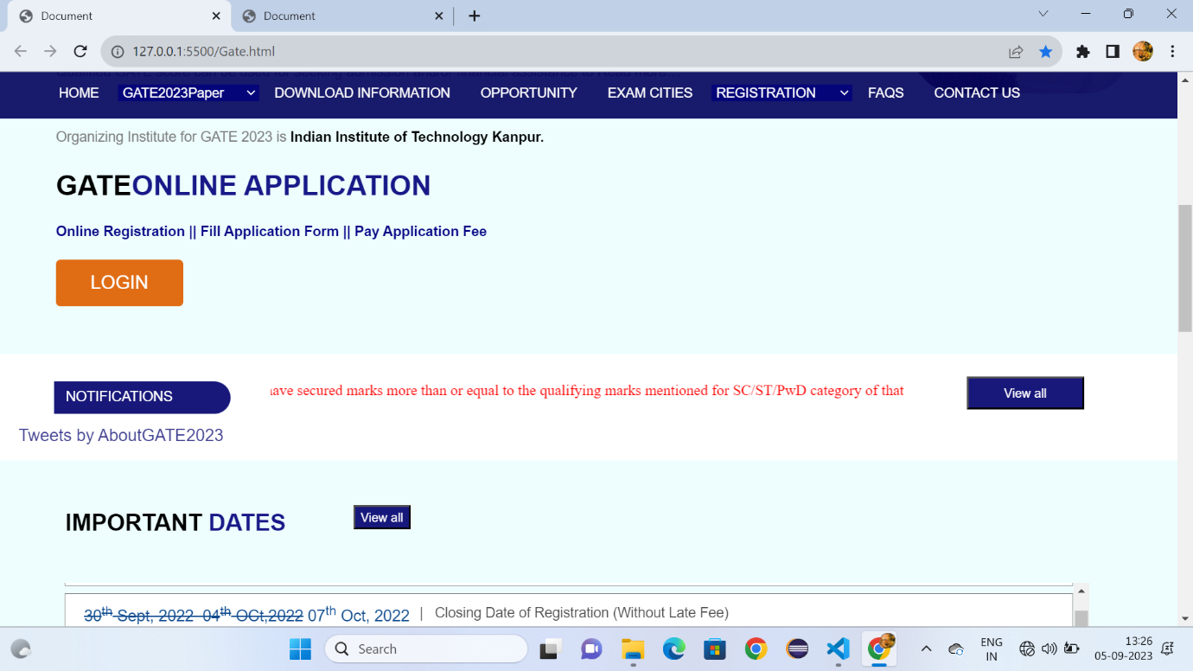

Fig:1.2

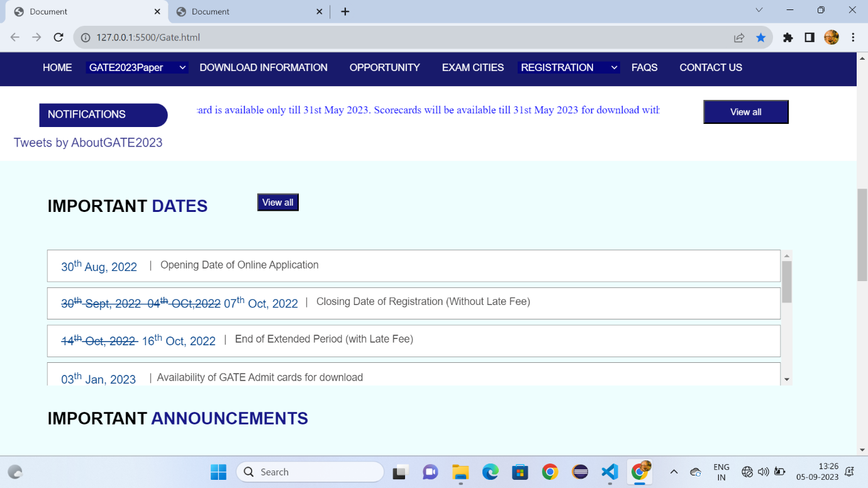

Fig:1.3

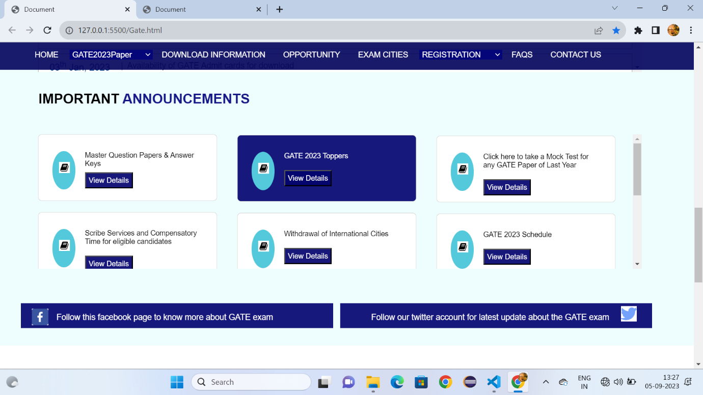

Fig:1.4

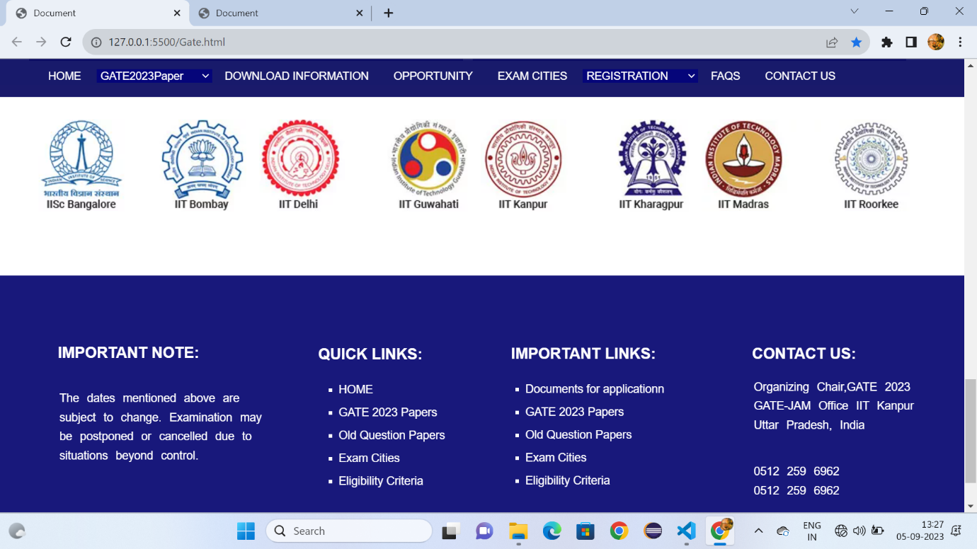

Fig:1.5

Download.html:-

<!DOCTYPE html>

<!DOCTYPE html>

<html lang="en">

<head>

    <meta charset="UTF-8">

    <meta name="viewport" content="width=device-width, initial-scale=1.0">

    <title>Document</title>

    <link rel="stylesheet" href="Downloadgate.css" >

    <style>

        body{

    margin: 0px;

        }

        a:hover{

            background-color: rgba(60, 105, 163, 0.9);

            padding-bottom: -15px;

        }

        .h:hover{

            background-color: rgba(60, 105, 163, 0.9);

            padding-bottom: -15px;

        }

        #d3:hover{

            background-color:rgba(60, 105, 163, 0.9);

            padding-bottom: -15px;

            height: 45px;

        }

        .p{

            font-size: 17px;

            font-family: sans-serif;

            color: rgb(13, 74, 143);

            text-decoration: none;

            margin-left: 20px;

          margin-top: 10px;

        }

        #d2{

            position: sticky;

            top:0px;

        }

        .i:hover{

            color: rgb(75, 74, 74);

        }

  </style>

</head>

<body>

    <header id="d1">

        <img style="margin-left: 50px;" src="https://gate.iitk.ac.in/images/xbanner-bg.png.pagespeed.ic.mRgukKISkj.webp" width="90%" height="150px">

    </header>

    <div id="d2">

        <a class="c6" style="padding-left: 5%;" href="Gate.html" target="_self">HOME</a>

        <select id="d3" class="h">

        <option >GATE2023Paper</option>

        <option class="c1">Papers&Syllabus</option>

        <option class="c1">Pattern</option>

        <option class="c1">Two Paper Combinations</option>

        <option class="c1">GATE 2023 Schedule</option>

        </select>

        <a class="c6" style="font-size: 90%;padding-left: 1%;" href="Downloadgate.html">DOWNLOAD INFORMATION</a>

        <a class="c6" style="font-size: 90%;padding-left: 1%;" href="opportunity.html">OPPORTUNITY</a>

        <a class="c6" style="font-size: 90%;padding-left: 1%;" href="Examcities.html">EXAM CITIES</a>

        <select id="d3" class="h">

            <option >REGISTRATION</option>

            <option class="c1">Eligibility Criteria</option>

            <option class="c1">Document required for filling the application</option>

            <option class="c1">Application Fees</option>

         </select>

         <a class="c6" style="font-size: 90%;padding-left: 1%;" href="FAQS.html">FAQS</a>

         <a class="c6" style="font-size: 90%;padding-left: 1%" href="Contactus.html">CONTACT US</a>

        </div>

        <div style="height: 1200px;background-color:rgba(89, 244, 244, 0.1) ;border: 2px solid rgba(89, 244, 244, 0.1);">

            <h1 style="font-family: sans-serif;font-size: x-large;"><span style="color: rgba(3, 3, 125, 0.912);margin-left: 60px;margin-top: 2%;position: absolute;">QUESTION PAPERS OF PREVIOUS YEAR</span> </h1>

            <h1 style="font-family: sans-serif;font-size: large;margin-top: 10%;margin-left: 6%;">Select Years</h1>

            <div style="width: 14%;height: 30px;margin-left: 70px;">

           <select id="e">

            <option style="background-color: blue;">--select--</option>

            <option>2007</option>

            <option>2008</option>

            <option>2009</option>

            <option>2010</option>

            <option>2011</option>

            <option>2012</option>

            <option>2013</option>

            <option>2014</option>

            <option>2015</option>

            <option>2016</option>

            <option>2018</option>

            <option>2019</option>

            <option>2020</option>

            <option>2021</option>

            <option>2022</option>

           </select>

        </div>

        <h1 style="font-family: sans-serif;font-size: x-large;margin-left: 5%;margin-top: 8%;">GATE 2023<span style="color: rgba(3, 3, 125, 0.912);">INFORMATION BROCHER</span> </h1>

        <div style="width: 88%;height: 160px;margin-left: 5%;margin-top: 50px;background-color: rgba(80, 181, 228, 0.1);">

          <ul>

            <li  class="i">version-2, Release Date - 6<sup>th</sup>Sep,2022</li>

            <li   class="i">version-2, Release Date - 22<sup>nd</sup>Agu,2022</li>

            <li  class="i">version-1, Release Date - 27<sup>th</sup>July,2022</li>

        </ul>

        <h1 style="font-family: sans-serif;font-size: x-large;margin-left: -1.3%;margin-top: 6%;">GATE 2023<span style="color: rgba(3, 3, 125, 0.912);">POSTER</span> </h1>

        <div style="width: 102%;height: 90px;margin-left: -1.3%;margin-top: 50px;background-color: rgba(80, 181, 228, 0.1);">

            <img style="width: 2.5%;height: 40px;margin-left: 30px;margin-top: 20px;" src="https://gate.iitk.ac.in/GATE2023/images/Poster.ico">

            <h1 id="c" class="i">For Indian Cities</h1>

            <img style="width: 2.5%;height: 40px;margin-left: 30%;margin-top: -40px;position: absolute;" src="https://gate.iitk.ac.in/GATE2023/images/Poster.ico">

            <h1 id="c1" class="i">For International Cities</h1>

            <h1 style="font-family: sans-serif;font-size: x-large;margin-left: -1.3%;margin-top: 6%;">GATE 2023<span style="color: rgba(3, 3, 125, 0.912);">  NEWSPAPER     ADVERTISMENT</span> </h1>

        <div style="width: 102%;height: 90px;margin-left: -1.3%;margin-top: 50px;background-color: rgba(80, 181, 228, 0.1);">

            <img style="width: 2.5%;height: 40px;margin-left: 30px;margin-top: 20px;" src="https://gate.iitk.ac.in/GATE2023/images/xAdv_ENG.png.pagespeed.ic.v4vLBMF1Ga.webp">

            <h1 id="c" class="i"><span style="color: green;font-size:15px;font-family: sans-serif;">English version</span>(Employement News - University News)</h1>

            <img style="width: 2.5%;height: 40px;margin-left: 50%;margin-top: -40px;position: absolute;" src="https://gate.iitk.ac.in/GATE2023/images/xAdv_ENG.png.pagespeed.ic.v4vLBMF1Ga.webp">

            <h1 id="c11" class="i">For International Cities</h1>

</div>

            <div style="width: 102%;height: 70px;margin-left: -1.3%;margin-top: 50px;background-color: rgba(111, 185, 51, 0.1);">

                <h1 id="c111" class="i">History of GATE (First Examination in 1983)</h1>

            </div>

        </div>

        </div>

        <div id="d22">

            <h3 style="font-family: sans-serif;font-size: 20px;color: white;margin-left: 6%;margin-top: 80px;">IMPORTANT NOTE:</h3>

            <br>

            <br>

            <ol style="list-style-type: none;margin-left: 3%;margin-top: -20px;">

                <li class="b">The dates mentioned above are </li>

                <li class="b">subject to change. Examination may</li>

                <li class="b">be postponed or cancelled due to</li>

                <li class="b">situations beyond control.</li>

            </ol>

            <h3 style="font-family: sans-serif;font-size: 20px;color: white;margin-left: 33%;margin-top: -173px;">QUICK LINKS:</h3>

            <ul>

                <li class="a"> <a style="color: white;text-decoration: none;" href="Gate.html">HOME</li></a>

            <li class="a"><a style="color: white;text-decoration: none;" href="Downloadgate.html">GATE 2023 Papers</li></a>

            <li class="a"><a style="color: white;text-decoration: none;" href="Downloadgate.html">Old Question Papers</li></a>

            <li class="a"><a style="color: white;text-decoration: none;" href="Examcities.html">Exam Cities</li></a>

            <li class="a"><a style="color: white;text-decoration: none;" href="Examcities.html">Eligibility Criteria</li></a>

            </ul>

            <h3 style="font-family: sans-serif;font-size: 20px;color: white;margin-left: 53%;margin-top: -230px;">IMPORTANT LINKS:</h3>

            <ul>

                <li class="a1"><a style="color: white;text-decoration: none;" href="GateDocuments.html">Documents for applicationn</li></a>

            <li class="a1"><a style="color: white;text-decoration: none;" href="Downloadgate.html">Two Paper Combinations</li></a>

            <li class="a1"><a style="color: white;text-decoration: none;" href="GateApplicationfee.html">Application Fees</li></a>

            <li class="a1"><a style="color: white;text-decoration: none;" href="FAQS.html">FQAs</li></a>

            </ul>

            <h3 style="font-family: sans-serif;font-size: 20px;color: white;margin-left: 78%;margin-top: -230px;">CONTACT US:</h3>

            <ol style="list-style-type: none;margin-left: 75%;margin-top: 30px;">

                <li class="b">Organizing Chair,GATE 2023 </li>

                <li class="b">GATE-JAM Office IIT Kanpur</li>

                <li class="b">Uttar Pradesh, India</li>

                <br>

                <br>

                <li class="b" >0512 259 6962</li>

                <li class="b">0512 259 6962</li>

            </ol>

            <br>

            <br>

            <hr style="width: 90%; color: white;">

            <p style="color: white;font-size: 15px; margin-left: 24%;">© Copyright: GATE 2023, Indian Institute of Technology Kanpur, Uttar Pradesh- 208016, India.</p>

        </div>

        </body>

        </html>

Download.css :-

#d1{

    background-attachment: cover;

    width: 100%;

}

#d2{

    width: 100%;

    height: 50px;

    background-color: rgba(2, 2, 92, 0.906);

}

.c6{

    color: white;

     min-height: 45Px;

     line-height: 45px;

    font-family: sans-serif;

    text-decoration: none;

    font-size: 90%;

    padding: 16px;

}

#d3{

 background-color:rgba(3, 3, 124, 0.9);

 color: white;

 border: none;

 font-size: 90%;

 padding-left: 0.1%;

 width: 12%;

}

.c1{

    background-color: white;

    color: black;

    font-family: sans-serif;

    line-height: 50px;

}

#e{

    width: 100%;

    height: 30px;

}

ul{

    color: rgb(15, 106, 149);

    font-size: large;

    line-height: 30px;

    padding-top: 19px

}

#c{

    color: rgb(15, 106, 149);

    font-size: large;

    line-height: 30px;

    margin-top: -40px;

    margin-left: 7%;

}

#c1{

    color: rgb(15, 106, 149);

    font-size: large;

    line-height: 30px;

    margin-top: -40px;

    margin-left: 38%;

}

#c11{color: rgb(15, 106, 149);

font-size: large;

line-height: 30px;

margin-top: -40px;

margin-left: 58%;

}

#c111{

    color: rgb(15, 106, 149);

    font-size: large;

    line-height: 30px;

    margin-top: -40px;

    margin-left: 7%;

    margin-left: 1%;

    position: absolute;

    margin-top: 1%;

}

#d22{

    height: 400px;

        padding-top: 10px;

    background-color:rgba(3, 3, 111, 0.918);

    opacity: 80;

    margin-top: 53.5%;

}

.b{

    font-family: sans-serif;

    font-size: 15px;

    color: white;

    line-height: 25px;

    word-spacing: 6px;

}

.a{

    font-size: 15px;

    font-family: sans-serif;

    color: white;

    list-style-type: square;

    margin-left: 33%;

    line-height: 30px;

}

.a1{

    font-size: 15px;

    font-family: sans-serif;

    color: white;

    list-style-type: square;

    margin-left: 53%;

    line-height: 30px;

}

**Output:**

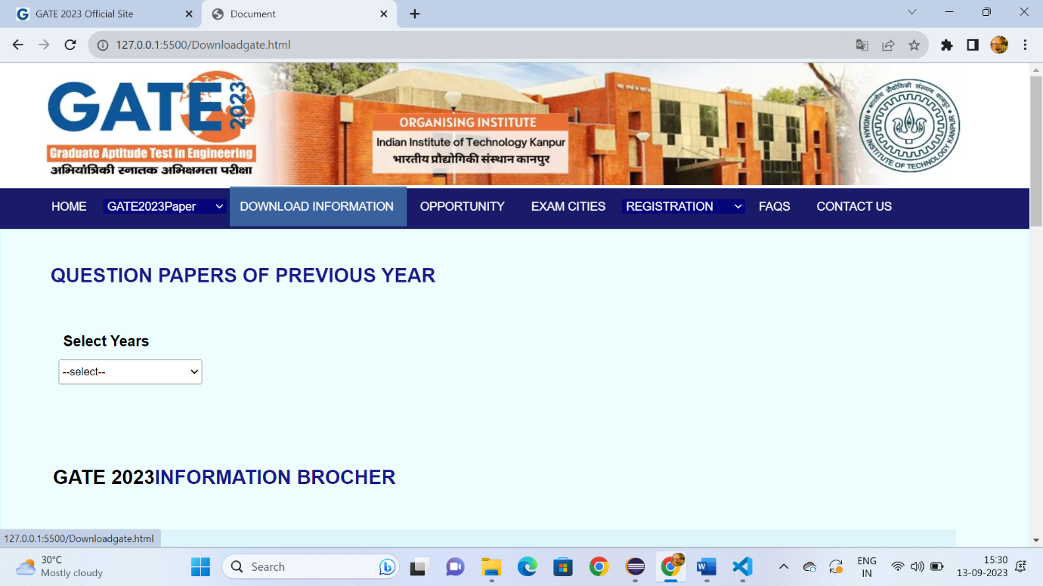

Fig:2.1

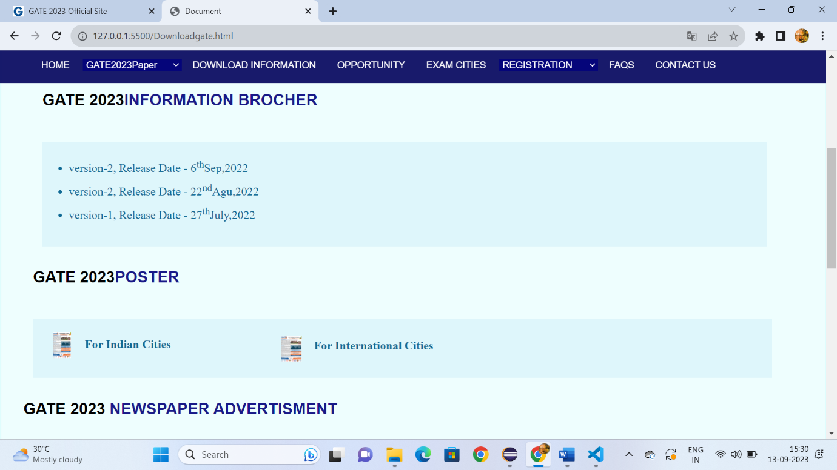

Fig:2.2

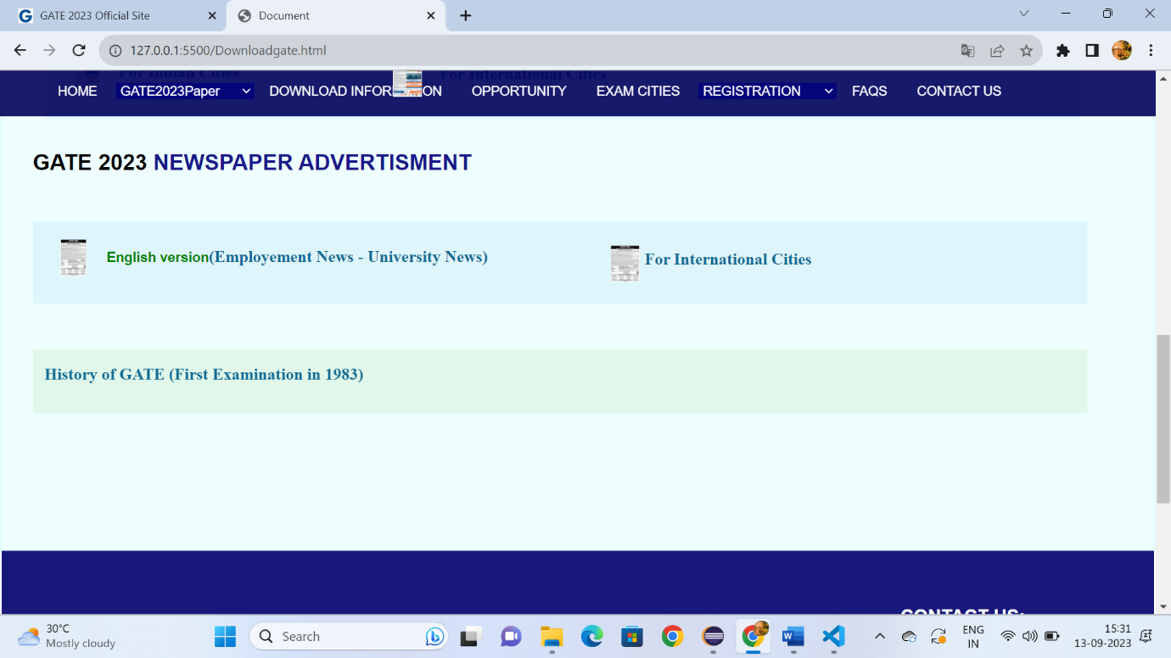

Fig:2.3

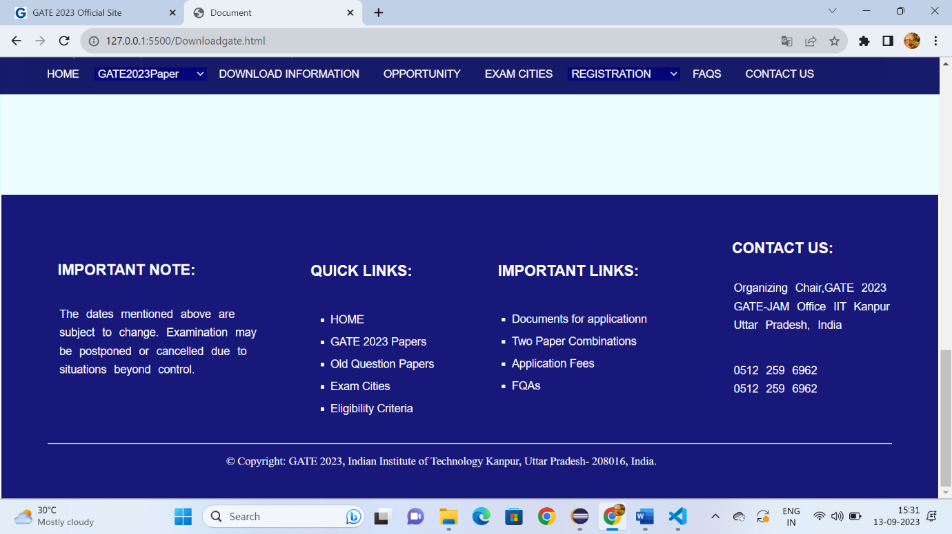

Fig:2.4

**Opportunity.html:**

<!DOCTYPE html>

<html lang="en">

<head>

    <meta charset="UTF-8">

    <meta name="viewport" content="width=device-width, initial-scale=1.0">

    <title>Document</title>

    <link rel="stylesheet" href="Downloadgate.css" >

    <style>

        *{

    margin: 0px;

    box-sizing: border-box;

        }

        a:hover{

            background-color: rgba(60, 105, 163, 0.9);

            padding-bottom: -15px;

        }

        .h:hover{

            background-color: rgba(60, 105, 163, 0.9);

            padding-bottom: -15px;

        }

        #d3:hover{

            background-color:rgba(60, 105, 163, 0.9);

            padding-bottom: -15px;

            height: 45px;

        }

        .p{

            font-size: 17px;

            font-family: sans-serif;

            color: rgb(13, 74, 143);

            text-decoration: none;

            margin-left: 20px;

          margin-top: 10px;

        }

        #d2{

            position: sticky;

            top:0px;

        }

        .i:hover{

            color: rgb(75, 74, 74);

        }

 </style>

</head>

<body>

    <header id="d1">

        <img style="margin-left: 50px;" src="https://gate.iitk.ac.in/images/xbanner-bg.png.pagespeed.ic.mRgukKISkj.webp" width="90%" height="150px">

    </header>

    <div id="d2">

        <a class="c6" style="padding-left: 5%;" href="Gate.html" target="_self">HOME</a>

        <select id="d3" class="h">

        <option >GATE2023Paper</option>

        <option class="c1">Papers&Syllabus</option>

        <option class="c1">Pattern</option>

        <option class="c1">Two Paper Combinations</option>

        <option class="c1">GATE 2023 Schedule</option>

        </select>

        <a class="c6" style="font-size: 90%;padding-left: 1%;" href="Downloadgate.html">DOWNLOAD INFORMATION</a>

        <a class="c6" style="font-size: 90%;padding-left: 1%;" href="opportunity.html">OPPORTUNITY</a>

        <a class="c6" style="font-size: 90%;padding-left: 1%;" href="Examcities.html">EXAM CITIES</a>

        <select id="d3" class="h">

            <option >REGISTRATION</option>

            <option class="c1">Eligibility Criteria</option>

            <option class="c1">Document required for filling the application</option>

            <option class="c1">Application Fees</option>

         </select>

         <a class="c6" style="font-size: 90%;padding-left: 1%;" href="FAQS.html">FAQS</a>

         <a class="c6" style="font-size: 90%;padding-left: 1%" href="Contactus.html">CONTACT US</a>

        </div>

        <div style="height: 1100px;background-color:rgba(89, 244, 244, 0.1) ;border: 2px solid rgba(89, 244, 244, 0.1);">

            <h1 style="font-family: sans-serif;font-size: x-large;margin-top: 2%;margin-left: 30px;"><span style="color: rgba(3, 3, 125, 0.912);margin-left: 60px;margin-top: 2%;position: absolute;">OPPORTUNITIES</span> </h1>

            <div style="width: 40%;height: 300px;margin-top: 13%;margin-left: 7%;">

                <p style="font-family: sans-serif;font-size: 15px;color: gray;line-height: 25px;">The Graduate Aptitude Test in Engineering (GATE) is an examination that primarily tests the comprehensive understanding of various undergraduate subjects in engineering and science for admission into the Masters Program and Recruitment by some Public Sector Companies. Some of the possible opportunities for GATE qualified candidates are :

                    </p>

                    <br>

                    <br>

                <p style="font-size: 15px;font-family: sans-serif;color: gray;line-height: 25px;"><b style="color: black;">Admission:</b> Valid GATE score can be used for seeking admission to: (i) Master’s programs and direct Doctoral programs in Engineering/ Technology/ Architecture/ Science/ Commerce/ Arts; and (ii) Doctoral programs in relevant branches of Arts and Science, in the institutions supported by the MoE and other Government agencies.</p>

                </p>

            </div>

            <div style="width: 48%;height: 300px;margin-left: 49%;margin-top: -24%;">

            <img style="height: 300px;" src="https://gate.iitk.ac.in/GATE2023/images/opporImg.jpg">

            </div>

            <div style="width: 89%;height: 500px;margin-top: 2%;margin-left: 7%;;">

                <p style="font-size: 15px;font-family: sans-serif;color: gray;line-height: 25px;"><b style="color: black;">Financial Assistance:   </b>Qualified GATE score can be used for seeking financial assistance towards the (i) Master’s programs and direct Doctoral programs in Engineering/ Technology/ Architecture/ Science/ Commerce/ Arts; and (ii) Doctoral programs in relevant branches of Arts and Science, in the institutions supported by the MoE and other Government agencies.</p>

                <br>

                <br>

                <p style="font-size: 15px;font-family: sans-serif;color: gray;line-height: 25px;">PG Scholarship (GATE/ GPAT) (Link: https://www.aicte-india.org/schemes/students-development-schemes/PG-Scholarship-Scheme) Financial Assistance given to M.Tech students is Rs. 12,400 per month and generally paid for 22 months. (Circular dt. 18th Feb 2015) (Circular dt. 16th July 2019)

                    Financial Asisstance given for Ph.D. Programmes (Direct PhD after BE/ BTech/ MSc. Equivalent with valid GATE score) is Rs. 31,000 per month for first two years and Rs. 35,000 per month from third year to fifth year. (Circular dt. 18th Feb 2015) (Circular dt. 16th July 2019)

</p>

<br>

<br>

<br>

<p style="font-size: 15px;font-family: sans-serif;color: gray;line-height: 25px;">

    <b style="color:black"> Recruitment:</b> Many Public Sector Undertakings (PSUs) have been using the GATE score in their recruitment process. A list (not exhaustive) of such PSU is provided below:

    Bharat Heavy Electricals Limited (BHEL), Bharat Sanchar Nigam Limited (BSNL), Coal India Limited (CIL), Centre for Railway Information Systems (CRIS), Chenab Valley Power Projects Limited (CVPPL), Damodar Valley Corporation (DVC), Electronics Corporation of India Limited (ECIL), Engineers India Limited (EIL), Gas Authority of India Limited (GAIL), Indian Oil Corporation Limited (IOCL), Mazagaon Dock Shipbuilders Limited (MDSL), National Aluminium Company Limited (NALCO), National Highways Authority of India (NHAI), NLC India Limited (NLCIL), National Mineral Development Corporation (NMDC), Nuclear Power Corporation of India Limited (NPCIL), National Thermal Power Corporation (NTPC), Oil and Natural Gas Corporation (ONGC), Power Grid Corporation of India (PGCIL), Power System Operation Corporation Limited (POSOCO), Rashtriya Ispat Nigam Limited (RINL), etc.

</p>

<br>

<br>

<br>

<br>

<h1 style="font-size: 15px;font-family: sans-serif;color: rgb(10, 91, 171);">Disclaimer: GATE scores are shared with Institutions supported by the MoE and Public Sector Undertakings for the purpose of admission and recruitment.</h1>

</div>

<div style="margin-top: 9%;" id="d22">

    <h3 style="font-family: sans-serif;font-size: 20px;color: white;margin-left: 6%;margin-top: 80px;">IMPORTANT NOTE:</h3>

    <br>

    <br>

    <ol style="list-style-type: none;margin-left: 3%;margin-top: -20px;">

        <li class="b">The dates mentioned above are </li>

        <li class="b">subject to change. Examination may</li>

        <li class="b">be postponed or cancelled due to</li>

        <li class="b">situations beyond control.</li>

    </ol>

    <h3 style="font-family: sans-serif;font-size: 20px;color: white;margin-left: 33%;margin-top: -153px;">QUICK LINKS:</h3>

    <ul>

        <li class="a"> <a style="color: white;text-decoration: none;" href="Gate.html">HOME</li></a>

        <li class="a"><a style="color: white;text-decoration: none;" href="Downloadgate.html">GATE 2023 Papers</li></a>

        <li class="a"><a style="color: white;text-decoration: none;" href="Downloadgate.html">Old Question Papers</li></a>

        <li class="a"><a style="color: white;text-decoration: none;" href="Examcities.html">Exam Cities</li></a>

        <li class="a"><a style="color: white;text-decoration: none;" href="Examcities.html">Eligibility Criteria</li></a>

    </ul>

    <h3 style="font-family: sans-serif;font-size: 20px;color: white;margin-left: 53%;margin-top: -190px;">IMPORTANT LINKS:</h3>

    <ul>

        <li class="a1"><a style="color: white;text-decoration: none;" href="GateDocuments.html">Documents for applicationn</li></a>

            <li class="a1"><a style="color: white;text-decoration: none;" href="Downloadgate.html">Two Paper Combinations</li></a>

            <li class="a1"><a style="color: white;text-decoration: none;" href="GateApplicationfee.html">Application Fees</li></a>

            <li class="a1"><a style="color: white;text-decoration: none;" href="FAQS.html">FQAs</li></a>

    </ul>

    <h3 style="font-family: sans-serif;font-size: 20px;color: white;margin-left: 78%;margin-top: -190px;">CONTACT US:</h3>

    <ol style="list-style-type: none;margin-left: 75%;margin-top: 20px;">

        <li class="b">Organizing Chair,GATE 2023 </li>

        <li class="b">GATE-JAM Office IIT Kanpur</li>

        <li class="b">Uttar Pradesh, India</li>

        <br>

        <br>

        <li class="b" >0512 259 6962</li>

        <li class="b">0512 259 6962</li>

    </ol>

    <br>

    <br>

    <hr style="width: 100%; color: white;margin-top: 1%;">

    <p style="color: white;font-size: 15px; margin-left: 24%;margin-top: 2%;position: absolute;">© Copyright: GATE 2023, Indian Institute of Technology Kanpur, Uttar Pradesh- 208016, India.</p>

</div>

        </body>

        </html>

**Opportunity.css:**

#d1{

    background-attachment: cover;

    width: 100%;

}

#d2{

    width: 100%;

    height: 50px;

    background-color: rgba(2, 2, 92, 0.906);

}

.c6{

    color: white;

     min-height: 45Px;

     line-height: 45px;

    font-family: sans-serif;

    text-decoration: none;

    font-size: 90%;

    padding: 16px;

}

#d3{

 background-color:rgba(3, 3, 124, 0.9);

 color: white;

 border: none;

 font-size: 90%;

 padding-left: 0.1%;

 width: 12%;

}

.c1{

    background-color: white;

    color: black;

    font-family: sans-serif;

    line-height: 50px;

}

#d22{

    height: 400px;

    padding-top: 10px;

    background-color:rgba(3, 3, 111, 0.918);

    opacity: 80;

}

.b{

    font-family: sans-serif;

    font-size: 15px;

    color: white;

    line-height: 25px;

    word-spacing: 6px;

}

.a{

    font-size: 15px;

    font-family: sans-serif;

    color: white;

    list-style-type: square;

    margin-left: 33%;

    line-height: 30px;

}

.a1{

    font-size: 15px;

    font-family: sans-serif;

    color: white;

    list-style-type: square;

    margin-left: 53%;

    line-height: 30px;

}

**Output:**



Fig:3.1

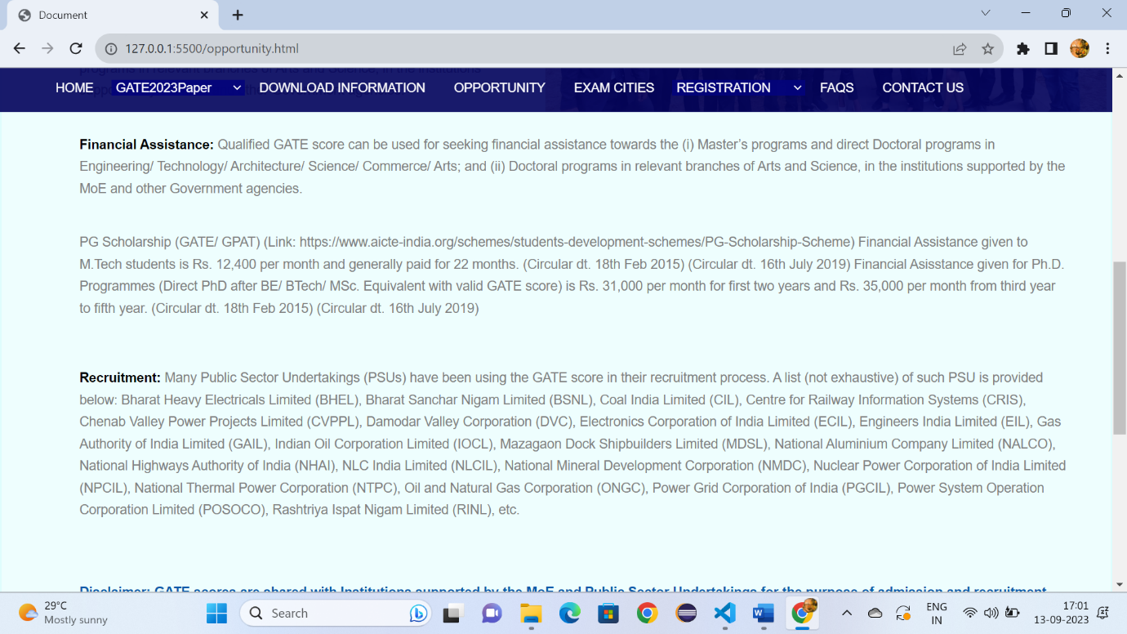

Fig:3.2

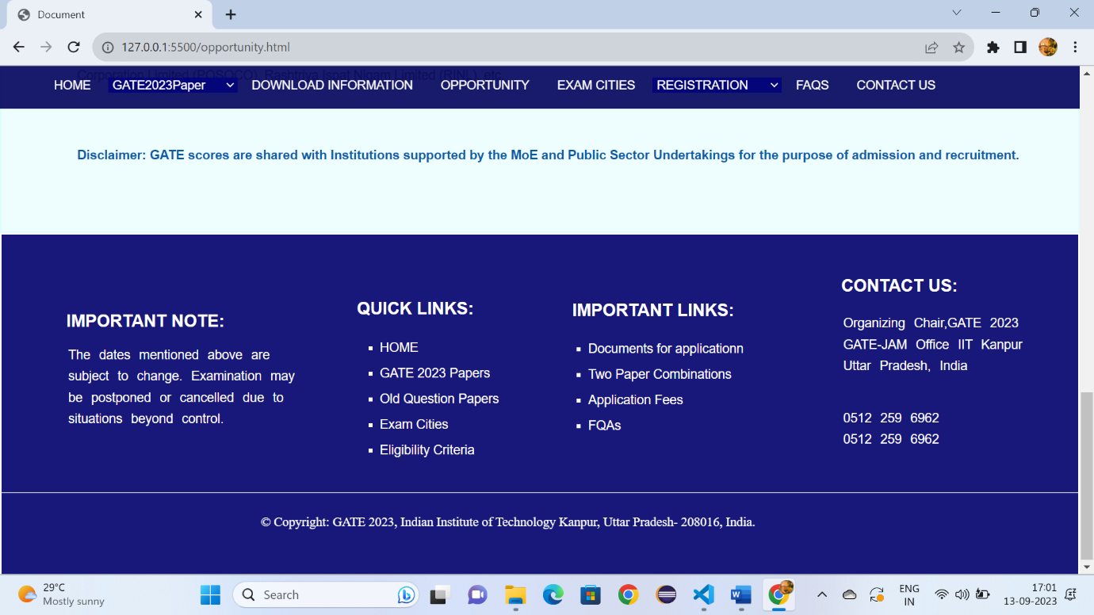

Fig:3.3

**Examcities.html:**

<!DOCTYPE html>

<html lang="en">

<head>

    <meta charset="UTF-8">

    <meta name="viewport" content="width=device-width, initial-scale=1.0">

    <title>Document</title>

    <link rel="stylesheet" href="Downloadgate.css" >

    <style>

        *{

    margin: 0px;

    box-sizing: border-box;

        }

        a:hover{

            background-color: rgba(60, 105, 163, 0.9);

            padding-bottom: -15px;

        }

        .h:hover{

            background-color: rgba(60, 105, 163, 0.9);

            padding-bottom: -15px;

        }

        .p{

            font-size: 17px;

            font-family: sans-serif;

            color: rgb(13, 74, 143);

            text-decoration: none;

            margin-left: 20px;

          margin-top: 10px;

        }

        #d3:hover{

            background-color:rgba(60, 105, 163, 0.9);

            padding-bottom: -15px;

            height: 45px;

        }

        #d2{

            position: sticky;

            top:0px;

        }

        .i:hover{

            color: rgb(75, 74, 74);

        }

</style>

</head>

<body>

    <header id="d1">

        <img style="margin-left: 50px;" src="https://gate.iitk.ac.in/images/xbanner-bg.png.pagespeed.ic.mRgukKISkj.webp" width="90%" height="150px">

    </header>

    <div id="d2">

        <a class="c6" style="padding-left: 5%;" href="Gate.html" target="_self">HOME</a>

        <select id="d3" class="h">

        <option >GATE2023Paper</option>

        <option class="c1">Papers&Syllabus</option>

        <option class="c1">Pattern</option>

        <option class="c1">Two Paper Combinations</option>

        <option class="c1">GATE 2023 Schedule</option>

        </select>

        <a class="c6" style="font-size: 90%;padding-left: 1%;" href="Downloadgate.html" target="_self">DOWNLOAD INFORMATION</a>

        <a class="c6" style="font-size: 90%;padding-left: 1%;" href="opportunity.html" target="_self">OPPORTUNITY</a>

        <a class="c6" style="font-size: 90%;padding-left: 1%;" href="Examcities.html" target="_self">EXAM CITIES</a>

        <select id="d3" class="h">

            <option >REGISTRATION</option>

            <option class="c1">Eligibility Criteria</option>

            <option class="c1">Document required for filling the application</option>

            <option class="c1">Application Fees</option>

         </select>

         <a class="c6" style="font-size: 90%;padding-left: 1%;" href="FAQS.html">FAQS</a>

         <a class="c6" style="font-size: 90%;padding-left: 1%" href="Contactus.html">CONTACT US</a>

        </div>

        <div style="height: 900px;background-color:rgba(89, 244, 244, 0.1) ;border: 2px solid rgba(89, 244, 244, 0.1);">

            <h1 style="font-family: sans-serif;font-size: x-large;"><span style="color: rgba(3, 3, 125, 0.912);margin-left: 60px;margin-top: 2%;position: absolute;">EXAM CITIES</span> </h1>

              <select style="font-size:small;font-family: sans-serif;width: 90%;height: 40px;margin-top: 8%;margin-left: 5%;background-color:rgba(182, 249, 249, 0.1) ;">

                <option >Zone 1-IISc Bangalore</option>

                <option>Chairperson, GATE,

                    IISc Bangalore,

                    Bengaluru - 560 012</option>

              </select>

              <select style="font-size:small;font-family: sans-serif;width: 90%;height: 40px;margin-top: 1%;margin-left: 5%;background-color:rgba(182, 249, 249, 0.1) ;">

                <option >Zone 2-IIT Bombay</option>

                <option>Chairperson, GATE,

                    IIT Bombay, Powai,

                    Mumbai - 400 076</option>

              </select>

              <select style="font-size:small;font-family: sans-serif;width: 90%;height: 40px;margin-top: 1%;margin-left: 5%;background-color:rgba(182, 249, 249, 0.1) ;">

                <option >Zone 3-IIT Delhi</option>

                <option>Chairperson, GATE,

                    IIT Bombay, Powai,

                    Mumbai - 400 076</option>

              </select>

              <select style="font-size:small;font-family: sans-serif;width: 90%;height: 40px;margin-top: 1%;margin-left: 5%;background-color:rgba(182, 249, 249, 0.1) ;">

                <option >Zone 4-IIT Guwahati</option>

                <option>Chairperson, GATE,

                    IIT Bombay, Powai,

                    Mumbai - 400 076</option>

              </select>

              <select style="font-size:small;font-family: sans-serif;width: 90%;height: 40px;margin-top: 1%;margin-left: 5%;background-color:rgba(182, 249, 249, 0.1) ;">

                <option >Zone 5-IIT Kanpur</option>

                <option>Chairperson, GATE,

                    IIT Bombay, Powai,

                    Mumbai - 400 076</option>

              </select>

              <select style="font-size:small;font-family: sans-serif;width: 90%;height: 40px;margin-top: 1%;margin-left: 5%;background-color:rgba(182, 249, 249, 0.1) ;">

                <option >Zone 6-IIT Kharagpur</option>

                <option>Chairperson, GATE,

                    IIT Bombay, Powai,

                    Mumbai - 400 076</option>

              </select>

              <select style="font-size:small;font-family: sans-serif;width: 90%;height: 40px;margin-top: 1%;margin-left: 5%;background-color:rgba(182, 249, 249, 0.1) ;">

                <option >Zone 7-IIT Madras</option>

                <option>Chairperson, GATE,

                    IIT Bombay, Powai,

                    Mumbai - 400 076</option>

              </select>

              <select style="font-size:small;font-family: sans-serif;width: 90%;height: 40px;margin-top: 1%;margin-left: 5%;background-color:rgba(182, 249, 249, 0.1) ;">

                <option >Zone 8-IIT Roorkee</option>

                <option>Chairperson, GATE,

                    IIT Bombay, Powai,

                    Mumbai - 400 076</option>

              </select>

              <select style="font-size:small;font-family: sans-serif;width: 90%;height: 50px;margin-top: 1%;margin-left: 5%;background-color:rgba(182, 249, 249, 0.1) ;">

                <option >See Announcement on Withdrawal of International Cities</option>

                <option>Chairperson, GATE,

                    IIT Bombay, Powai,

                    Mumbai - 400 076</option>

              </select>

              <p style="font-size: large;font-family: sans-serif; color: gray;margin-left: 5%;margin-top: 3%;">This is a tentative list of examination cities. Any changes will be updated on the website.</p>

              <p style="font-family: sans-serif;margin-top: 1%;margin-left: 5%;"><b>Choice of Examination City:</b></p>

              <ul style="margin-left: 5%;">

                <li style="color: gray;">A candidate can choose THREE cities from the list of examination cities given above.</li>

                <li style="color: gray;">All the three choices must be from the same GATE 2023 zone.</li>

                <li style="color: gray;"> GATE 2023 reserves the right to add a new city or remove an existing one, and allot a city that may not be from any of the choices selected by the candidate.</li>

              </ul>

            </div>

            <div style="margin-top: -1%;" id="d22">

                <h3 style="font-family: sans-serif;font-size: 20px;color: white;margin-left: 6%;margin-top: 80px;">IMPORTANT NOTE:</h3>

                <br>

                <br>

                <ol style="list-style-type: none;margin-left: 3%;margin-top: -20px;">

                    <li class="b">The dates mentioned above are </li>

                    <li class="b">subject to change. Examination may</li>

                    <li class="b">be postponed or cancelled due to</li>

                    <li class="b">situations beyond control.</li>

                </ol>

                <h3 style="font-family: sans-serif;font-size: 20px;color: white;margin-left: 33%;margin-top: -153px;">QUICK LINKS:</h3>

                <ul>

                    <li class="a"> <a style="color: white;text-decoration: none;" href="Gate.html">HOME</li></a>

                    <li class="a"><a style="color: white;text-decoration: none;" href="Downloadgate.html">GATE 2023 Papers</li></a>

                    <li class="a"><a style="color: white;text-decoration: none;" href="Downloadgate.html">Old Question Papers</li></a>

                    <li class="a"><a style="color: white;text-decoration: none;" href="Examcities.html">Exam Cities</li></a>

                    <li class="a"><a style="color: white;text-decoration: none;" href="Examcities.html">Eligibility Criteria</li></a>

                </ul>

                <h3 style="font-family: sans-serif;font-size: 20px;color: white;margin-left: 53%;margin-top: -190px;">IMPORTANT LINKS:</h3>

                <ul>

                    <li class="a1"><a style="color: white;text-decoration: none;" href="GateDocuments.html">Documents for applicationn</li></a>

            <li class="a1"><a style="color: white;text-decoration: none;" href="Downloadgate.html">Two Paper Combinations</li></a>

            <li class="a1"><a style="color: white;text-decoration: none;" href="GateApplicationfee.html">Application Fees</li></a>

            <li class="a1"><a style="color: white;text-decoration: none;" href="FAQS.html">FQAs</li></a>

                </ul>

                <h3 style="font-family: sans-serif;font-size: 20px;color: white;margin-left: 78%;margin-top: -190px;">CONTACT US:</h3>

                <ol style="list-style-type: none;margin-left: 75%;margin-top: 20px;">

                    <li class="b">Organizing Chair,GATE 2023 </li>

                    <li class="b">GATE-JAM Office IIT Kanpur</li>

                    <li class="b">Uttar Pradesh, India</li>

                    <br>

                    <br>

                    <li class="b" >0512 259 6962</li>

                    <li class="b">0512 259 6962</li>

                </ol>

                <br>

                <br>

                <hr style="width: 100%; color: white;margin-top: 1%;">

                <p style="color: white;font-size: 15px; margin-left: 24%;margin-top: 2%;position: absolute;">© Copyright: GATE 2023, Indian Institute of Technology Kanpur, Uttar Pradesh- 208016, India.</p>

            </div>

</body>

</html>

**Examcities.css:**

#d1{

    background-attachment: cover;

    width: 100%;

}

#d2{

    width: 100%;

    height: 50px;

    background-color: rgba(2, 2, 92, 0.906);

}

.c6{

    color: white;

     min-height: 45Px;

     line-height: 45px;

    font-family: sans-serif;

    text-decoration: none;

    font-size: 90%;

    padding: 16px;

}

#d3{

 background-color:rgba(3, 3, 124, 0.9);

 color: white;

 border: none;

 font-size: 90%;

 padding-left: 0.1%;

 width: 12%;

}

.c1{

    background-color: white;

    color: black;

    font-family: sans-serif;

    line-height: 50px;

}

#d22{

    height: 400px;

        padding-top: 10px;

    background-color:rgba(3, 3, 111, 0.918);

    opacity: 80;

}

.b{

    font-family: sans-serif;

    font-size: 15px;

    color: white;

    line-height: 25px;

    word-spacing: 6px;

}

.a{

    font-size: 15px;

    font-family: sans-serif;

    color: white;

    list-style-type: square;

    margin-left: 33%;

    line-height: 30px;

}

.a1{

    font-size: 15px;

    font-family: sans-serif;

    color: white;

    list-style-type: square;

    margin-left: 53%;

    line-height: 30px;

}

**Output:**

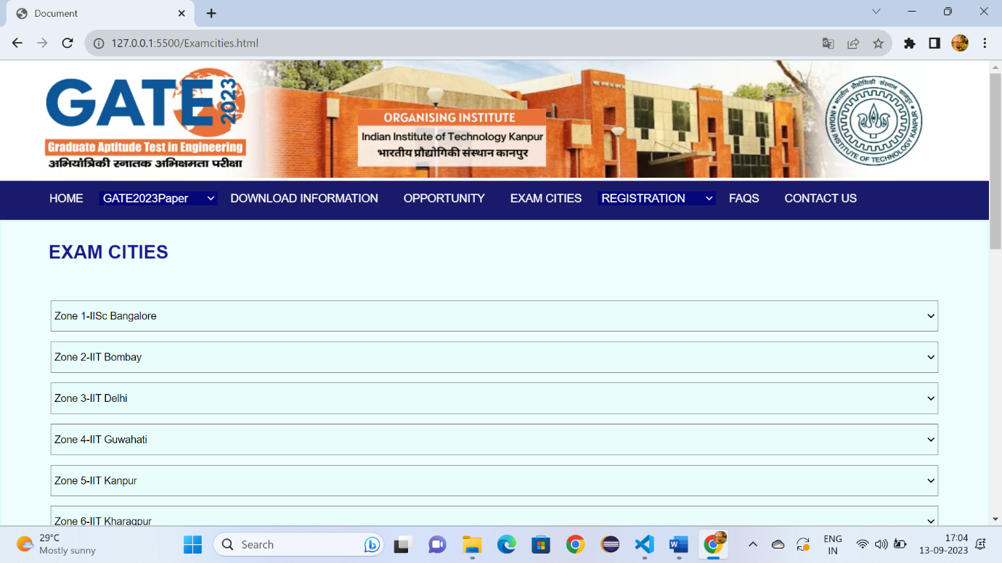

Fig:4.1

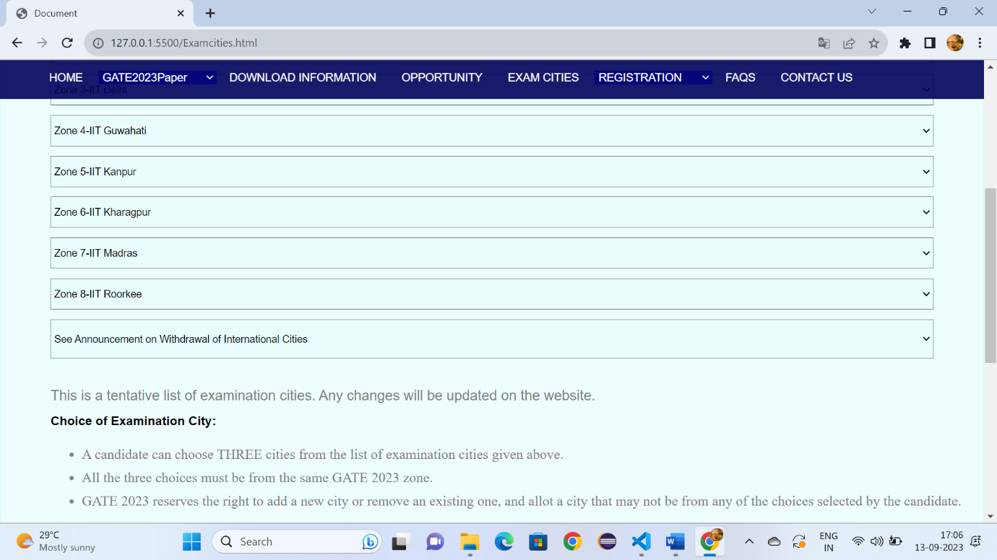

Fig:4.2

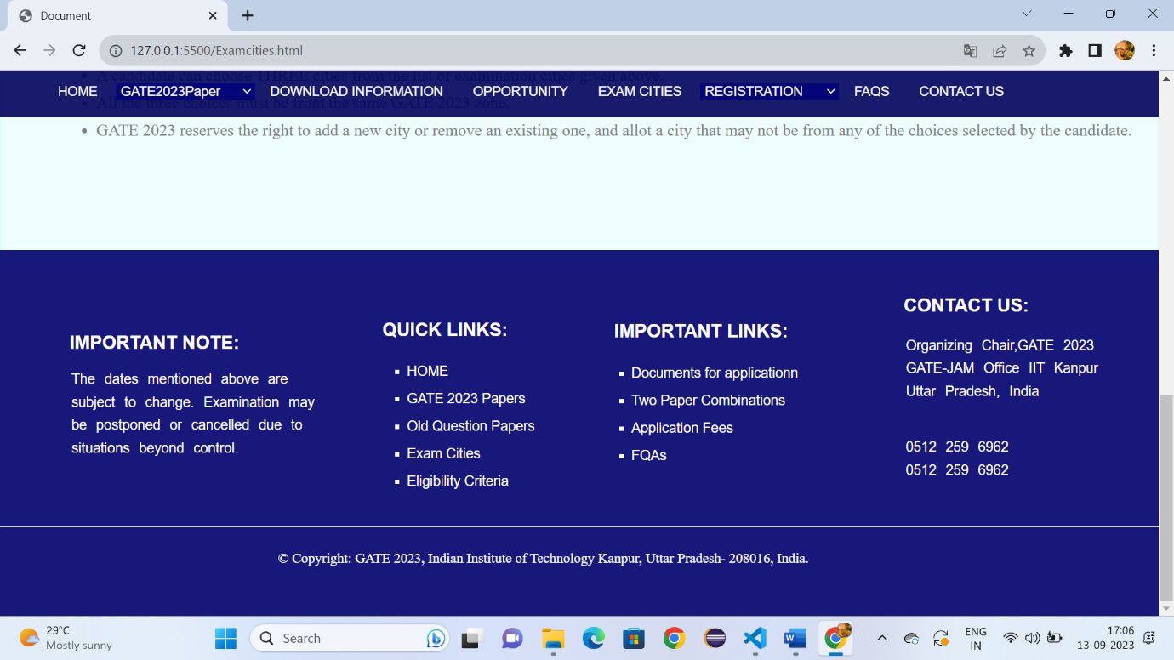

Fig:4.2

**FQAS.html:**

<!DOCTYPE html>

<!DOCTYPE html>

<html lang="en">

<head>

    <meta charset="UTF-8">

    <meta name="viewport" content="width=device-width, initial-scale=1.0">

    <title>Document</title>

    <link rel="stylesheet" href="Downloadgate.css" >

    <style>

        *{

    margin: 0px;

    box-sizing: border-box;

        }

        a:hover{

            background-color: rgba(60, 105, 163, 0.9);

            padding-bottom: -15px;

        }

        .h:hover{

            background-color: rgba(60, 105, 163, 0.9);

            padding-bottom: -15px;

        }

        #d3:hover{

            background-color:rgba(60, 105, 163, 0.9);

            padding-bottom: -15px;

            height: 45px;

        }

        .p{

            font-size: 17px;

            font-family: sans-serif;

            color: rgb(13, 74, 143);

            text-decoration: none;

            margin-left: 20px;

          margin-top: 10px;

        }

        #d2{

            position: sticky;

            top:0px;

        }

        .i:hover{

            color: rgb(75, 74, 74);

        }

  </style>

</head>

<body>

    <header id="d1">

        <img style="margin-left: 50px;" src="https://gate.iitk.ac.in/images/xbanner-bg.png.pagespeed.ic.mRgukKISkj.webp" width="90%" height="150px">

    </header>

    <div id="d2">

        <a class="c6" style="padding-left: 5%;" href="Gate.html" target="_self">HOME</a>

        <select id="d3" class="h">

        <option >GATE2023Paper</option>

        <option class="c1">Papers&Syllabus</option>

        <option class="c1">Pattern</option>

        <option class="c1">Two Paper Combinations</option>

        <option class="c1">GATE 2023 Schedule</option>

        </select>

        <a class="c6" style="font-size: 90%;padding-left: 1%;" href="Downloadgate.html" target="_self">DOWNLOAD INFORMATION</a>

        <a class="c6" style="font-size: 90%;padding-left: 1%;" href="opportunity.html" target="_self">OPPORTUNITY</a>

        <a class="c6" style="font-size: 90%;padding-left: 1%;" href="Examcities.html" target="_self">EXAM CITIES</a>

        <select id="d3" class="h">

            <option >REGISTRATION</option>

            <option class="c1">Eligibility Criteria</option>

            <option class="c1">Document required for filling the application</option>

            <option class="c1">Application Fees</option>

         </select>

         <a class="c6" style="font-size: 90%;padding-left: 1%;" href="FAQS.htmlS">FAQS</a>

         <a class="c6" style="font-size: 90%;padding-left: 1%" href="Contactus.html">CONTACT US</a>

        </div>

        <div style="height: 600px;background-color:rgba(89, 244, 244, 0.1) ;border: 2px solid rgba(89, 244, 244, 0.1);">

            <h1 style="font-family: sans-serif;font-size: x-large;"><span style="color: rgba(3, 3, 125, 0.912);margin-left: 60px;margin-top: 2%;position: absolute;">FREQENTLY ASKED QUESTIONS(FAQS)</span> </h1>

              <select style="font-size:small;font-family: sans-serif;width: 90%;height: 40px;margin-top: 8%;margin-left: 5%;background-color:rgba(182, 249, 249, 0.1) ;">

                <option >Application Process</option>

                <option>1)I am currently studying in 3rd year B.A./B.Com./B.Sc. Am I eligible to appear for GATE-2023?

                    YES, any undergraduate student currently in 3rd year or higher years of any government approved program in Engineering/Technology/Architecture/Arts/Commerce/Science is eligible to appear for GATE 2023.

                    <br>

                   2) I am currently studying in 3rd year B.E., but through parallel entry in the 2nd year after finishing Diploma, am I eligible to appear for GATE 2023?

                    YES, any undergraduate student currently in 3rd year or higher years of any government approved program in Engineering/Technology/Architecture/Arts/Commerce/Science is eligible to appear for GATE 2023.

                    3)Is there any age limit to appear for GATE 2023?

                    NO. There is NO age limit to appear for GATE 2023.

                   4) Are there any restrictions on the number of times one can appear for GATE?

                    NO. One can appear for the GATE examination any number of times.

                    5)Can I appear in any of the GATE 2023 papers?

                    Although, the candidate is free to choose any of the papers (up to two from the given combinations), candidate should select paper appropriate to the discipline of qualifying degree.

                    </option>

              </select>

              <select style="font-size:small;font-family: sans-serif;width: 90%;height: 40px;margin-top: 1%;margin-left: 5%;background-color:rgba(182, 249, 249, 0.1) ;">

                <option >Admit Card</option>

                <option>Chairperson, GATE,

                    IIT Bombay, Powai,

                    Mumbai - 400 076</option>

              </select>

              <select style="font-size:small;font-family: sans-serif;width: 90%;height: 40px;margin-top: 1%;margin-left: 5%;background-color:rgba(182, 249, 249, 0.1) ;">

                <option >GATE 2023 Examination</option>

                <option>Chairperson, GATE,

                    IIT Bombay, Powai,

                    Mumbai - 400 076</option>

              </select>

              <select style="font-size:small;font-family: sans-serif;width: 90%;height: 40px;margin-top: 1%;margin-left: 5%;background-color:rgba(182, 249, 249, 0.1) ;">

                <option >PwD and Dyslexic candidates</option>

                <option>Chairperson, GATE,

                    IIT Bombay, Powai,

                    Mumbai - 400 076</option>

              </select>

              <select style="font-size:small;font-family: sans-serif;width: 90%;height: 40px;margin-top: 1%;margin-left: 5%;background-color:rgba(182, 249, 249, 0.1) ;">

                <option >Additional Information for availing Scribe services and Compensatory Time</option>

                <option>Chairperson, GATE,

                    IIT Bombay, Powai,

                    Mumbai - 400 076</option>

              </select>

              <select style="font-size:small;font-family: sans-serif;width: 90%;height: 40px;margin-top: 1%;margin-left: 5%;background-color:rgba(182, 249, 249, 0.1) ;">

                <option >GATE Score card</option>

                <option>Chairperson, GATE,

                    IIT Bombay, Powai,

                    Mumbai - 400 076</option>

              </select>

            </div>

            <div style="margin-top: -1%;" id="d22">

                <h3 style="font-family: sans-serif;font-size: 20px;color: white;margin-left: 6%;margin-top: 80px;">IMPORTANT NOTE:</h3>

                <br>

                <br>

                <ol style="list-style-type: none;margin-left: 3%;margin-top: -20px;">

                    <li class="b">The dates mentioned above are </li>

                    <li class="b">subject to change. Examination may</li>

                    <li class="b">be postponed or cancelled due to</li>

                    <li class="b">situations beyond control.</li>

                </ol>

                <h3 style="font-family: sans-serif;font-size: 20px;color: white;margin-left: 33%;margin-top: -153px;">QUICK LINKS:</h3>

                <ul>

                    <li class="a"> <a style="color: white;text-decoration: none;" href="Gate.html">HOME</li></a>

                    <li class="a"><a style="color: white;text-decoration: none;" href="Downloadgate.html">GATE 2023 Papers</li></a>

                    <li class="a"><a style="color: white;text-decoration: none;" href="Downloadgate.html">Old Question Papers</li></a>

                    <li class="a"><a style="color: white;text-decoration: none;" href="Examcities.html">Exam Cities</li></a>

                    <li class="a"><a style="color: white;text-decoration: none;" href="Examcities.html">Eligibility Criteria</li></a>

      </ul>

                <h3 style="font-family: sans-serif;font-size: 20px;color: white;margin-left: 53%;margin-top: -190px;">IMPORTANT LINKS:</h3>

        <ul>

                    <li class="a1"><a style="color: white;text-decoration: none;" href="GateDocuments.html">Documents for applicationn</li></a>

            <li class="a1"><a style="color: white;text-decoration: none;" href="Downloadgate.html">Two Paper Combinations</li></a>

            <li class="a1"><a style="color: white;text-decoration: none;" href="GateApplicationfee.html">Application Fees</li></a>

            <li class="a1"><a style="color: white;text-decoration: none;" href="FAQS.html">FQAs</li></a>

      </ul>

                <h3 style="font-family: sans-serif;font-size: 20px;color: white;margin-left: 78%;margin-top: -190px;">CONTACT US:</h3>

                <ol style="list-style-type: none;margin-left: 75%;margin-top: 20px;">

                    <li class="b">Organizing Chair,GATE 2023 </li>

                    <li class="b">GATE-JAM Office IIT Kanpur</li>

                    <li class="b">Uttar Pradesh, India</li>

                    <br>

                    <br>

                    <li class="b" >0512 259 6962</li>

                    <li class="b">0512 259 6962</li>

                  </ol>

                <br>

                <br>

                <hr style="width: 100%; color: white;margin-top: 1%;">

                <p style="color: white;font-size: 15px; margin-left: 24%;margin-top: 2%;position: absolute;">© Copyright: GATE 2023, Indian Institute of Technology Kanpur, Uttar Pradesh- 208016, India.</p>

</div>

</body>

</html>

**FQAS.css:**

#d1{

  background-attachment: cover;

    width: 100%;

}

#d2{

    width: 100%;

    height: 50px;

    background-color: rgba(2, 2, 92, 0.906);

}

.c6{

    color: white;

     min-height: 45Px;

     line-height: 45px;

    font-family: sans-serif;

    text-decoration: none;

    font-size: 90%;

    padding: 16px;

}

#d3{

 background-color:rgba(3, 3, 124, 0.9);

 color: white;

 border: none;

 font-size: 90%;

 padding-left: 0.1%;

 width: 12%;

}

.c1{

    background-color: white;

    color: black;

    font-family: sans-serif;

    line-height: 50px;

}

#d22{

    height: 400px;

        padding-top: 10px;

    background-color:rgba(3, 3, 111, 0.918);

    opacity: 80;

}

.b{

    font-family: sans-serif;

    font-size: 15px;

    color: white;

    line-height: 25px;

    word-spacing: 6px;

}

.a{

    font-size: 15px;

    font-family: sans-serif;

    color: white;

    list-style-type: square;

    margin-left: 33%;

    line-height: 30px;

}

.a1{

    font-size: 15px;

    font-family: sans-serif;

    color: white;

    list-style-type: square;

    margin-left: 53%;

    line-height: 30px;

}

**Output:**

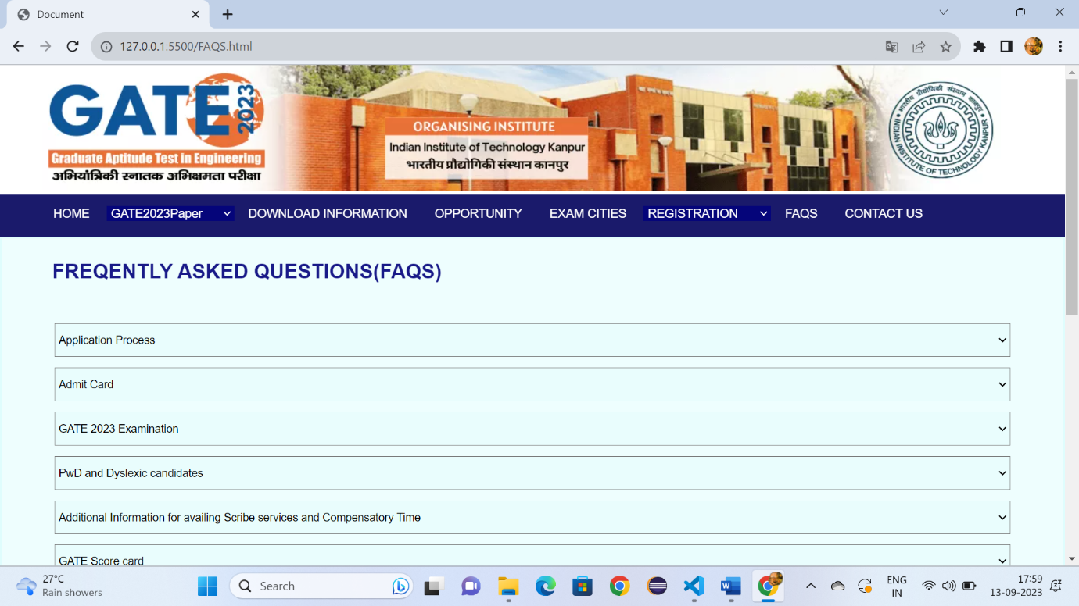

Fig:5.1

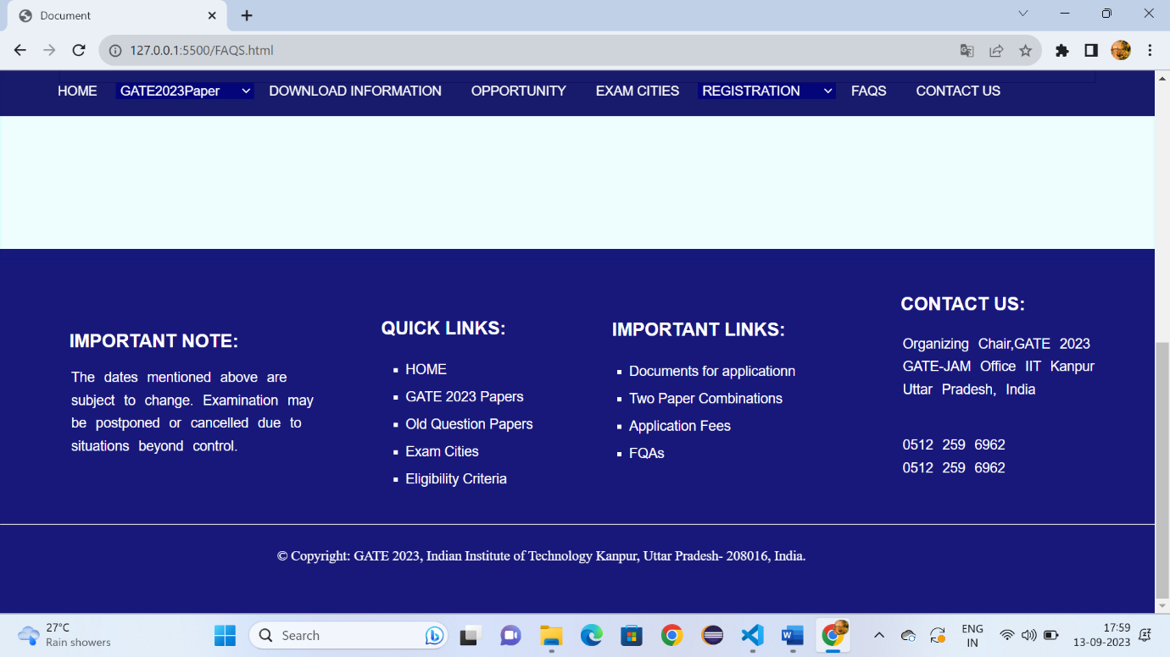

Fig:5.2

**Contactus.html:**

<!DOCTYPE html>

<!DOCTYPE html>

<html lang="en">

<head>

    <meta charset="UTF-8">

    <meta name="viewport" content="width=device-width, initial-scale=1.0">

    <title>Document</title>

    <link rel="stylesheet" href="Downloadgate.css" >

    <style>

        *{

    margin: 0px;

    box-sizing: border-box;

        }

        a:hover{

            background-color: rgba(60, 105, 163, 0.9);

            padding-bottom: -15px;

        }

        .h:hover{

            background-color: rgba(60, 105, 163, 0.9);

            padding-bottom: -15px;

        }

        #d3:hover{

            background-color:rgba(60, 105, 163, 0.9);

            padding-bottom: -15px;

            height: 45px;

        }

        .p{

            font-size: 17px;

            font-family: sans-serif;

            color: rgb(13, 74, 143);

            text-decoration: none;

            margin-left: 20px;

          margin-top: 10px;

  }

        #d2{

            position: sticky;

            top:0px;

        }

        .i:hover{

            color: rgb(75, 74, 74);

        }

    </style>

</head>

<body>

    <header id="d1">

        <img style="margin-left: 50px;" src="https://gate.iitk.ac.in/images/xbanner-bg.png.pagespeed.ic.mRgukKISkj.webp" width="90%" height="150px">

    </header>

    <div id="d2">

        <a class="c6" style="padding-left: 5%;" href="Gate.html" target="_self">HOME</a>

        <select id="d3" class="h">

        <option >GATE2023Paper</option>

        <option class="c1">Papers&Syllabus</option>

        <option class="c1">Pattern</option>

        <option class="c1">Two Paper Combinations</option>

        <option class="c1">GATE 2023 Schedule</option>

        </select>

        <a class="c6" style="font-size: 90%;padding-left: 1%;" href="Downloadgate.html" target="_self">DOWNLOAD INFORMATION</a>

        <a class="c6" style="font-size: 90%;padding-left: 1%;" href="opportunity.html" target="_self">OPPORTUNITY</a>

        <a class="c6" style="font-size: 90%;padding-left: 1%;" href="Examcities.html" target="_self">EXAM CITIES</a>

        <select id="d3" class="h">

            <option >REGISTRATION</option>

            <option class="c1">Eligibility Criteria</option>

            <option class="c1">Document required for filling the application</option>

            <option class="c1">Application Fees</option>

         </select>

         <a class="c6" style="font-size: 90%;padding-left: 1%;" href="FAQS.html">FAQS</a>

         <a class="c6" style="font-size: 90%;padding-left: 1%" href="Contactus.html">CONTACT US</a>

        </div>

        <div style="height: 1100px;background-color:rgba(89, 244, 244, 0.1) ;border: 2px solid rgba(89, 244, 244, 0.1);">

            <h1 style="font-family: sans-serif;font-size: x-large;"><span style="color: rgba(3, 3, 125, 0.912);margin-left: 60px;margin-top: 2%;position: absolute;">CONTACT US</span> </h1>

             <div style="width: 90%;height: 50px;margin-left: 5%;margin-top: 7%;background-color:rgba(19, 150, 150, 0.1) ;">

            <p style="font-size: large;font-family: sans-serif;color: gray; margin-top: 1.2%;margin-left: 15%;position: absolute;"><spam style="font-size: large;font-family: sans-serif;color: rgb(93, 139, 236);">Contact Hours:</spam>&nbsp;&nbsp;Monday to Friday&nbsp;&nbsp;10:00 AM to 1:00 PM&nbsp;&nbsp;2:00 PM to 5:30 PM &nbsp;&nbsp;(Government working days only)</p>

            <table cellspacing="0" border="1"

                style="width: 90%;height: 800px;margin-left: 0.1%;border: 1px solid;margin-top: 6%;position: absolute;">

                <tr aria-rowspan="1px">

                <th>Zone</th>

                <th>Contact Address</th>

                <th>Phone Number</th>

                <th>E-Mail ID</th>

                </tr>

            <tbody>

              <tr>

                <td>Zone-1</td>

                <td>Chairperson, GATE<br>

                    India Institute of Science Bangalore<br>

                    Bengaluru 560012

                </td>

                <td>080-22932392<br>

                080-23601227

                </td>

                <td>gate @ gate class="iisc ac in</td>

              </tr>

              <tr>

                <td>Zone-2</td>

                <td>Chairperson, GATE<br>

                    India Institute of Technology Bombay<br>

                    Powai Mumbai 400 076</td>

                    <td>022-25767068<br>

                    022-25767022</td>

                <td>gateoffice@iltbac.in</td>

              </tr>

              <tr>

                <td>Zone-3</td>

                <td>Chairperson, GATE<br>

                    India Institute of Technology Bombay<br>

                    Powai Mumbai 400 076</td>

                    <td>022-25767068<br>

                    022-25767022</td>

                <td>gateoffice@iltbac.in</td>

              </tr>

              <tr>

                <td>Zone-4</td>

                <td>Chairperson, GATE<br>

                    India Institute of Technology Bombay<br>

                    Powai Mumbai 400 076</td>

                    <td>022-25767068<br>

                    022-25767022</td>

                <td>gateoffice@iltbac.in</td>

              </tr>

              <tr>

                <td>Zone-5</td>

                <td>Chairperson, GATE<br>

                    India Institute of Technology Bombay<br>

                    Powai Mumbai 400 076</td>

                    <td>022-25767068<br>

                    022-25767022</td>

                <td>gateoffice@iltbac.in</td>

              </tr>

              <tr>

                <td>Zone-6</td>

                <td>Chairperson, GATE<br>

                    India Institute of Technology Bombay<br>

                    Powai Mumbai 400 076</td>

                    <td>022-25767068<br>

                    022-25767022</td>

                <td>gateoffice@iltbac.in</td>

              </tr>

              <tr>

                <td>Zone-7</td>

                <td>Chairperson, GATE<br>

                    India Institute of Technology Bombay<br>

                    Powai Mumbai 400 076</td>

                    <td>022-25767068<br>

                    022-25767022</td>

                <td>gateoffice@iltbac.in</td>

              </tr>

              <tr >

                <td>Zone-8</td>

                <td>Chairperson, GATE<br>

                    India Institute of Technology Bombay<br>

                    Powai Mumbai 400 076</td>

                    <td>022-25767068<br>

                    022-25767022</td>

                <td>gateoffice@iltbac.in</td>

              </tr>

            </tbody>

            </table>

            </div>

              </div>

            <div style="margin-top: -1%;" id="d22">

                <h3 style="font-family: sans-serif;font-size: 20px;color: white;margin-left: 6%;margin-top: 80px;">IMPORTANT NOTE:</h3>

                <br>

                <br>

                <ol style="list-style-type: none;margin-left: 3%;margin-top: -20px;">

                    <li class="b">The dates mentioned above are </li>

                    <li class="b">subject to change. Examination may</li>

                    <li class="b">be postponed or cancelled due to</li>

                    <li class="b">situations beyond control.</li>

                </ol>

                <h3 style="font-family: sans-serif;font-size: 20px;color: white;margin-left: 33%;margin-top: -153px;">QUICK LINKS:</h3>

                <ul>

                    <li class="a"> <a style="color: white;text-decoration: none;" href="Gate.html">HOME</li></a>

                    <li class="a"><a style="color: white;text-decoration: none;" href="Downloadgate.html">GATE 2023 Papers</li></a>

                    <li class="a"><a style="color: white;text-decoration: none;" href="Downloadgate.html">Old Question Papers</li></a>

                    <li class="a"><a style="color: white;text-decoration: none;" href="Examcities.html">Exam Cities</li></a>

                    <li class="a"><a style="color: white;text-decoration: none;" href="Examcities.html">Eligibility Criteria</li></a>

                </ul>

                <h3 style="font-family: sans-serif;font-size: 20px;color: white;margin-left: 53%;margin-top: -190px;">IMPORTANT LINKS:</h3>

                <ul>

                    <li class="a1"><a style="color: white;text-decoration: none;" href="GateDocuments.html">Documents for applicationn</li></a>

            <li class="a1"><a style="color: white;text-decoration: none;" href="Downloadgate.html">Two Paper Combinations</li></a>

            <li class="a1"><a style="color: white;text-decoration: none;" href="GateApplicationfee.html">Application Fees</li></a>

            <li class="a1"><a style="color: white;text-decoration: none;" href="FAQS.html">FQAs</li></a>

                </ul>

                <h3 style="font-family: sans-serif;font-size: 20px;color: white;margin-left: 78%;margin-top: -190px;">CONTACT US:</h3>

                <ol style="list-style-type: none;margin-left: 75%;margin-top: 20px;">

                    <li class="b">Organizing Chair,GATE 2023 </li>

                    <li class="b">GATE-JAM Office IIT Kanpur</li>

                    <li class="b">Uttar Pradesh, India</li>

                    <br>

                    <br>

                    <li class="b" >0512 259 6962</li>

                    <li class="b">0512 259 6962</li>

                </ol>

                <br>

                <br>

                <hr style="width: 100%; color: white;margin-top: 1%;">

                <p style="color: white;font-size: 15px; margin-left: 24%;margin-top: 2%;position: absolute;">© Copyright: GATE 2023, Indian Institute of Technology Kanpur, Uttar Pradesh- 208016, India.</p>

            </div>

</body>

</html>

**Contactus.css:**

#d1{

    background-attachment: cover;

    width: 100%;

}

#d2{

    width: 100%;

    height: 50px;

    background-color: rgba(2, 2, 92, 0.906);

}

.c6{

    color: white;

     min-height: 45Px;

     line-height: 45px;

    font-family: sans-serif;

    text-decoration: none;

    font-size: 90%;

    padding: 16px;

}

#d3{

 background-color:rgba(3, 3, 124, 0.9);

 color: white;

 border: none;

 font-size: 90%;

 padding-left: 0.1%;

 width: 12%;

}

.c1{

    background-color: white;

    color: black;

    font-family: sans-serif;

    line-height: 50px;

}

#d22{

    height: 400px;

        padding-top: 10px;

    background-color:rgba(3, 3, 111, 0.918);

    opacity: 80;

}

.b{

    font-family: sans-serif;

    font-size: 15px;

    color: white;

    line-height: 25px;

    word-spacing: 6px;

}

.a{

    font-size: 15px;

    font-family: sans-serif;

    color: white;

    list-style-type: square;

    margin-left: 33%;

    line-height: 30px;

}

.a1{

    font-size: 15px;

    font-family: sans-serif;

    color: white;

    list-style-type: square;

    margin-left: 53%;

    line-height: 30px;

}

**Output:**

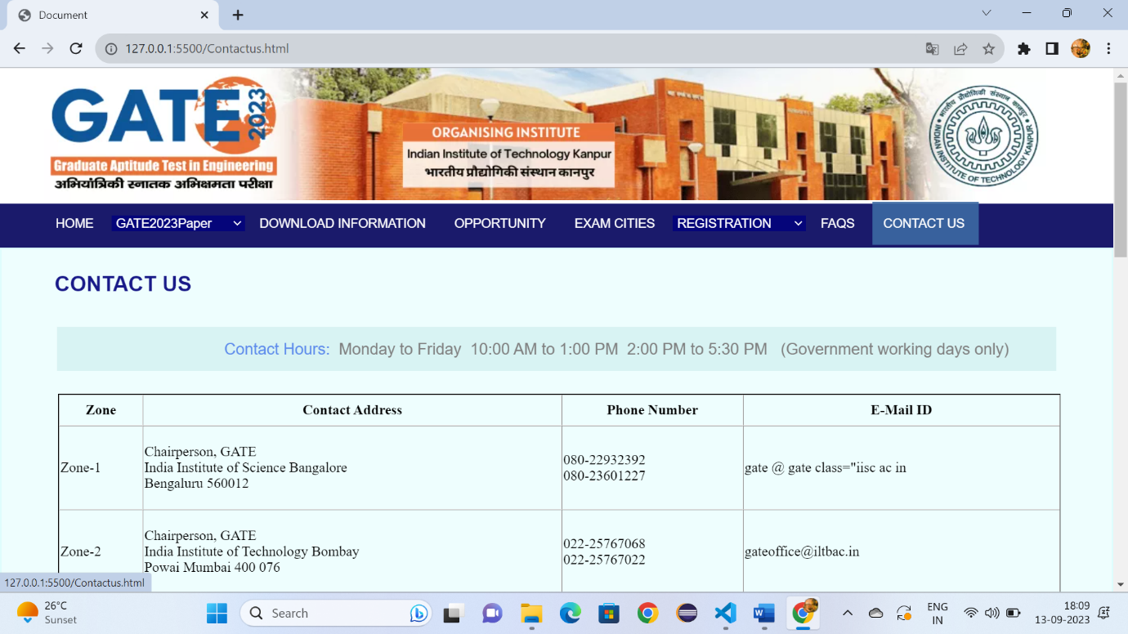

Fig6.1

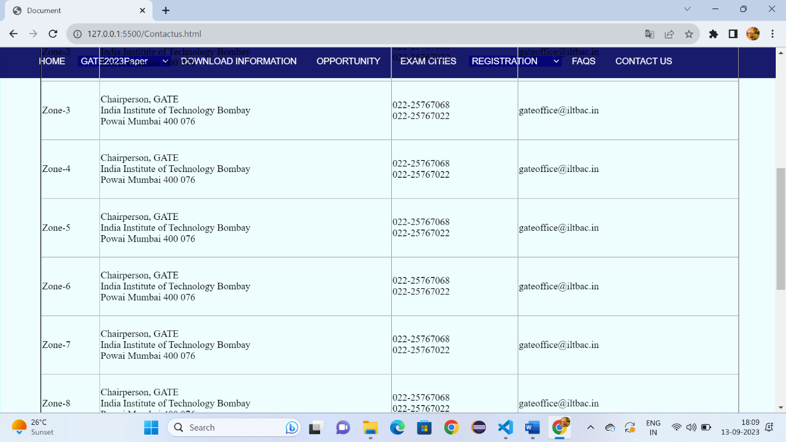

Fig:6.2

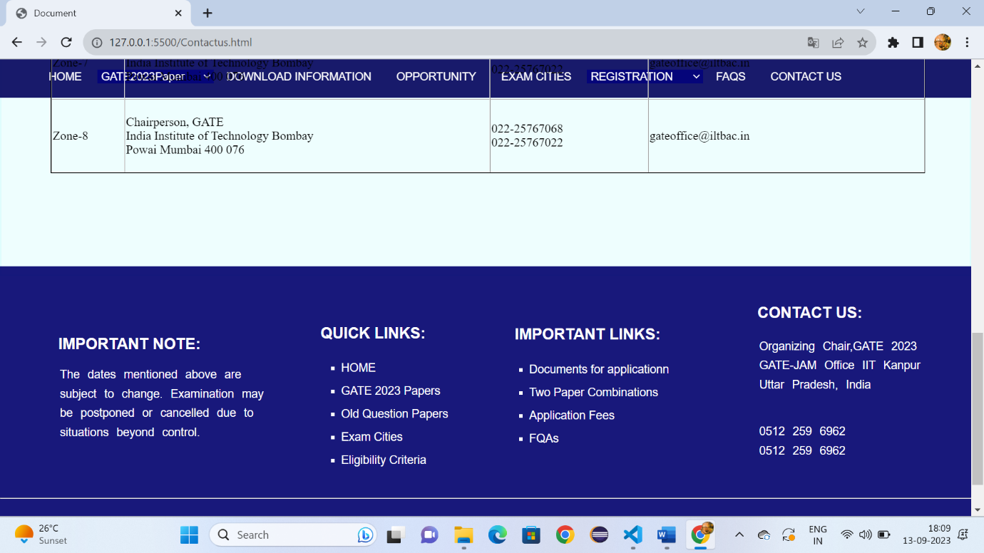

Fig:6.3

**Login.html:**

<!DOCTYPE html>

<html lang="en">

<head>

    <meta charset="UTF-8">

    <meta name="viewport" content="width=device-width, initial-scale=1.0">

    <title>Document</title>

    <link rel="stylesheet" href="Gatelogin.css">

    <link rel="stylesheet" href="https://cdnjs.cloudflare.com/ajax/libs/font-awesome/4.7.0/css/font-awesome.min.css">

</head>

    <style>

        *{

            margin: 0px;

        }

        .i:hover{

            background-color:rgb(192, 190, 190);

            padding-bottom: -15px;

            height: 32px;

        }

        .o:hover{

            background-color:rgb(192, 190, 190);

            height: 120px;

        }

    </style>

</head>

<body>

    <header id="d1">

        <img style="margin-left: 50px;" src="https://gate.iitk.ac.in/images/xbanner-bg.png.pagespeed.ic.mRgukKISkj.webp" width="90%" height="150px">

    </header>

    <div style="width: 88%;height: 50px;margin-left: 5%;background-color: rgb(248, 247, 247);">

    <a class="i" href="">Home</a>

    <a class="i" href="">GATE 2023</a>

    <a class="i" href="">Login</a>

    </div>

    <div id="p">

        <a class="o" href="">Information Brochure</a>

        <br>

        <a class="o" href="">Documents for application</a>

        <br>

        <a class="o" href="">Important Dates</a>

        <br>

        <a class="o" href="">Eligibility</a>

        <br>

        <a class="o" href="">FAQs</a>

        <br>

        <a  class="o" href=""> Important Notice</a>

    </div>

    <div style="width: 60%;height: 40px;border: 1px solid;margin-left: 28%;margin-top: -470px;">

      <div style="width: 6%;height: 40px;border: 1px solid;background-color: gray;"><i class="fa fa-chevron-right" style="font-size:34px"></i></div>

      <p style="color: rgb(88, 86, 86);font-family: sans-serif;font-size: x-large;margin-top: -35px;margin-left: 60px;">Login, If Already Registered</p>

    </div>

    <div style="width: 60%;height: 550px;margin-left: 28%;">

    <label style="padding-top: 2%;position: absolute;margin-left: 2%;font-family: sans-serif;font-size: 15px;"><b>Enrolment ID / Email Address</b></label><br>

    <input style="width: 90%;height: 30px;margin-top: 5%;margin-left: 3%;" type="email" name="i" id="i">

    <br>

    <br>

    <p style="margin-left: 3%;color: rgb(104, 102, 102);font-family: sans-serif;font-size: small;">Enter Enrolment ID/ Email ID sent during registration</p>

    <label style="padding-top: 2%;position: absolute;margin-left: 2%;font-family: sans-serif;font-size: 15px;"><b>Registration ID</b></label><br>

    <input style="width: 90%;height: 30px;margin-top: 5%;margin-left: 3%;" type="email" name="i" id="i">

    <br>

    <br>

    <p style="margin-left: 3%;color: rgb(104, 102, 102);font-family: sans-serif;font-size: small;">Enter Registration ID(case sensitive)</p>

    <label style="padding-top: 2%;position: absolute;margin-left: 2%;font-family: sans-serif;font-size: 15px;"><b>Registration ID</b></label><br>

    <input style="width: 90%;height: 30px;margin-top: 5%;margin-left: 3%;background-color: rgb(246, 245, 245);" type="date" value="DD-MM-YY">

    <img style="margin-left: 3%;margin-top: 3%;" src="https://app.gate.iitk.ac.in/genCaptcha">

    <br>

    <label style="padding-top: 2%;position: absolute;margin-left: 2%;font-family: sans-serif;font-size:15px;"><b>Evaluate this arithmetic expression and place the value below </b></label><br>

    <input style="width: 90%;height: 30px;margin-top: 5%;margin-left: 3%;" type="text" placeholder="Evaluate this arithmetic expression and place the value" name="i" id="i">

   <br>

   <br>

    <input style="margin-left: 3%;background-color: rgb(28, 28, 145);border-radius: 5px;width: 13%;height: 30px;color: white;" type="submit" value="submit">

</div>

<div style="width: 88%;height: 50px;margin-left: 5%;background-color: rgb(248, 247, 247);">

    <h4 style="color: rgb(117, 116, 116);font-family: sans-serif;margin-top: 15px;position: absolute;margin-left: 2%;">@2022-23</h4>

    <a style="margin-left: 8%;position: absolute;" class="i" href="">IIT Kanpur</a>

    </div>

</body>

</html>

**Login.css:**

#id1{

    background-repeat: no-repeat;

    background-attachment: cover;

    margin-top: 20px;

    size: 50px;

    display: flex;

}

.i{

    color: rgb(27, 27, 123);

    text-decoration: none;

    float: right;

    line-height: 30px;

    min-height: 30px;

    padding: 10px;

    font-family: sans-serif;

}

#p{

    height: 500px;

    border-right: 1px solid gray;

    width: 20%;

    margin-left: 5%;

}

.o{

    font-family: sans-serif;

    font-size: small;

    text-decoration: none;

    text-align: center;

    line-height: 40px;

    margin-left: 15%;

}

**Output:**

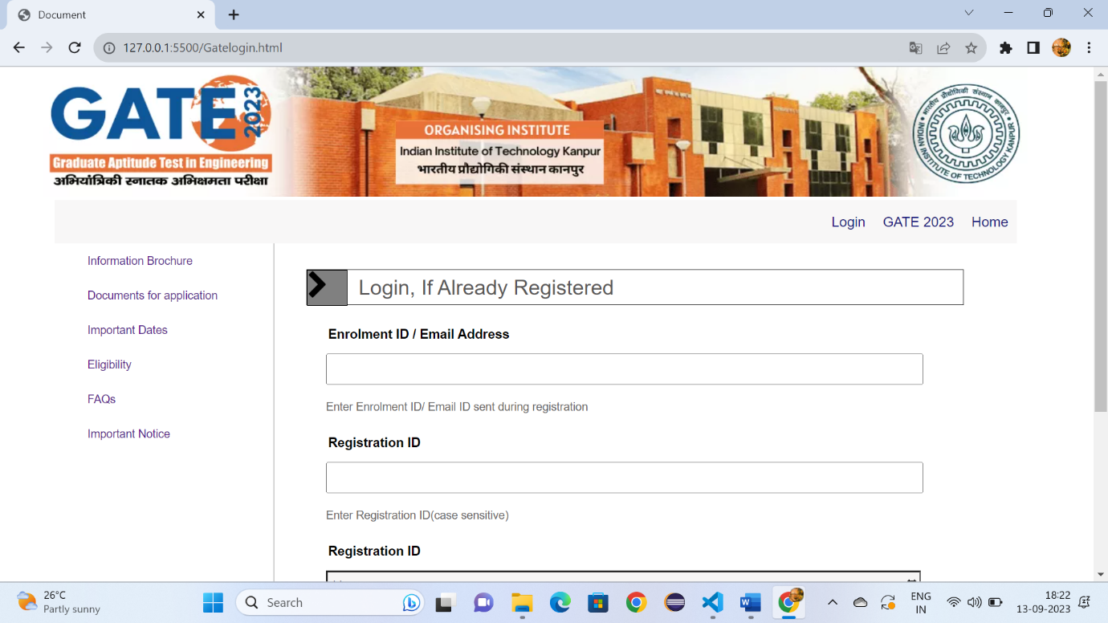

Fig:7.1

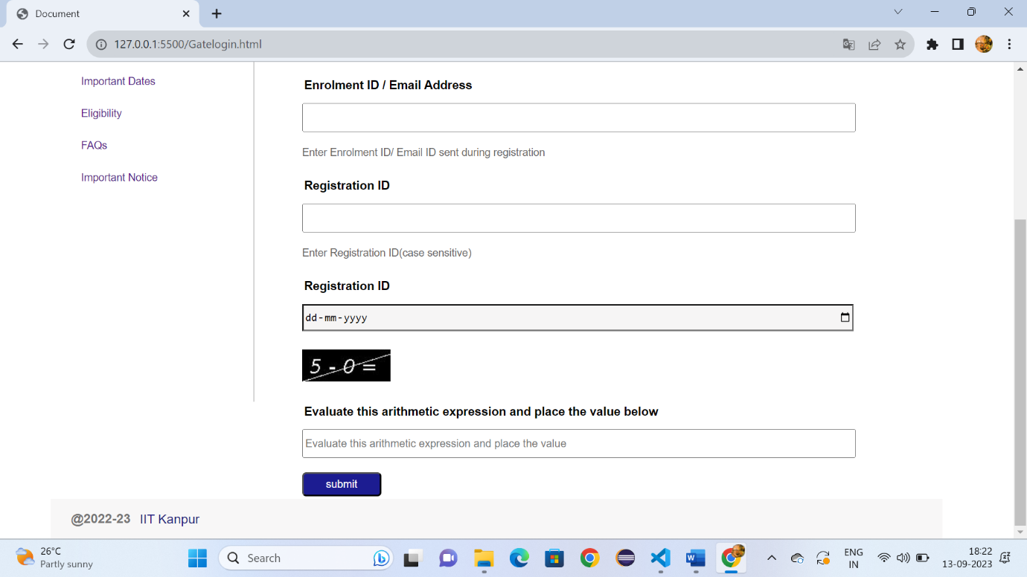

Fig:7.2

**Viewall.html:**

<!DOCTYPE html>

<html lang="en">

<head>

    <meta charset="UTF-8">

    <meta name="viewport" content="width=device-width, initial-scale=1.0">

    <title>Document</title>

    <link rel="stylesheet" href="Downloadgate.css" >

    <style>

        *{

    margin: 0px;

    box-sizing: border-box;

        }

        a:hover{

            background-color: rgba(60, 105, 163, 0.9);

            padding-bottom: -15px;

        }

        .h:hover{

            background-color: rgba(60, 105, 163, 0.9);

            padding-bottom: -15px;

        }

        #d3:hover{

            background-color:rgba(60, 105, 163, 0.9);

            padding-bottom: -15px;

            height: 45px;

        }

        .p{

            font-size: 17px;

            font-family: sans-serif;

            color: rgb(13, 74, 143);

            text-decoration: none;

            margin-left: 20px;

          margin-top: 10px;

        }

        #d2{

            position: sticky;

            top:0px;

        }

        .i:hover{

            color: rgb(75, 74, 74);

        }

        td{

            font-family: sans-serif;

             border: 1px solid;

            padding-left: 1%;

            background-color: white;

        }

</style>

</head>

<body>

    <header id="d1">

        <img style="margin-left: 50px;" src="https://gate.iitk.ac.in/images/xbanner-bg.png.pagespeed.ic.mRgukKISkj.webp" width="90%" height="150px">

    </header>

    <div id="d2">

        <a class="c6" style="padding-left: 5%;" href="Gate.html" target="_self">HOME</a>

        <select id="d3" class="h">

        <option >GATE2023Paper</option>

        <option class="c1">Papers&Syllabus</option>

        <option class="c1">Pattern</option>

        <option class="c1">Two Paper Combinations</option>

        <option class="c1">GATE 2023 Schedule</option>

        </select>

        <a class="c6" style="font-size: 90%;padding-left: 1%;" href="Downloadgate.html" target="_self">DOWNLOAD INFORMATION</a>

        <a class="c6" style="font-size: 90%;padding-left: 1%;" href="opportunity.html" target="_self">OPPORTUNITY</a>

        <a class="c6" style="font-size: 90%;padding-left: 1%;" href="Examcities.html" target="_self">EXAM CITIES</a>

        <select id="d3" class="h">

            <option >REGISTRATION</option>

            <option class="c1">Eligibility Criteria</option>

            <option class="c1">Document required for filling the application</option>

            <option class="c1">Application Fees</option>

         </select>

         <a class="c6" style="font-size: 90%;padding-left: 1%;" href="FAQS.html">FAQS</a>

         <a class="c6" style="font-size: 90%;padding-left: 1%" href="Contactus.html">CONTACT US</a>

        </div>

        <div style="height: 1000px;background-color:rgba(89, 244, 244, 0.1) ;border: 2px solid rgba(89, 244, 244, 0.1);">

            <h1 style="font-family: sans-serif;font-size: x-large;"><span style="color: rgba(3, 3, 125, 0.912);margin-left: 60px;margin-top: 2%;position: absolute;">IMPORTANT DATES RELATED TO GATE 2023

            </span> </h1>

             <br>

            <div style="width:80% ;height: 700px;margin-left: 5%;margin-top: 6%;">

            <table cellspacing="0"

                style="width: 100%;height: 700px;">

                <tr aria-rowspan="1px">

                <td style="font-family: sans-serif;font-size: large;margin: 0px;background-color: rgba(89, 244, 244, 0.1);"><b>Activity</b></td>

                <td style="font-family: sans-serif;font-size: large;background-color: rgba(89, 244, 244, 0.1);"><b>Day</b></td>

                <td style="font-family: sans-serif;font-size: large;background-color: rgba(89, 244, 244, 0.1);"><b>Date</b></td>

                <th></th>

                </tr>

<tbody>

              <tr>

                <td style="font-family: sans-serif;">Online Application Process Opens<a style="text-decoration: none;" href="">  (https://gate.iitk.ac.in)</a></td>

                <td style="color: rgb(17, 17, 151);font-family: sans-serif;">Tuesday</td>

                 <td style="color: rgb(17, 17, 151);font-family: sans-serif;">30<sup>th</sup>August 2022</td>

              </tr>

              <tr>

                <td style="font-family: sans-serif;">Closing Date of REGULAR online registration/ application process (Without Late Fee)</td>

                <td style="color: rgb(17, 17, 151);font-family: sans-serif;">Friday</td>

                <td style="color: rgb(17, 17, 151);font-family: sans-serif;width: 30%;"><strike> September 2022 04thOctober 2022</strike> 07thOctober 2022</td>

              </tr>

              <tr>

                <td style="font-family: sans-serif;">Closing Date of EXTENDED online registration/ application process (With Late Fee)</td>

                <td style="color: rgb(17, 17, 151);font-family: sans-serif;width: 15%;">Friday</td>

                <td style="color: rgb(17, 17, 151);font-family: sans-serif;"><strike>7th October 2022 14th October 2022 </strike>16th October 2022</td>

</tr>

              <tr>

                <td>Modifications in GATE 2023 Application</td>

                <td style="color: rgb(17, 17, 151);font-family: sans-serif;">Tuesday to Monday</td>

                <td style="color: rgb(17, 17, 151);font-family: sans-serif;">08th to 14th November 2022</td>

</tr>

              <tr>

                <td>Availability of GATE Admit cards for download</td>

                <td style="color: rgb(17, 17, 151);font-family: sans-serif;">Tuesday</td>

                <td style="color: rgb(17, 17, 151);font-family: sans-serif;">03rd January 2023</td>

</tr>

              <tr>

                <td>GATE 2023 Examinations</td>

                <td style="color: rgb(17, 17, 151);font-family: sans-serif;">Saturday & Sunday</td>

                <td style="color: rgb(17, 17, 151);font-family: sans-serif;">04th, 05 th and 11th, 12th Febuary 2023</td>

</tr>

              <tr>

              <td>Candidate's response available in Application portal</td>

              <td style="color: rgb(17, 17, 151);font-family: sans-serif;">Wednesday</td>

                <td style="color: rgb(17, 17, 151);font-family: sans-serif;">15th Febuary 2023</td>

          </tr>

              <tr >

                <td>Answer keys available on Application portal</td>

                <td style="color: rgb(17, 17, 151);font-family: sans-serif;">Tuesday</td>

                  <td style="color: rgb(17, 17, 151);font-family: sans-serif;">21st Febuary 2023</td>

              </tr>

              <tr >

                <td>Submission of challenges by candidates on Answer Keys</td>

                <td style="color: rgb(17, 17, 151);font-family: sans-serif;">Wednesday to Saturday</td>

                  <td style="color: rgb(17, 17, 151);font-family: sans-serif;">22nd to 25th Febuary 2023</td>

               </tr>

               <tr >

                <td>Announcement of Results for GATE 2023</td>

                <td style="color: rgb(17, 17, 151);font-family: sans-serif;">Thursday</td>

                  <td style="color: rgb(17, 17, 151);font-family: sans-serif;">16th March 2023</td>

               </tr>

               <tr >

                <td>Availability of Score Card for download by candidates</td>

                <td style="color: rgb(17, 17, 151);font-family: sans-serif;">Thursday</td>

                  <td style="color: rgb(17, 17, 151);font-family: sans-serif;">21st March 2023</td>

               </tr>

             </tbody>

          </table>

        </div>

</div>

</div>

            <div style="margin-top: -1%;" id="d22">

                <h3 style="font-family: sans-serif;font-size: 20px;color: white;margin-left: 6%;margin-top: 80px;">IMPORTANT NOTE:</h3>

                <br>

                <br>

                <ol style="list-style-type: none;margin-left: 3%;margin-top: -20px;">

                    <li class="b">The dates mentioned above are </li>

                    <li class="b">subject to change. Examination may</li>

                    <li class="b">be postponed or cancelled due to</li>

                    <li class="b">situations beyond control.</li>

                </ol>

                <h3 style="font-family: sans-serif;font-size: 20px;color: white;margin-left: 33%;margin-top: -153px;">QUICK LINKS:</h3>

    <ul>

                  <li class="a"> <a style="color: white;text-decoration: none;" href="Gate.html">HOME</li></a>

                  <li class="a"><a style="color: white;text-decoration: none;" href="Downloadgate.html">GATE 2023 Papers</li></a>

                  <li class="a"><a style="color: white;text-decoration: none;" href="Downloadgate.html">Old Question Papers</li></a>

                  <li class="a"><a style="color: white;text-decoration: none;" href="Examcities.html">Exam Cities</li></a>

                  <li class="a"><a style="color: white;text-decoration: none;" href="Examcities.html">Eligibility Criteria</li></a>

     </ul>

                <h3 style="font-family: sans-serif;font-size: 20px;color: white;margin-left: 53%;margin-top: -190px;">IMPORTANT LINKS:</h3>

               <ul>

                  <li class="a1"><a style="color: white;text-decoration: none;" href="GateDocuments.html">Documents for applicationn</li></a>

                  <li class="a1"><a style="color: white;text-decoration: none;" href="Downloadgate.html">Two Paper Combinations</li></a>

                  <li class="a1"><a style="color: white;text-decoration: none;" href="GateApplicationfee.html">Application Fees</li></a>

                  <li class="a1"><a style="color: white;text-decoration: none;" href="FAQS.html">FQAs</li></a>

          </ul>

                <h3 style="font-family: sans-serif;font-size: 20px;color: white;margin-left: 78%;margin-top: -190px;">CONTACT US:</h3>

              <ol style="list-style-type: none;margin-left: 75%;margin-top: 20px;">

                    <li class="b">Organizing Chair,GATE 2023 </li>

                    <li class="b">GATE-JAM Office IIT Kanpur</li>

                    <li class="b">Uttar Pradesh, India</li>

                    <br>

                    <br>

                    <li class="b" >0512 259 6962</li>

                    <li class="b">0512 259 6962</li>

                 </ol>

                <br>

                <br>

                <hr style="width: 100%; color: white;margin-top: 1%;">

                <p style="color: white;font-size: 15px; margin-left: 24%;margin-top: 2%;position: absolute;">© Copyright: GATE 2023, Indian Institute of Technology Kanpur, Uttar Pradesh- 208016, India.</p>

</div>

</body>

</html>

**Output:**

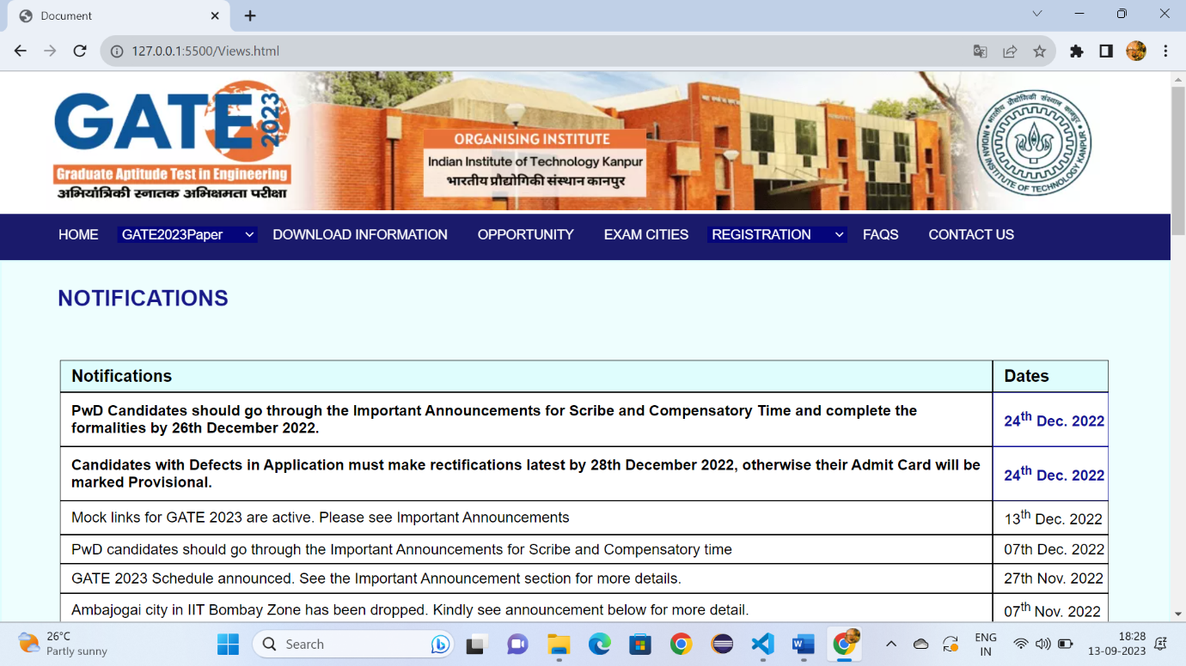

**Fig:8.1**

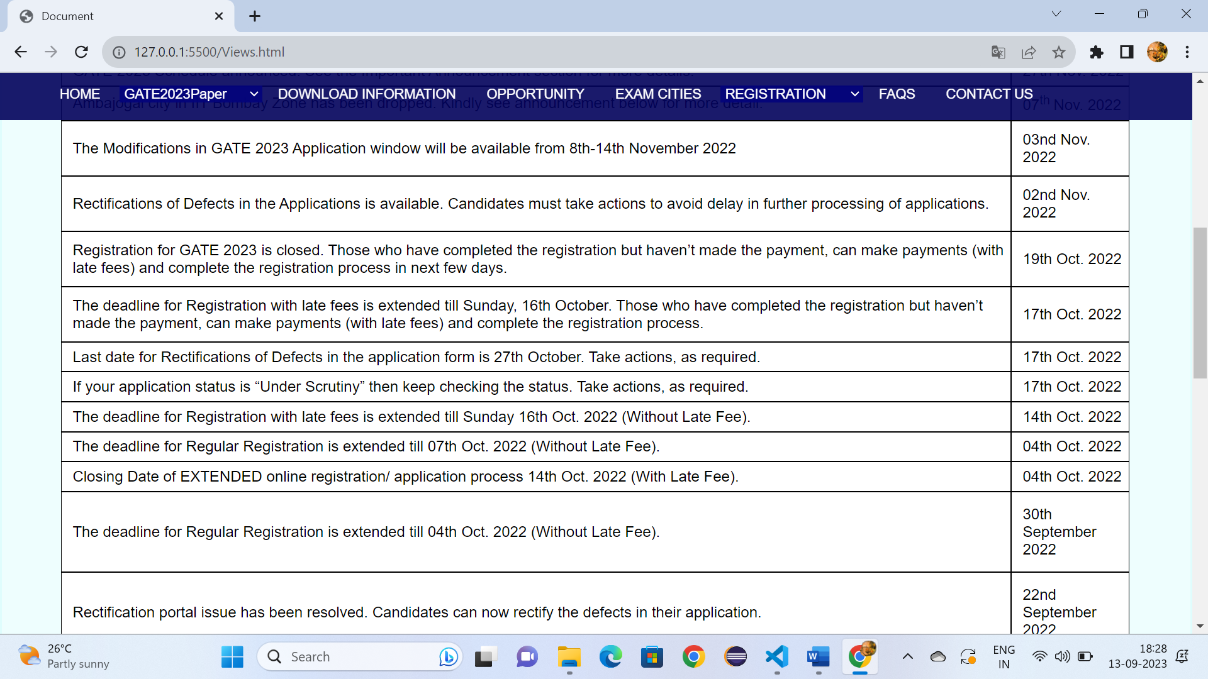

**Fig:8.2**

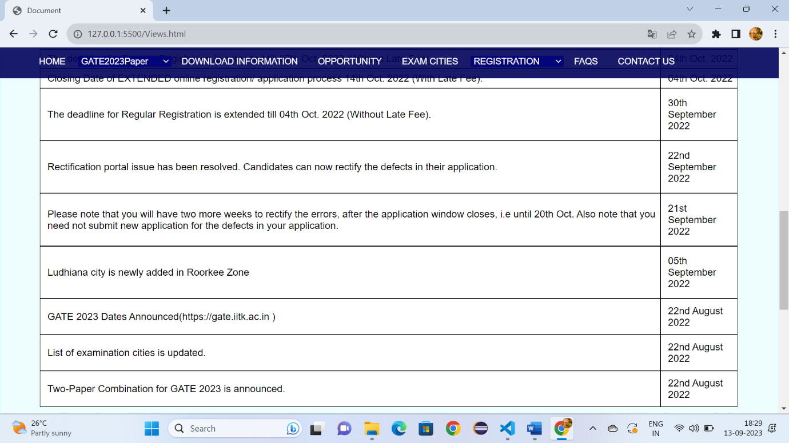

**Fig:8.3**

**View.html:**

<!DOCTYPE html>

<html lang="en">

<head>

    <meta charset="UTF-8">

    <meta name="viewport" content="width=device-width, initial-scale=1.0">

    <title>Document</title>

    <link rel="stylesheet" href="Downloadgate.css" >

    <style>

        *{

    margin: 0px;

    box-sizing: border-box;

        }

        a:hover{

            background-color: rgba(60, 105, 163, 0.9);

            padding-bottom: -15px;

        }

        .h:hover{

            background-color: rgba(60, 105, 163, 0.9);

            padding-bottom: -15px;

        }

        #d3:hover{

            background-color:rgba(60, 105, 163, 0.9);

            padding-bottom: -15px;

            height: 45px;

        }

        .p{

            font-size: 17px;

            font-family: sans-serif;

            color: rgb(13, 74, 143);

            text-decoration: none;

            margin-left: 20px;

          margin-top: 10px;

        }

        #d2{

            position: sticky;

            top:0px;

        }

        .i:hover{

            color: rgb(75, 74, 74);

        }

        td{

            font-family: sans-serif;

             border: 1px solid;

            padding-left: 1%;

            background-color: white;

        }

    </style>

</head>

<body>

    <header id="d1">

        <img style="margin-left: 50px;" src="https://gate.iitk.ac.in/images/xbanner-bg.png.pagespeed.ic.mRgukKISkj.webp" width="90%" height="150px">

    </header>

    <div id="d2">

        <a class="c6" style="padding-left: 5%;" href="Gate.html" target="_self">HOME</a>

        <select id="d3" class="h">

        <option >GATE2023Paper</option>

        <option class="c1">Papers&Syllabus</option>

        <option class="c1">Pattern</option>

        <option class="c1">Two Paper Combinations</option>

        <option class="c1">GATE 2023 Schedule</option>

        </select>

        <a class="c6" style="font-size: 90%;padding-left: 1%;" href="Downloadgate.html" target="_self">DOWNLOAD INFORMATION</a>

        <a class="c6" style="font-size: 90%;padding-left: 1%;" href="opportunity.html" target="_self">OPPORTUNITY</a>

        <a class="c6" style="font-size: 90%;padding-left: 1%;" href="Examcities.html" target="_self">EXAM CITIES</a>

        <select id="d3" class="h">

            <option >REGISTRATION</option>

            <option class="c1">Eligibility Criteria</option>

            <option class="c1">Document required for filling the application</option>

            <option class="c1">Application Fees</option>

         </select>

         <a class="c6" style="font-size: 90%;padding-left: 1%;" href="FAQS.html">FAQS</a>

         <a class="c6" style="font-size: 90%;padding-left: 1%" href="Contactus.html">CONTACT US</a>

        </div>

        <div style="height: 1500px;background-color:rgba(89, 244, 244, 0.1) ;border: 2px solid rgba(89, 244, 244, 0.1);">

            <h1 style="font-family: sans-serif;font-size: x-large;"><span style="color: rgba(3, 3, 125, 0.912);margin-left: 60px;margin-top: 2%;position: absolute;">NOTIFICATIONS</span> </h1>

             <br>

            <div style="width: 90%;height: 1200px;margin-left: 5%;margin-top: 7%;">

            <table cellspacing="0"

                style="width: 100%;height: 1200px;">

        <tr aria-rowspan="1px">

                <td style="font-family: sans-serif;font-size: large;margin: 0px;background-color: rgba(89, 244, 244, 0.1);"><b>Notifications</b></td>

                <td style="font-family: sans-serif;font-size: large;background-color: rgba(89, 244, 244, 0.1);"><b>Dates</b></td>

                <th></th>

                </tr>

            <tbody>

              <tr>

                <td style="font-family: sans-serif;"><b>PwD Candidates should go through the Important Announcements for Scribe and Compensatory Time and complete the formalities by 26th December 2022.</b></td>

                 <td style="color: rgb(17, 17, 151);font-family: sans-serif;"><b>24<sup>th</sup> Dec. 2022</b></td>

              </tr>

              <tr>

                <td style="font-family: sans-serif;"><b>Candidates with Defects in Application must make rectifications latest by 28th December 2022, otherwise their Admit Card will be marked Provisional.</b></td>

                <td style="color: rgb(17, 17, 151);font-family: sans-serif;"><b>24<sup>th</sup> Dec. 2022</b></td>

              </tr>

              <tr>

                <td style="font-family: sans-serif;">Mock links for GATE 2023 are active. Please see Important Announcements</td>

                <td>13<sup>th</sup> Dec. 2022</td>

              </tr>

              <tr>

                <td>PwD candidates should go through the Important Announcements for Scribe and Compensatory time</td>

                <td>07<su>th</su> Dec. 2022</td>

              </tr>

              <tr>

                <td>GATE 2023 Schedule announced. See the Important Announcement section for more details.</td>

                <td>27<su>th</su> Nov. 2022</td>

              </tr>

              <tr>

                <td>Ambajogai city in IIT Bombay Zone has been dropped. Kindly see announcement below for more detail.</td>

              <td>07<sup>th </sup>Nov. 2022</td>

              </tr>

              <tr>

              <td>The Modifications in GATE 2023 Application window will be available from 8th-14th November 2022</td>

              <td>03nd Nov. 2022</td>

              </tr>

              <tr >

               <td>Rectifications of Defects in the Applications is available. Candidates must take actions to avoid delay in further processing of applications.</td>

               <td>02nd Nov. 2022</td>

              </tr>

              <tr >

                <td>Registration for GATE 2023 is closed. Those who have completed the registration but haven’t made the payment, can make payments (with late fees) and complete the registration process in next few days.</td>

                <td>19th Oct. 2022</td>

               </tr>

               <tr >

                <td>The deadline for Registration with late fees is extended till Sunday, 16th October. Those who have completed the registration but haven’t made the payment, can make payments (with late fees) and complete the registration process.</td>

                <td>17th Oct. 2022</td>

               </tr>

               <tr >

                <td>Last date for Rectifications of Defects in the application form is 27th October. Take actions, as required.</td>

                <td>17th Oct. 2022</td>

               </tr>

               <tr>

                <td>If your application status is “Under Scrutiny” then keep checking the status. Take actions, as required.</td>

                <td>17th Oct. 2022</td>

               </tr>

               <tr>

                <td>The deadline for Registration with late fees is extended till Sunday 16th Oct. 2022 (Without Late Fee).</td>

                <td>14th Oct. 2022</td>

               </tr>

               <tr>

                <td>The deadline for Regular Registration is extended till 07th Oct. 2022 (Without Late Fee).</td>

                <td>04th Oct. 2022</td>

               </tr>

               <tr>

                <td>Closing Date of EXTENDED online registration/ application process 14th Oct. 2022 (With Late Fee).</td>

                <td>04th Oct. 2022</td>

               </tr>

               <tr>

                <td>The deadline for Regular Registration is extended till 04th Oct. 2022 (Without Late Fee).</td>

                <td>30th September 2022</td>

               </tr>

               <tr>

                <td>

                    Rectification portal issue has been resolved. Candidates can now rectify the defects in their application.

                </td>

                <td>22nd September 2022</td>

               </tr>

               <tr>

                <td>Please note that you will have two more weeks to rectify the errors, after the application window closes, i.e until 20th Oct. Also note that you need not submit new application for the defects in your application.</td>

                <td>21st September 2022</td>

               </tr>

               <tr>

                <td>Ludhiana city is newly added in Roorkee Zone</td>

                <td>05th September 2022</td>

               </tr>

               <tr>

                <td>GATE 2023 Dates Announced(https://gate.iitk.ac.in )</td>

                <td>22nd August 2022</td>

               </tr>

               <tr>

                <td>List of examination cities is updated.</td>

                <td>22nd August 2022</td>

               </tr>

               <tr>

                <td>Two-Paper Combination for GATE 2023 is announced.</td>

                <td>22nd August 2022</td>

                </tr>

            </tbody>

            </table>

        </div>

            </div>

              </div>

            <div style="margin-top: -1%;" id="d22">

                <h3 style="font-family: sans-serif;font-size: 20px;color: white;margin-left: 6%;margin-top: 80px;">IMPORTANT NOTE:</h3>

                <br>

                <br>

                <ol style="list-style-type: none;margin-left: 3%;margin-top: -20px;">

                    <li class="b">The dates mentioned above are </li>

                    <li class="b">subject to change. Examination may</li>

                    <li class="b">be postponed or cancelled due to</li>

                    <li class="b">situations beyond control.</li>

                </ol>

                <h3 style="font-family: sans-serif;font-size: 20px;color: white;margin-left: 33%;margin-top: -153px;">QUICK LINKS:</h3>

                <ul>

                    <li class="a"> <a style="color: white;text-decoration: none;" href="Gate.html">HOME</li></a>

                    <li class="a"><a style="color: white;text-decoration: none;" href="Downloadgate.html">GATE 2023 Papers</li></a>

                    <li class="a"><a style="color: white;text-decoration: none;" href="Downloadgate.html">Old Question Papers</li></a>

                    <li class="a"><a style="color: white;text-decoration: none;" href="Examcities.html">Exam Cities</li></a>

                    <li class="a"><a style="color: white;text-decoration: none;" href="Examcities.html">Eligibility Criteria</li></a>

      </ul>

                <h3 style="font-family: sans-serif;font-size: 20px;color: white;margin-left: 53%;margin-top: -190px;">IMPORTANT LINKS:</h3>

             <ul>

                    <li class="a1"><a style="color: white;text-decoration: none;" href="GateDocuments.html">Documents for applicationn</li></a>

                    <li class="a1"><a style="color: white;text-decoration: none;" href="Downloadgate.html">Two Paper Combinations</li></a>

                    <li class="a1"><a style="color: white;text-decoration: none;" href="GateApplicationfee.html">Application Fees</li></a>

                    <li class="a1"><a style="color: white;text-decoration: none;" href="FAQS.html">FQAs</li></a>

                </ul>

                <h3 style="font-family: sans-serif;font-size: 20px;color: white;margin-left: 78%;margin-top: -190px;">CONTACT US:</h3>

              <ol style="list-style-type: none;margin-left: 75%;margin-top: 20px;">

                    <li class="b">Organizing Chair,GATE 2023 </li>

                    <li class="b">GATE-JAM Office IIT Kanpur</li>

                    <li class="b">Uttar Pradesh, India</li>

                    <br>

                    <br>

                    <li class="b" >0512 259 6962</li>

                    <li class="b">0512 259 6962</li>

                  </ol>

                <br>

                <br>

                <hr style="width: 100%; color: white;margin-top: 1%;">

                <p style="color: white;font-size: 15px; margin-left: 24%;margin-top: 2%;position: absolute;">© Copyright: GATE 2023, Indian Institute of Technology Kanpur, Uttar Pradesh- 208016, India.</p>

</div>

</body>

</html>

**Output:**

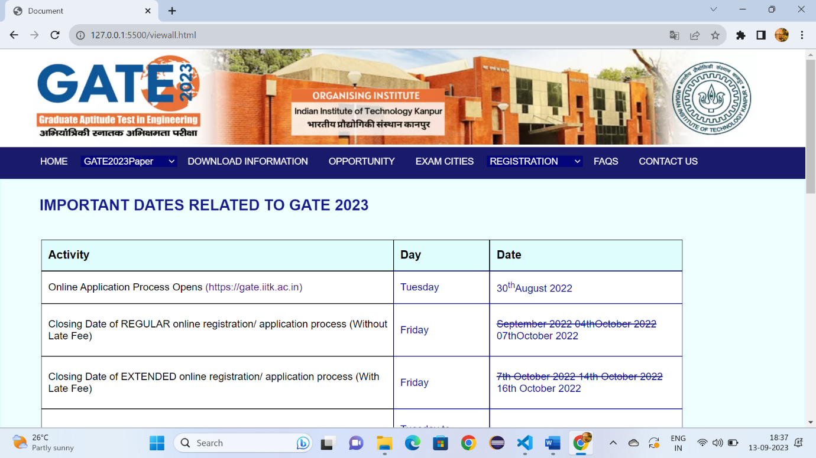

Fig:9.1

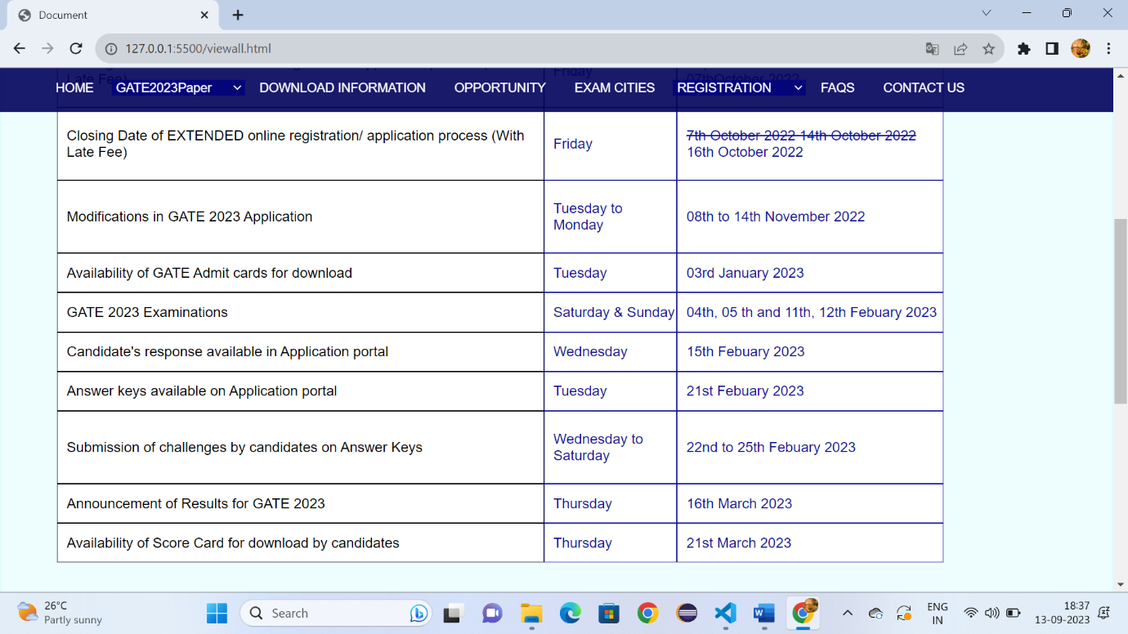

Fig:9.2

**MasterPaper.html:**

<!DOCTYPE html>

<html lang="en">

<head>

    <meta charset="UTF-8">

    <meta name="viewport" content="width=device-width, initial-scale=1.0">

    <title>Document</title>

    <link rel="stylesheet" href="Downloadgate.css" >

    <style>

        *{

    margin: 0px;

    box-sizing: border-box;

        }

        a:hover{

            background-color: rgba(60, 105, 163, 0.9);

            padding-bottom: -15px;

        }

        .h:hover{

            background-color: rgba(60, 105, 163, 0.9);

            padding-bottom: -15px;

        }

        #d3:hover{

            background-color:rgba(60, 105, 163, 0.9);

            padding-bottom: -15px;

            height: 45px;

        }

        .p{

            font-size: 17px;

            font-family: sans-serif;

            color: rgb(13, 74, 143);

            text-decoration: none;

            margin-left: 20px;

          margin-top: 10px;

        }

        #d2{

            position: sticky;

            top:0px;

        }

        .i:hover{

            color: rgb(75, 74, 74);

        }

        td{

            font-family: sans-serif;

             border: 1px solid gray;

            padding-left: 1%;

            background-color: white;

        }

    </style>

</head>

<body>

    <header id="d1">

        <img style="margin-left: 50px;" src="https://gate.iitk.ac.in/images/xbanner-bg.png.pagespeed.ic.mRgukKISkj.webp" width="90%" height="150px">

    </header>

    <div id="d2">

        <a class="c6" style="padding-left: 5%;" href="Gate.html" target="_self">HOME</a>

        <select id="d3" class="h">

        <option >GATE2023Paper</option>

        <option class="c1">Papers&Syllabus</option>

        <option class="c1">Pattern</option>

        <option class="c1">Two Paper Combinations</option>

        <option class="c1">GATE 2023 Schedule</option>

        </select>

        <a class="c6" style="font-size: 90%;padding-left: 1%;" href="Downloadgate.html" target="_self">DOWNLOAD INFORMATION</a>

        <a class="c6" style="font-size: 90%;padding-left: 1%;" href="opportunity.html" target="_self">OPPORTUNITY</a>

        <a class="c6" style="font-size: 90%;padding-left: 1%;" href="Examcities.html" target="_self">EXAM CITIES</a>

        <select id="d3" class="h">

            <option >REGISTRATION</option>

            <option class="c1">Eligibility Criteria</option>

            <option class="c1">Document required for filling the application</option>

            <option class="c1">Application Fees</option>

         </select>

         <a class="c6" style="font-size: 90%;padding-left: 1%;" href="FAQS.html">FAQS</a>

         <a class="c6" style="font-size: 90%;padding-left: 1%" href="Contactus.html">CONTACT US</a>

        </div>

        <div style="height: 1500px;background-color:rgba(89, 244, 244, 0.1) ;border: 2px solid rgba(89, 244, 244, 0.1);">

            <h1 style="font-family: sans-serif;font-size: x-large;"><span style="color: rgba(3, 3, 125, 0.912);margin-left: 60px;margin-top: 2%;position: absolute;">GATE 2023 MASTER QUESTION PAPERS & ANSER KEY/RANGE</span> </h1>

             <br>

            <div style="width: 90%;height: 1200px;margin-left: 5%;margin-top: 7%;">

            <table cellspacing="0"

                style="width: 100%;height: 1200px;">

              <tr aria-rowspan="1px">

                <td style="font-family: sans-serif;font-size: small;margin: 0px;font-size: 17px;color: rgb(10, 10, 133);"><b>Aerospace Engineering(AE)</b></td>

                <td style="font-family: sans-serif;font-size: small;font-size: 17px;width: 30%;text-align: center;color: rgb(10, 10, 133);"><b>Answer Key/Range</b></td>

</tr>

<tbody>

              <tr>

                <td style="font-family: sans-serif;font-size: small;margin: 0px;font-size: 17px;color: rgb(10, 10, 133);"><b>Agricultural Engineering(AG)</b></td>

                <td style="font-family: sans-serif;font-size: small;font-size: 17px;width: 30%;text-align: center;color: rgb(10, 10, 133);"><b>Answer Key/Range</b></td>

</tr>

              <tr>

                <td style="font-family: sans-serif;font-size: small;margin: 0px;font-size: 17px;color: rgb(10, 10, 133);"><b>Architecture and Planning(AR)</b></td>

                <td style="font-family: sans-serif;font-size: small;font-size: 17px;text-align: center;color: rgb(10, 10, 133);"><b>Answer Key/Range</b></td>

</tr>

              <tr>

                <td style="font-family: sans-serif;font-size: small;margin: 0px;font-size: 17px;color: rgb(10, 10, 133);"><b>Biomedical Engineering(BM)</b></td>

                <td style="font-family: sans-serif;font-size: small;font-size: 17px;width: 30%;text-align: center;color: rgb(10, 10, 133);"><b>Answer Key/Range</b></td>

              </tr>

              <tr>

                <td style="font-family: sans-serif;font-size: small;margin: 0px;font-size: 17px;color: rgb(10, 10, 133);"><b>Biotechnology(BT)</b></td>

                <td style="font-family: sans-serif;font-size: small;font-size: 17px;width: 30%;text-align: center;color: rgb(10, 10, 133);"><b>Answer Key/Range</b></td>

              </tr>

              <tr>

                <td style="font-family: sans-serif;font-size: small;margin: 0px;font-size: 17px;color: rgb(10, 10, 133);"><b>Civil Engineering(CE-1)(Forenoon)</b></td>

                <td style="font-family: sans-serif;font-size: small;font-size: 17px;width: 30%;text-align: center;color: rgb(10, 10, 133);"><b>Answer Key/Range</b></td>

              </tr>

              <tr>

                <td style="font-family: sans-serif;font-size: small;margin: 0px;font-size: 17px;color: rgb(10, 10, 133);"><b>Civil Engineering(CE-2)(Afternoon)</b></td>

                <td style="font-family: sans-serif;font-size: small;font-size: 17px;width: 30%;text-align: center;color: rgb(10, 10, 133);"><b>Answer Key/Range</b></td>

              </tr>

              <tr>

                <td style="font-family: sans-serif;font-size: small;margin: 0px;font-size: 17px;color: rgb(10, 10, 133);"><b>Chemical Engineering(CH)</b></td>

                <td style="font-family: sans-serif;font-size: small;font-size: 17px;width: 30%;text-align: center;color: rgb(10, 10, 133);"><b>Answer Key/Range</b></td>

  </tr>

              <tr >

                <td style="font-family: sans-serif;font-size: small;margin: 0px;font-size: 17px;color: rgb(10, 10, 133);"><b>Computer Science and Information Technology(CS)</b></td>

                <td style="font-family: sans-serif;font-size: small;font-size: 17px;width: 30%;text-align: center;color: rgb(10, 10, 133);"><b>Answer Key/Range</b></td>

              </tr>

              <tr >

                <td style="font-family: sans-serif;font-size: small;margin: 0px;font-size: 17px;color: rgb(10, 10, 133);"><b>Electronics and Communication Engineering(EC)</b></td>

                <td style="font-family: sans-serif;font-size: small;font-size: 17px;width: 30%;text-align: center;color: rgb(10, 10, 133);"><b>Answer Key/Range</b></td>

               </tr>

               <tr >

                <td style="font-family: sans-serif;font-size: small;margin: 0px;font-size: 17px;color: rgb(10, 10, 133);"><b>Electrical Engineering(EE)</b></td>

                <td style="font-family: sans-serif;font-size: small;font-size: 17px;width: 30%;text-align: center;color: rgb(10, 10, 133);"><b>Answer Key/Range</b></td>

               </tr>

               <tr >

                <td style="font-family: sans-serif;font-size: small;margin: 0px;font-size: 17px;color: rgb(10, 10, 133);"><b>Environmental Science & Engineering(ES)</b></td>

                <td style="font-family: sans-serif;font-size: small;font-size: 17px;width: 30%;text-align: center;color: rgb(10, 10, 133);"><b>Answer Key/Range</b></td>

               </tr>

               <tr>

                <td style="font-family: sans-serif;font-size: small;margin: 0px;font-size: 17px;color: rgb(10, 10, 133);"><b>Ecology and Evolution(EY)</b></td>

                <td style="font-family: sans-serif;font-size: small;font-size: 17px;width: 30%;text-align: center;color: rgb(10, 10, 133);"><b>Answer Key/Range</b></td>

               </tr>

               <tr>

                <td style="font-family: sans-serif;font-size: small;margin: 0px;font-size: 17px;color: rgb(10, 10, 133);"><b>Geology and Geophysics-Geology(GG-1)</b></td>

                <td style="font-family: sans-serif;font-size: small;font-size: 17px;width: 30%;text-align: center;color: rgb(10, 10, 133);"><b>Answer Key/Range</b></td>

               </tr>

               <tr>

                <td style="font-family: sans-serif;font-size: small;margin: 0px;font-size: 17px;color: rgb(10, 10, 133);"><b>Instrumental Engineering(IN)</b></td>

                <td style="font-family: sans-serif;font-size: small;font-size: 17px;width: 30%;text-align: center;color: rgb(10, 10, 133);"><b>Answer Key/Range</b></td>

               </tr>

               <tr>

                <td style="font-family: sans-serif;font-size: small;margin: 0px;font-size: 17px;color: rgb(10, 10, 133);">Mathematics(MA)</b></td>

                <td style="font-family: sans-serif;font-size: small;font-size: 17px;width: 30%;text-align: center;color: rgb(10, 10, 133);"><b>Answer Key/Range</b></td>

               </tr>

               <tr>

                <td style="font-family: sans-serif;font-size: small;margin: 0px;font-size: 17px;color: rgb(10, 10, 133);"><b>Mechanical Engineering(ME)</b></td>

                <td style="font-family: sans-serif;font-size: small;font-size: 17px;width: 30%;text-align: center;color: rgb(10, 10, 133);"><b>Answer Key/Range</b></td>

               </tr>

               <tr>

                <td style="font-family: sans-serif;font-size: small;margin: 0px;font-size: 17px;color: rgb(10, 10, 133);"><b>Mining Engineeing(ME)</b></td>

                <td style="font-family: sans-serif;font-size: small;font-size: 17px;width: 30%;text-align: center;color: rgb(10, 10, 133);"><b>Answer Key/Range</b></td>

               </tr>

               <tr>

                <td style="font-family: sans-serif;font-size: small;margin: 0px;font-size: 17px;color: rgb(10, 10, 133);"><b>Metallurgical Engineeing(MT)</b></td>

                <td style="font-family: sans-serif;font-size: small;font-size: 17px;width: 30%;text-align: center;color: rgb(10, 10, 133);"><b>Answer Key/Range</b></td>

               </tr>

               <tr>

                <td style="font-family: sans-serif;font-size: small;margin: 0px;font-size: 17px;color: rgb(10, 10, 133);"><b>Mining Engineeing(ME)</b></td>

                <td style="font-family: sans-serif;font-size: small;font-size: 17px;width: 30%;text-align: center;color: rgb(10, 10, 133);"><b>Answer Key/Range</b></td>

               </tr>

               <tr>

                <td style="font-family: sans-serif;font-size: small;margin: 0px;font-size: 17px;color: rgb(10, 10, 133);"><b>Naval Architecture and Marine Engineeing(NM)</b></td>

                <td style="font-family: sans-serif;font-size: small;font-size: 17px;width: 30%;text-align: center;color: rgb(10, 10, 133);"><b>Answer Key/Range</b></td>

               </tr>

               <tr>

                <td style="font-family: sans-serif;font-size: small;margin: 0px;font-size: 17px;color: rgb(10, 10, 133);"><b>Aerospace Engineering(AE)</b></td>

                <td style="font-family: sans-serif;font-size: small;font-size: 17px;width: 30%;text-align: center;color: rgb(10, 10, 133);"><b>Answer Key/Range</b></td>

               </tr>

               <tr>

                <td style="font-family: sans-serif;font-size: small;margin: 0px;font-size: 17px;color: rgb(10, 10, 133);"><b>Aerospace Engineering(AE)</b></td>

                <td style="font-family: sans-serif;font-size: small;font-size: 17px;width: 30%;text-align: center;color: rgb(10, 10, 133);"><b>Answer Key/Range</b></td>

                              </tr>

</tbody>

    </table>

        </div>

  </div>

</div>

            <div style="margin-top: -1%;" id="d22">

                <h3 style="font-family: sans-serif;font-size: 20px;color: white;margin-left: 6%;margin-top: 80px;">IMPORTANT NOTE:</h3>

                <br>

                <br>

           <ol style="list-style-type: none;margin-left: 3%;margin-top: -20px;">

                    <li class="b">The dates mentioned above are </li>

                    <li class="b">subject to change. Examination may</li>

                    <li class="b">be postponed or cancelled due to</li>

                    <li class="b">situations beyond control.</li>

                </ol>

                <h3 style="font-family: sans-serif;font-size: 20px;color: white;margin-left: 33%;margin-top: -153px;">QUICK LINKS:</h3>

                <ul>

                  <li class="a"> <a style="color: white;text-decoration: none;" href="Gate.html">HOME</li></a>

                  <li class="a"><a style="color: white;text-decoration: none;" href="Downloadgate.html">GATE 2023 Papers</li></a>

                  <li class="a"><a style="color: white;text-decoration: none;" href="Downloadgate.html">Old Question Papers</li></a>

                  <li class="a"><a style="color: white;text-decoration: none;" href="Examcities.html">Exam Cities</li></a>

                  <li class="a"><a style="color: white;text-decoration: none;" href="Examcities.html">Eligibility Criteria</li></a>

   </ul>

                <h3 style="font-family: sans-serif;font-size: 20px;color: white;margin-left: 53%;margin-top: -190px;">IMPORTANT LINKS:</h3>

    <ul>

                  <li class="a1"><a style="color: white;text-decoration: none;" href="GateDocuments.html">Documents for applicationn</li></a>

                  <li class="a1"><a style="color: white;text-decoration: none;" href="Downloadgate.html">Two Paper Combinations</li></a>

                  <li class="a1"><a style="color: white;text-decoration: none;" href="GateApplicationfee.html">Application Fees</li></a>

                  <li class="a1"><a style="color: white;text-decoration: none;" href="FAQS.html">FQAs</li></a>

</ul>

                <h3 style="font-family: sans-serif;font-size: 20px;color: white;margin-left: 78%;margin-top: -190px;">CONTACT US:</h3>

                <ol style="list-style-type: none;margin-left: 75%;margin-top: 20px;">

                    <li class="b">Organizing Chair,GATE 2023 </li>

                    <li class="b">GATE-JAM Office IIT Kanpur</li>

                    <li class="b">Uttar Pradesh, India</li>

                    <br>

                    <br>

                    <li class="b" >0512 259 6962</li>

                    <li class="b">0512 259 6962</li>

                </ol>

                <br>

                <br>

                <hr style="width: 100%; color: white;margin-top: 1%;">

                <p style="color: white;font-size: 15px; margin-left: 24%;margin-top: 2%;position: absolute;">© Copyright: GATE 2023, Indian Institute of Technology Kanpur, Uttar Pradesh- 208016, India.</p>

</div>

</body>

</html>

**Output:**

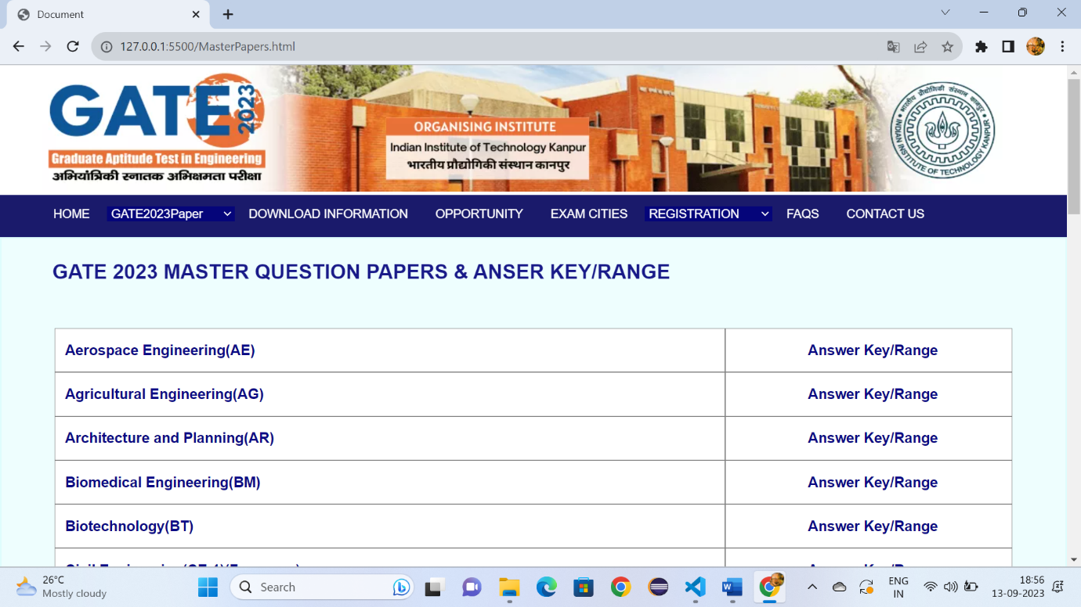

**Fig:10.1**

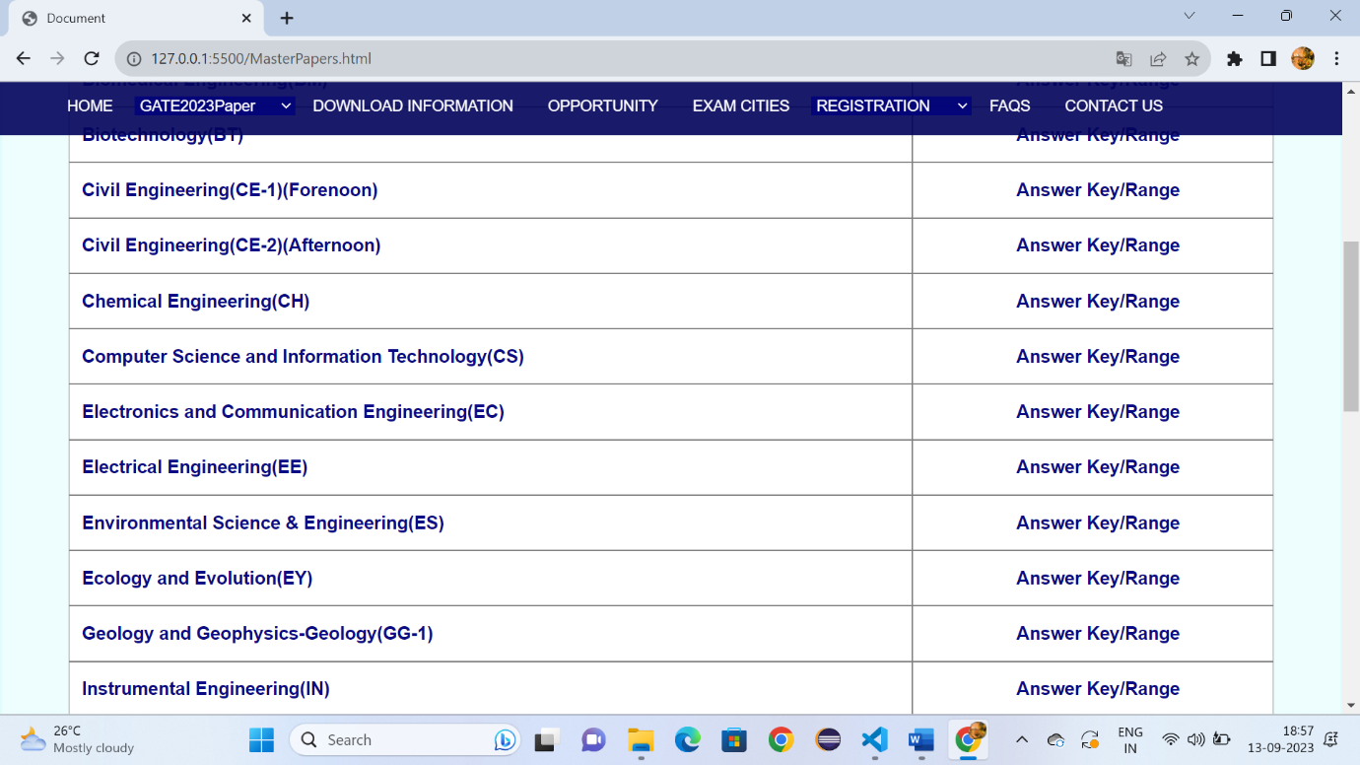

**Fig:10.2**

**GateSchedule:**

<!DOCTYPE html>

<html lang="en">

<head>

    <meta charset="UTF-8">

    <meta name="viewport" content="width=device-width, initial-scale=1.0">

    <title>Document</title>

    <link rel="stylesheet" href="Downloadgate.css" >

    <style>

        *{

    margin: 0px;

    box-sizing: border-box;

        }

        a:hover{

            background-color: rgba(60, 105, 163, 0.9);

            padding-bottom: -15px;

        }

        .h:hover{

            background-color: rgba(60, 105, 163, 0.9);

            padding-bottom: -15px;

        }

        #d3:hover{

            background-color:rgba(60, 105, 163, 0.9);

            padding-bottom: -15px;

            height: 45px;

        }

        .p{

            font-size: 17px;

            font-family: sans-serif;

            color: rgb(13, 74, 143);

            text-decoration: none;

            margin-left: 20px;

          margin-top: 10px;

        }

        #d2{

            position: sticky;

            top:0px;

        }

        .i:hover{

            color: rgb(75, 74, 74);

        }

        td{

            font-family: sans-serif;

             border: 1px solid;

            padding-left: 1%;

        }

        th{

            font-family: sans-serif;

             border: 1px solid;

        }

    </style>

</head>

<body>

    <header id="d1">

        <img style="margin-left: 50px;" src="https://gate.iitk.ac.in/images/xbanner-bg.png.pagespeed.ic.mRgukKISkj.webp" width="90%" height="150px">

    </header>

    <div id="d2">

        <a class="c6" style="padding-left: 5%;" href="Gate.html" target="_self">HOME</a>

        <select id="d3" class="h">

        <option >GATE2023Paper</option>

        <option class="c1">Papers&Syllabus</option>

        <option class="c1">Pattern</option>

        <option class="c1">Two Paper Combinations</option>

        <option class="c1">GATE 2023 Schedule</option>

        </select>

        <a class="c6" style="font-size: 90%;padding-left: 1%;" href="Downloadgate.html" target="_self">DOWNLOAD INFORMATION</a>

        <a class="c6" style="font-size: 90%;padding-left: 1%;" href="opportunity.html" target="_self">OPPORTUNITY</a>

        <a class="c6" style="font-size: 90%;padding-left: 1%;" href="Examcities.html" target="_self">EXAM CITIES</a>

        <select id="d3" class="h">

            <option >REGISTRATION</option>

            <option class="c1">Eligibility Criteria</option>

            <option class="c1">Document required for filling the application</option>

            <option class="c1">Application Fees</option>

         </select>

         <a class="c6" style="font-size: 90%;padding-left: 1%;" href="FAQS.html">FAQS</a>

         <a class="c6" style="font-size: 90%;padding-left: 1%" href="Contactus.html">CONTACT US</a>

        </div>

        <div style="height: 1000px;background-color:rgba(89, 244, 244, 0.1) ;border: 2px solid rgba(89, 244, 244, 0.1);">

            <h1 style="font-family: sans-serif;font-size: x-large;"><span style="color: rgba(3, 3, 125, 0.912);margin-left: 60px;margin-top: 2%;position: absolute;">CONGRATULATIONS TO ALL TOPPERS OF GATE 2023</span> </h1>

             <br>

            <div style="width: 90%;height: 1200px;margin-left: 5%;margin-top: 7%;">

            <table cellspacing="0"

                style="width: 100%;height: 800px;">

<tr aria-rowspan="1px">

                    <tr>

                        <th>Date (Day)</th>

                        <th>Tmie(IST)</th>

                        <TH>Activities/Paper</TH>

                     </tr>

               <tr>

                <th rowspan="2" style="background-color: gold;">Saturday, 4th February 2023</th>

                <th style="background-color: gold;">09:30 am to 12:30 pm

                    (Forenoon Session – FN)</th>

                    <td style="background-color: gold;">CS</td>

               </tr>

               <tr>

                <th style="background-color: gold;">02:30 pm to 05:30 pm

                    (Afternoon Session – AN)</th>

                    <td style="background-color: gold;">AR, ME</td>

               </tr>

               <th rowspan="2" style="background-color: gold;">Sunday, 5th February 2023</th>

               <th style="background-color: gold;">09:30 am to 12:30 pm

                (Forenoon Session – FN)</th>

                <td style="background-color: gold;">EE, ES, XH</td>

           </tr>

           <tr>

            <th style="background-color: gold;">02:30 pm to 05:30 pm

                (Afternoon Session – AN)</th>

                <td style="background-color: gold;">BM, CY, EC</td>

           </tr>

           <th rowspan="2">Saturday, 11th February 2023</th>

               <th>09:30 am to 12:30 pm

                (Forenoon Session – FN)</th>

                <td>GG, IN, MA, PE, XE, XL</td>

           </tr>

           <tr>

            <th>02:30 pm to 05:30 pm

                (Afternoon Session – AN)</th>

                <td>AE, AG, BT, CH, EY, GE, MT, NM, PH, PI, TF</td>

           </tr>

           <th rowspan="2">Sunday, 12th February 2023</th>

               <th>09:30 am to 12:30 pm

                (Forenoon Session – FN)</th>

                <td>CE1, ST</td>

           </tr>

           <tr>

            <th>02:30 pm to 05:30 pm

                (Afternoon Session – AN)</th>

                <td>CE2, MN</td>

           </tr>

    </tbody>

   </table>

        </div>

            </div>

              </div>

            <div style="margin-top: -1%;" id="d22">

                <h3 style="font-family: sans-serif;font-size: 20px;color: white;margin-left: 6%;margin-top: 80px;">IMPORTANT NOTE:</h3>

                <br>

                <br>

                <ol style="list-style-type: none;margin-left: 3%;margin-top: -20px;">

                    <li class="b">The dates mentioned above are </li>

                    <li class="b">subject to change. Examination may</li>

                    <li class="b">be postponed or cancelled due to</li>

                    <li class="b">situations beyond control.</li>

                </ol>

                <h3 style="font-family: sans-serif;font-size: 20px;color: white;margin-left: 33%;margin-top: -153px;">QUICK LINKS:</h3>

                <ul>

                    <li class="a"> <a style="color: white;text-decoration: none;" href="Gate.html">HOME</li></a>

                    <li class="a"><a style="color: white;text-decoration: none;" href="Downloadgate.html">GATE 2023 Papers</li></a>

                    <li class="a"><a style="color: white;text-decoration: none;" href="Downloadgate.html">Old Question Papers</li></a>

                    <li class="a"><a style="color: white;text-decoration: none;" href="Examcities.html">Exam Cities</li></a>

                    <li class="a"><a style="color: white;text-decoration: none;" href="Examcities.html">Eligibility Criteria</li></a>

</ul>

                <h3 style="font-family: sans-serif;font-size: 20px;color: white;margin-left: 53%;margin-top: -190px;">IMPORTANT LINKS:</h3>

                <ul>

                    <li class="a1"><a style="color: white;text-decoration: none;" href="GateDocuments.html">Documents for applicationn</li></a>

                    <li class="a1"><a style="color: white;text-decoration: none;" href="Downloadgate.html">Two Paper Combinations</li></a>

                    <li class="a1"><a style="color: white;text-decoration: none;" href="GateApplicationfee.html">Application Fees</li></a>

                    <li class="a1"><a style="color: white;text-decoration: none;" href="FAQS.html">FQAs</li></a>

                </ul>

                <h3 style="font-family: sans-serif;font-size: 20px;color: white;margin-left: 78%;margin-top: -190px;">CONTACT US:</h3>

                <ol style="list-style-type: none;margin-left: 75%;margin-top: 20px;">

                    <li class="b">Organizing Chair,GATE 2023 </li>

                    <li class="b">GATE-JAM Office IIT Kanpur</li>

                    <li class="b">Uttar Pradesh, India</li>

                    <br>

                    <br>

                    <li class="b" >0512 259 6962</li>

                    <li class="b">0512 259 6962</li>

                </ol>

                <br>

                <br>

                <hr style="width: 100%; color: white;margin-top: 1%;">

                <p style="color: white;font-size: 15px; margin-left: 24%;margin-top: 2%;position: absolute;">© Copyright: GATE 2023, Indian Institute of Technology Kanpur, Uttar Pradesh- 208016, India.</p>

    </div>

</body>

</html>

**Output:**

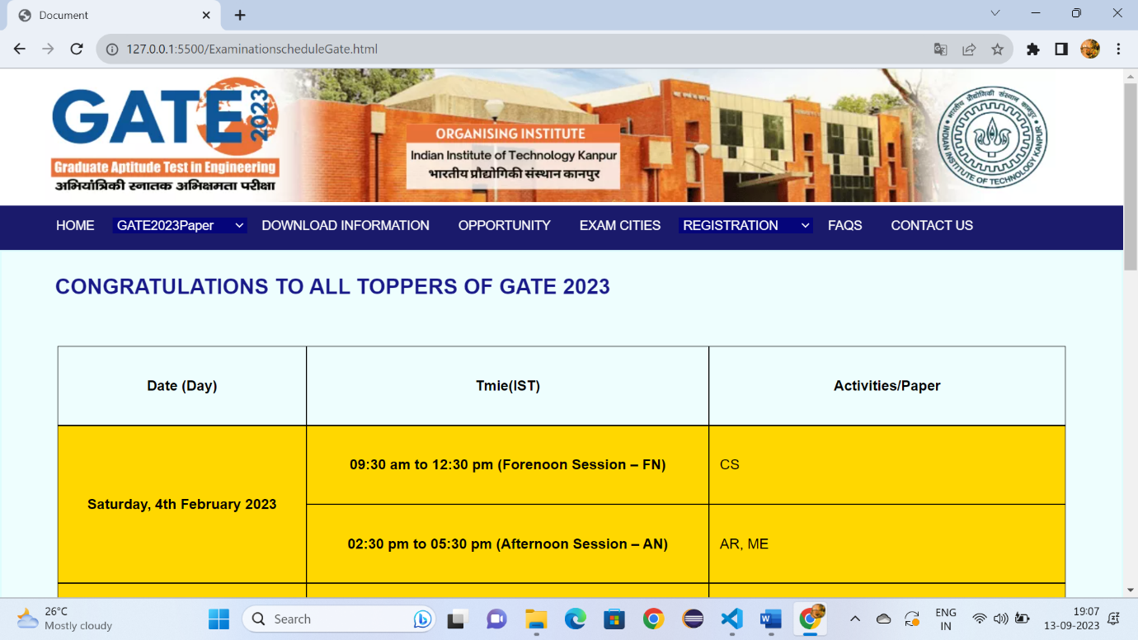 Fig:1

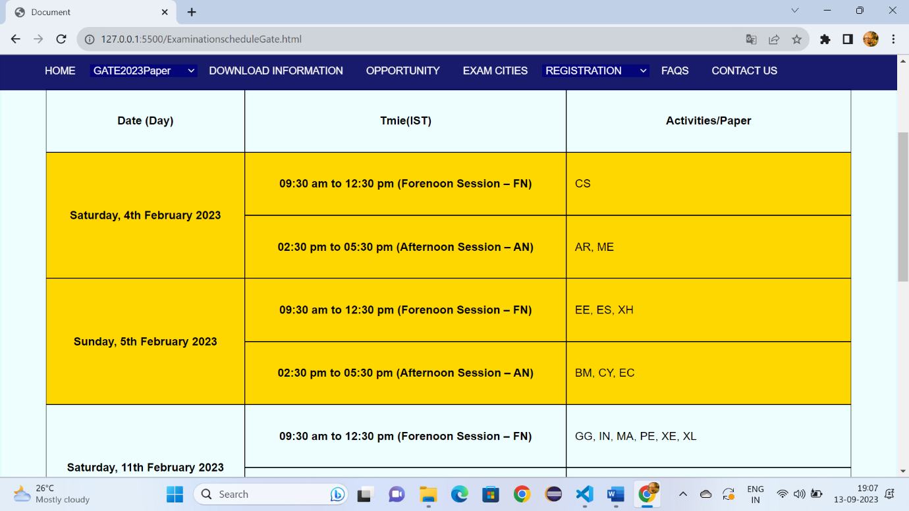

Fig:11.2

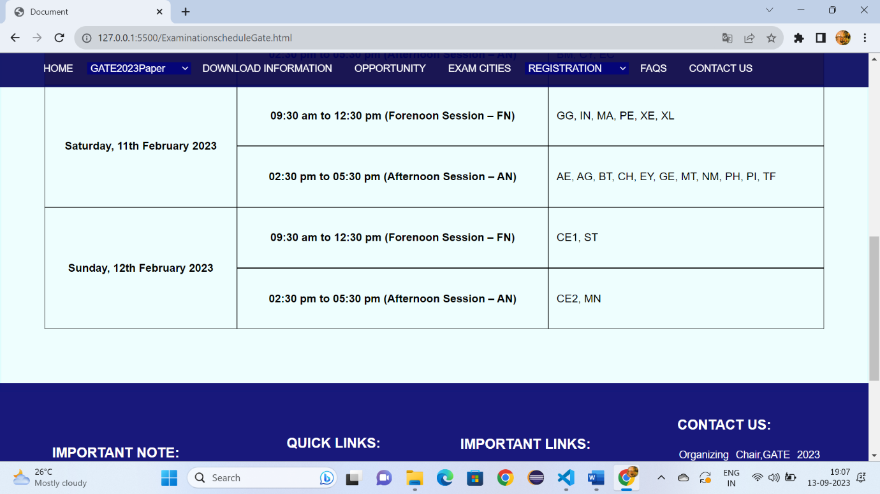

Fig:11.3

**Internationacities.html:**

<!DOCTYPE html>

<html lang="en">

<head>

    <meta charset="UTF-8">

    <meta name="viewport" content="width=device-width, initial-scale=1.0">

    <title>Document</title>

    <link rel="stylesheet" href="Downloadgate.css" >

    <style>

        *{

    margin: 0px;

    box-sizing: border-box;

        }

        a:hover{

            background-color: rgba(60, 105, 163, 0.9);

            padding-bottom: -15px;

        }

        .h:hover{

            background-color: rgba(60, 105, 163, 0.9);

            padding-bottom: -15px;

        }

        #d3:hover{

            background-color:rgba(60, 105, 163, 0.9);

            padding-bottom: -15px;

            height: 45px;

        }

        .p{

            font-size: 17px;

            font-family: sans-serif;

            color: rgb(13, 74, 143);

            text-decoration: none;

            margin-left: 20px;

          margin-top: 10px;

        }

        #d2{

            position: sticky;

            top:0px;

        }

        .i:hover{

            color: rgb(75, 74, 74);

        }

        td{

            font-family: sans-serif;

             border: 1px solid;

            padding-left: 1%;

            background-color: white;

        }

    </style>

</head>

<body>

    <header id="d1">

        <img style="margin-left: 50px;" src="https://gate.iitk.ac.in/images/xbanner-bg.png.pagespeed.ic.mRgukKISkj.webp" width="90%" height="150px">

    </header>

    <div id="d2">

        <a class="c6" style="padding-left: 5%;" href="Gate.html" target="_self">HOME</a>

        <select id="d3" class="h">

        <option >GATE2023Paper</option>

        <option class="c1">Papers&Syllabus</option>

        <option class="c1">Pattern</option>

        <option class="c1">Two Paper Combinations</option>

        <option class="c1">GATE 2023 Schedule</option>

        </select>

        <a class="c6" style="font-size: 90%;padding-left: 1%;" href="Downloadgate.html" target="_self">DOWNLOAD INFORMATION</a>

        <a class="c6" style="font-size: 90%;padding-left: 1%;" href="opportunity.html" target="_self">OPPORTUNITY</a>

        <a class="c6" style="font-size: 90%;padding-left: 1%;" href="Examcities.html" target="_self">EXAM CITIES</a>

        <select id="d3" class="h">

            <option >REGISTRATION</option>

            <option class="c1">Eligibility Criteria</option>

            <option class="c1">Document required for filling the application</option>

            <option class="c1">Application Fees</option>

         </select>

         <a class="c6" style="font-size: 90%;padding-left: 1%;" href="FAQS.html">FAQS</a>

         <a class="c6" style="font-size: 90%;padding-left: 1%" href="Contactus.html">CONTACT US</a>

        </div>

        <div style="height: 600px;background-color:rgba(89, 244, 244, 0.1) ;border: 2px solid rgba(89, 244, 244, 0.1);">

            <h1 style="font-family: sans-serif;font-size: x-large;"><span style="color: rgba(3, 3, 125, 0.912);margin-left: 60px;margin-top: 2%;position: absolute;">INTERNATIONAL CENTRES</span> </h1>

             <br>

              <p style="font-family: sans-serif;font-size: 17px;color: rgb(95, 92, 92);margin-left: 5%;margin-top: 6%;line-height: 30px;">Centres at Dhaka (Bangladesh), Kathmandu (Nepal), Kuala Lumpur (Malaysia), Male (Maldives), Port Louis (Mauritius), Singapore (Singapore) and Thimphu (Bhutan) are withdrawn due to operational issues. GATE 2023 Examination will NOT be conducted in these cities. </p>

              <br>

              <p style="font-family: sans-serif;font-size: 17px;color: rgb(95, 92, 92);margin-left: 5%;margin-top: 1%;line-height: 30px;">In Dubai (UAE) the examination on 5th February (for papers BM, CY, EC, EE, ES, XH) and 12th February 2023 (for papers CE1, CE2, MN and ST) will NOT be conducted.</p>

              <br>

              <p style="font-family: sans-serif;font-size: 17px;color: rgb(95, 92, 92);margin-left: 5%;margin-top: -1%;line-height: 30px;">Candidates registered for examination in these cities can exercise one of the following options:<br><br>

                You can withdraw your GATE 2023 candidature and get the full refund for application fees.

                You can select one of the cities available in India (See gate.iitk.ac.in). You will be refunded the original registration fees. However, to write examination in India, you have to pay the fees for PER PAPER as follows:<br><br>

                Candidate must login to their account to exercise Option B.

                You must convey their decision by sending email to gate@iitk.ac.in by 5th December 2022 with the following details:<br>

                1) Your enrolment id and name<br>

                2) Option Chosen - A) Withdrawal of GATE 2023 Candidature OR<br>

                           B) Writing Examination in India

            </p>

              </div>

            <div style="margin-top: -1%;" id="d22">

                <h3 style="font-family: sans-serif;font-size: 20px;color: white;margin-left: 6%;margin-top: 80px;">IMPORTANT NOTE:</h3>

                <br>

                <br>

                <ol style="list-style-type: none;margin-left: 3%;margin-top: -20px;">

                    <li class="b">The dates mentioned above are </li>

                    <li class="b">subject to change. Examination may</li>

                    <li class="b">be postponed or cancelled due to</li>

                    <li class="b">situations beyond control.</li>

                </ol>

                <h3 style="font-family: sans-serif;font-size: 20px;color: white;margin-left: 33%;margin-top: -153px;">QUICK LINKS:</h3>

                <ul>

                    <li class="a"> <a style="color: white;text-decoration: none;" href="Gate.html">HOME</li></a>

            <li class="a"><a style="color: white;text-decoration: none;" href="Downloadgate.html">GATE 2023 Papers</li></a>

            <li class="a"><a style="color: white;text-decoration: none;" href="Downloadgate.html">Old Question Papers</li></a>

            <li class="a"><a style="color: white;text-decoration: none;" href="Examcities.html">Exam Cities</li></a>

            <li class="a"><a style="color: white;text-decoration: none;" href="Examcities.html">Eligibility Criteria</li></a>

                </ul>

                <h3 style="font-family: sans-serif;font-size: 20px;color: white;margin-left: 53%;margin-top: -190px;">IMPORTANT LINKS:</h3>

                <ul>

                    <li class="a1"><a style="color: white;text-decoration: none;" href="GateDocuments.html">Documents for applicationn</li></a>

                    <li class="a1"><a style="color: white;text-decoration: none;" href="Downloadgate.html">Two Paper Combinations</li></a>

                    <li class="a1"><a style="color: white;text-decoration: none;" href="GateApplicationfee.html">Application Fees</li></a>

                    <li class="a1"><a style="color: white;text-decoration: none;" href="FAQS.html">FQAs</li></a>

                </ul>

                <h3 style="font-family: sans-serif;font-size: 20px;color: white;margin-left: 78%;margin-top: -190px;">CONTACT US:</h3>

                <ol style="list-style-type: none;margin-left: 75%;margin-top: 20px;">

                    <li class="b">Organizing Chair,GATE 2023 </li>

                    <li class="b">GATE-JAM Office IIT Kanpur</li>

                    <li class="b">Uttar Pradesh, India</li>

                    <br>

                    <br>

                    <li class="b" >0512 259 6962</li>

                    <li class="b">0512 259 6962</li>

                </ol>

                <br>

                <br>

                <hr style="width: 100%; color: white;margin-top: 1%;">

                <p style="color: white;font-size: 15px; margin-left: 24%;margin-top: 2%;position: absolute;">© Copyright: GATE 2023, Indian Institute of Technology Kanpur, Uttar Pradesh- 208016, In

</div>

</body>

</html>

**Output:**

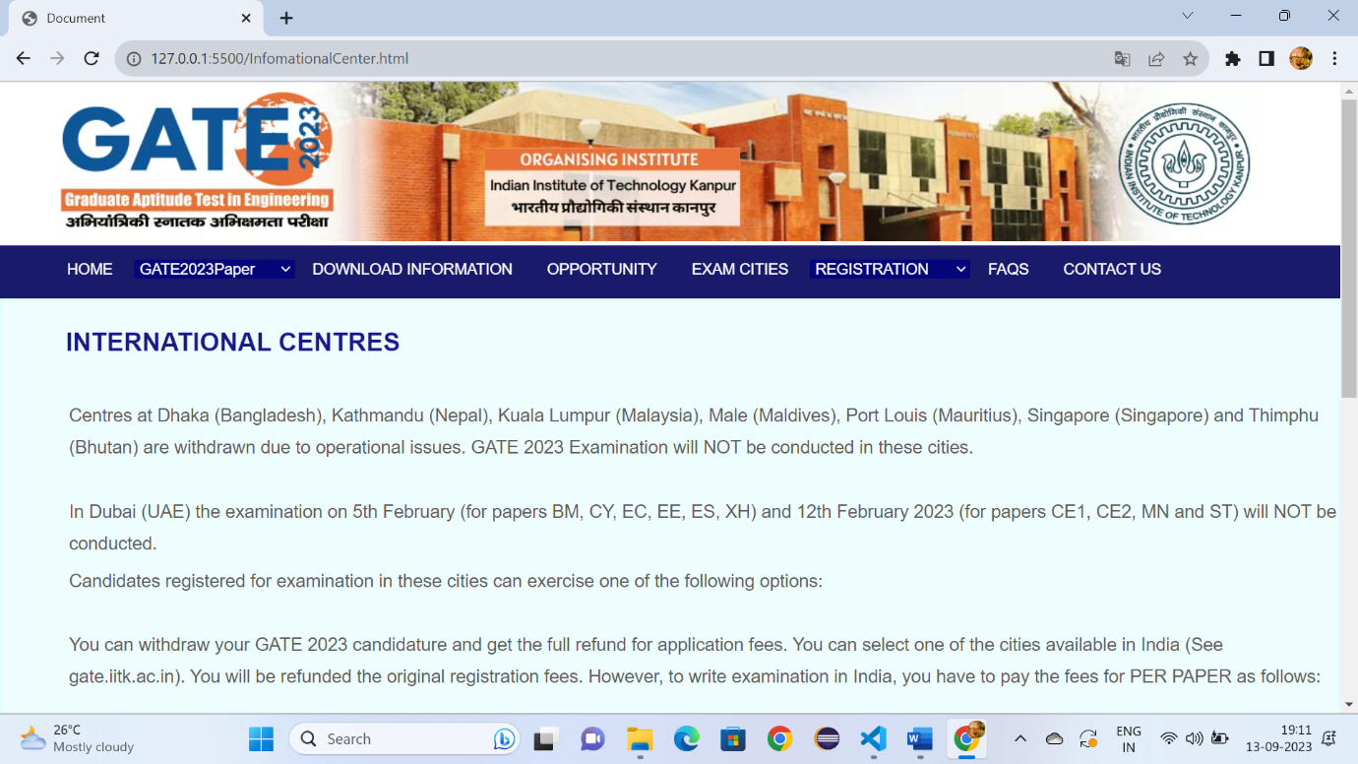

Fig:12.1

**Documents.html:**

<!DOCTYPE html>

<html lang="en">

<head>

    <meta charset="UTF-8">

    <meta name="viewport" content="width=device-width, initial-scale=1.0">

    <title>Document</title>

    <link rel="stylesheet" href="Downloadgate.css" >

    <style>

        *{

    margin: 0px;

    box-sizing: border-box;

        }

        a:hover{

            background-color: rgba(60, 105, 163, 0.9);

            padding-bottom: -15px;

        }

        .h:hover{

            background-color: rgba(60, 105, 163, 0.9);

            padding-bottom: -15px;

        }

        #d3:hover{

            background-color:rgba(60, 105, 163, 0.9);

            padding-bottom: -15px;

            height: 45px;

        }

        .p{

            font-size: 17px;

            font-family: sans-serif;

            color: rgb(13, 74, 143);

            text-decoration: none;

            margin-left: 20px;

          margin-top: 10px;

        }

        #d2{

            position: sticky;

            top:0px;

        }

        .i:hover{

            color: rgb(75, 74, 74);

        }

        td{

            font-family: sans-serif;

             border: 1px solid;

            padding-left: 1%;

            background-color: white;

        }

</style>

</head>

<body>

    <header id="d1">

        <img style="margin-left: 50px;" src="https://gate.iitk.ac.in/images/xbanner-bg.png.pagespeed.ic.mRgukKISkj.webp" width="90%" height="150px">

    </header>

    <div id="d2">

        <a class="c6" style="padding-left: 5%;" href="Gate.html" target="_self">HOME</a>

        <select id="d3" class="h">

        <option >GATE2023Paper</option>

        <option class="c1">Papers&Syllabus</option>

        <option class="c1">Pattern</option>

        <option class="c1">Two Paper Combinations</option>

        <option class="c1">GATE 2023 Schedule</option>

        </select>

        <a class="c6" style="font-size: 90%;padding-left: 1%;" href="Downloadgate.html" target="_self">DOWNLOAD INFORMATION</a>

        <a class="c6" style="font-size: 90%;padding-left: 1%;" href="opportunity.html" target="_self">OPPORTUNITY</a>

        <a class="c6" style="font-size: 90%;padding-left: 1%;" href="Examcities.html" target="_self">EXAM CITIES</a>

        <select id="d3" class="h">

            <option >REGISTRATION</option>

            <option class="c1">Eligibility Criteria</option>

            <option class="c1">Document required for filling the application</option>

            <option class="c1">Application Fees</option>

         </select>

         <a class="c6" style="font-size: 90%;padding-left: 1%;" href="FAQS.html">FAQS</a>

         <a class="c6" style="font-size: 90%;padding-left: 1%" href="Contactus.html">CONTACT US</a>

        </div>

        <div style="height: 800px;background-color:rgba(89, 244, 244, 0.1) ;border: 2px solid rgba(89, 244, 244, 0.1);">

            <h1 style="font-family: sans-serif;font-size: x-large;"><span style="color: rgba(3, 3, 125, 0.912);margin-left: 60px;margin-top: 2%;position: absolute;">REQUIRED DOCUMENTS</span> </h1>

             <br>

              <p style="font-family: sans-serif;font-size: 17px;color: rgb(95, 92, 92);margin-left: 5%;margin-top: 6%;line-height: 30px;">Personal information (name, date of birth, personal mobile number, parents' name, parents' mobile number, etc.).

                Please note that the name of the candidate in the application form must exactly be the same as that in the valid photo ID, which the candidate MUST produce in original while appearing for GATE-2023 examination at the centre.

                GATE 2023 scorecard will be issued as per the name entered in the application form.<br>

                Prefix/title such as Mr / Shri / Dr / Mrs / Smt / Prof / Capt / Maj / Lt / Col / Er / Ar, etc. MUST NOT be used before name.<br>

                Address for Communication (including PIN code).<br>

                Eligibility degree details.<br>

                GATE paper(s) / subjects and their codes in which the candidate wishes to appear.<br>

                THREE Choices of GATE examination cities (from same zone).<br>

                Net-banking /debit card / credit card / UPI / wallet details for fee payment.

            <br>

        <br>

    <br>

    1).High quality image of candidate's photograph conforming to the requirements specified (See Brochure Section 4.4.7 A).<br>

    2).High quality image of candidate's signature conforming to the requirements specified (See Brochure Section 4.4.7 B).<br>

    3).Scanned copy of Category (SC/ST) certificate in pdf format (if applicable).<br>

    4).Scanned copy of PwD Certificate in pdf format (if applicable).<br>

    5).Scanned copy of Certificate of Dyslexia (if applicable) in pdf format.<br>

    6).Scanned copy of any of the valid photo Identity document: Aadhar-UID (preferable), Passport, PAN Card, Voter ID and Driving License (should have Name, Date of birth of the candidate and unique Photo ID number. This must be carried in original to the examination hall for verification)

    </p>

 </div>

            <div style="margin-top: -1%;" id="d22">

                <h3 style="font-family: sans-serif;font-size: 20px;color: white;margin-left: 6%;margin-top: 80px;">IMPORTANT NOTE:</h3>

                <br>

                <br>

                <ol style="list-style-type: none;margin-left: 3%;margin-top: -20px;">

                    <li class="b">The dates mentioned above are </li>

                    <li class="b">subject to change. Examination may</li>

                    <li class="b">be postponed or cancelled due to</li>

                    <li class="b">situations beyond control.</li>

                </ol>

                <h3 style="font-family: sans-serif;font-size: 20px;color: white;margin-left: 33%;margin-top: -153px;">QUICK LINKS:</h3>

                <ul>

                    <li class="a"> <a style="color: white;text-decoration: none;" href="Gate.html">HOME</li></a>

                    <li class="a"><a style="color: white;text-decoration: none;" href="Downloadgate.html">GATE 2023 Papers</li></a>

                    <li class="a"><a style="color: white;text-decoration: none;" href="Downloadgate.html">Old Question Papers</li></a>

                    <li class="a"><a style="color: white;text-decoration: none;" href="Examcities.html">Exam Cities</li></a>

                    <li class="a"><a style="color: white;text-decoration: none;" href="Examcities.html">Eligibility Criteria</li></a>

     </ul>

                <h3 style="font-family: sans-serif;font-size: 20px;color: white;margin-left: 53%;margin-top: -190px;">IMPORTANT LINKS:</h3>

                <ul>

                    <li class="a1"><a style="color: white;text-decoration: none;" href="GateDocuments.html">Documents for applicationn</li></a>

                    <li class="a1"><a style="color: white;text-decoration: none;" href="Downloadgate.html">Two Paper Combinations</li></a>

                    <li class="a1"><a style="color: white;text-decoration: none;" href="GateApplicationfee.html">Application Fees</li></a>

                    <li class="a1"><a style="color: white;text-decoration: none;" href="FAQS.html">FQAs</li></a>

                </ul>

                <h3 style="font-family: sans-serif;font-size: 20px;color: white;margin-left: 78%;margin-top: -190px;">CONTACT US:</h3>

                <ol style="list-style-type: none;margin-left: 75%;margin-top: 20px;">

                    <li class="b">Organizing Chair,GATE 2023 </li>

                    <li class="b">GATE-JAM Office IIT Kanpur</li>

                    <li class="b">Uttar Pradesh, India</li>

                    <br>

                    <br>

                    <li class="b" >0512 259 6962</li>

                    <li class="b">0512 259 6962</li>

                </ol>

                <br>

                <br>

                <hr style="width: 100%; color: white;margin-top: 1%;">

                <p style="color: white;font-size: 15px; margin-left: 24%;margin-top: 2%;position: absolute;">© Copyright: GATE 2023, Indian Institute of Technology Kanpur, Uttar Pradesh- 208016, India.</p>

 </div>

</body>

</html>

**Output:**

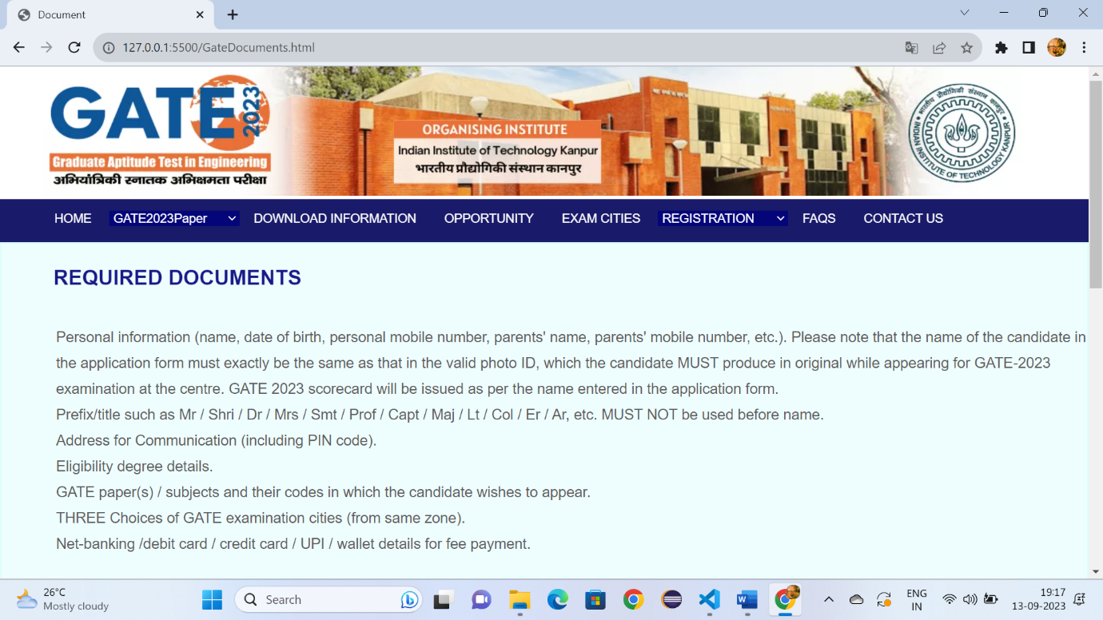

Fig:13.1

**ApplicationFee.html:**

<!DOCTYPE html>

<html lang="en">

<head>

    <meta charset="UTF-8">

    <meta name="viewport" content="width=device-width, initial-scale=1.0">

    <title>Document</title>

    <link rel="stylesheet" href="Downloadgate.css" >

    <style>

        *{

    margin: 0px;

    box-sizing: border-box;

        }

        a:hover{

            background-color: rgba(60, 105, 163, 0.9);

            padding-bottom: -15px;

        }

        .h:hover{

            background-color: rgba(60, 105, 163, 0.9);

            padding-bottom: -15px;

        }

        #d3:hover{

            background-color:rgba(60, 105, 163, 0.9);

            padding-bottom: -15px;

            height: 45px;

        }

        .p{

            font-size: 17px;

            font-family: sans-serif;

            color: rgb(13, 74, 143);

            text-decoration: none;

            margin-left: 20px;

          margin-top: 10px;

        }

        #d2{

            position: sticky;

            top:0px;

        }

        .i:hover{

            color: rgb(75, 74, 74);

        }

        td{

            font-family: sans-serif;

             border: 1px solid;

            padding-left: 1%;

            background-color: white;

        }

 </style>

</head>

<body>

    <header id="d1">

        <img style="margin-left: 50px;" src="https://gate.iitk.ac.in/images/xbanner-bg.png.pagespeed.ic.mRgukKISkj.webp" width="90%" height="150px">

    </header>

    <div id="d2">

        <a class="c6" style="padding-left: 5%;" href="Gate.html" target="_self">HOME</a>

        <select id="d3" class="h">

        <option >GATE2023Paper</option>

        <option class="c1">Papers&Syllabus</option>

        <option class="c1">Pattern</option>

        <option class="c1">Two Paper Combinations</option>

        <option class="c1">GATE 2023 Schedule</option>

        </select>

        <a class="c6" style="font-size: 90%;padding-left: 1%;" href="Downloadgate.html" target="_self">DOWNLOAD INFORMATION</a>

        <a class="c6" style="font-size: 90%;padding-left: 1%;" href="opportunity.html" target="_self">OPPORTUNITY</a>

        <a class="c6" style="font-size: 90%;padding-left: 1%;" href="Examcities.html" target="_self">EXAM CITIES</a>

        <select id="d3" class="h">

            <option >REGISTRATION</option>

            <option class="c1">Eligibility Criteria</option>

            <option class="c1">Document required for filling the application</option>

            <option class="c1">Application Fees</option>

         </select>

         <a class="c6" style="font-size: 90%;padding-left: 1%;" href="FAQS.html">FAQS</a>

         <a class="c6" style="font-size: 90%;padding-left: 1%" href="Contactus.html">CONTACT US</a>

        </div>

        <div style="height: 800px;background-color:rgba(89, 244, 244, 0.1) ;border: 2px solid rgba(89, 244, 244, 0.1);">

            <h1 style="font-family: sans-serif;font-size: x-large;"><span style="color: rgba(3, 3, 125, 0.912);margin-left: 60px;margin-top: 2%;position: absolute;">For Examination Centres in India</span> </h1>

             <br>

            <div style="width: 90%;height: 600px;margin-left: 5%;margin-top: 7%;">

            <table cellspacing="0"

                style="width: 100%;height: 400px;">

                <tr aria-rowspan="1px">

                <td style="font-family: sans-serif;font-size: large;margin: 0px;background-color: rgba(89, 244, 244, 0.1);"><b>Candidate Cateogry</b></td>

                <td style="font-family: sans-serif;font-size: large;background-color: rgba(89, 244, 244, 0.1);"><b>Regular Period

                    (30th Aug to 30th Sept 2022)</b></td>

                    <td style="font-family: sans-serif;font-size: large;background-color: rgba(89, 244, 244, 0.1);"><b>

                        During the Extended Period

                        (1st Oct to 7th Oct 2022)  </b></td>

                <th></th>

                </tr>

<tbody>

          <tr>

                <td style="font-family: sans-serif;">Female candidates (per paper)</td>

                <td style="font-family: sans-serif;">₹ 850</td>

                <td style="font-family: sans-serif;">₹ 1350</td>

              </tr>

              <tr>

                <td style="font-family: sans-serif;">SC / ST / PwD* category candidates (per paper)</td>

            <td style="font-family: sans-serif;">₹ 850</td>

                <td style="font-family: sans-serif;">₹ 1350</td>

              </tr>

              <tr>

                <td style="font-family: sans-serif;">All other candidates including foreign nationals (per paper)</td>

              <td style="font-family: sans-serif;">₹ 1700</td>

                <td style="font-family: sans-serif;">₹ 2200</td>

              </tr>

              </tbody>

            </table>

        </div>

</div>

</div>

            <div style="margin-top: -1%;" id="d22">

                <h3 style="font-family: sans-serif;font-size: 20px;color: white;margin-left: 6%;margin-top: 80px;">IMPORTANT NOTE:</h3>

                <br>

                <br>

                <ol style="list-style-type: none;margin-left: 3%;margin-top: -20px;">

                    <li class="b">The dates mentioned above are </li>

                    <li class="b">subject to change. Examination may</li>

                    <li class="b">be postponed or cancelled due to</li>

                    <li class="b">situations beyond control.</li>

                </ol>

                <h3 style="font-family: sans-serif;font-size: 20px;color: white;margin-left: 33%;margin-top: -153px;">QUICK LINKS:</h3>

                <ul>

                    <li class="a"> <a style="color: white;text-decoration: none;" href="Gate.html">HOME</li></a>

                    <li class="a"><a style="color: white;text-decoration: none;" href="Downloadgate.html">GATE 2023 Papers</li></a>

                    <li class="a"><a style="color: white;text-decoration: none;" href="Downloadgate.html">Old Question Papers</li></a>

                    <li class="a"><a style="color: white;text-decoration: none;" href="Examcities.html">Exam Cities</li></a>

                    <li class="a"><a style="color: white;text-decoration: none;" href="Examcities.html">Eligibility Criteria</li></a>

      </ul>

                <h3 style="font-family: sans-serif;font-size: 20px;color: white;margin-left: 53%;margin-top: -190px;">IMPORTANT LINKS:</h3>

                <ul>

                    <li class="a1"><a style="color: white;text-decoration: none;" href="GateDocuments.html">Documents for applicationn</li></a>

                    <li class="a1"><a style="color: white;text-decoration: none;" href="Downloadgate.html">Two Paper Combinations</li></a>

                    <li class="a1"><a style="color: white;text-decoration: none;" href="GateApplicationfee.html">Application Fees</li></a>

                    <li class="a1"><a style="color: white;text-decoration: none;" href="FAQS.html">FQAs</li></a>

                </ul>

                <h3 style="font-family: sans-serif;font-size: 20px;color: white;margin-left: 78%;margin-top: -190px;">CONTACT US:</h3>

                <ol style="list-style-type: none;margin-left: 75%;margin-top: 20px;">

                    <li class="b">Organizing Chair,GATE 2023 </li>

                    <li class="b">GATE-JAM Office IIT Kanpur</li>

                    <li class="b">Uttar Pradesh, India</li>

                    <br>

                    <br>

                    <li class="b" >0512 259 6962</li>

                    <li class="b">0512 259 6962</li>

                  </ol>

                <br>

                <br>

                <hr style="width: 100%; color: white;margin-top: 1%;">

                <p style="color: white;font-size: 15px; margin-left: 24%;margin-top: 2%;position: absolute;">© Copyright: GATE 2023, Indian Institute of Technology Kanpur, Uttar Pradesh- 208016, India.</p>

</div>

</body>

</html>

**Output:**

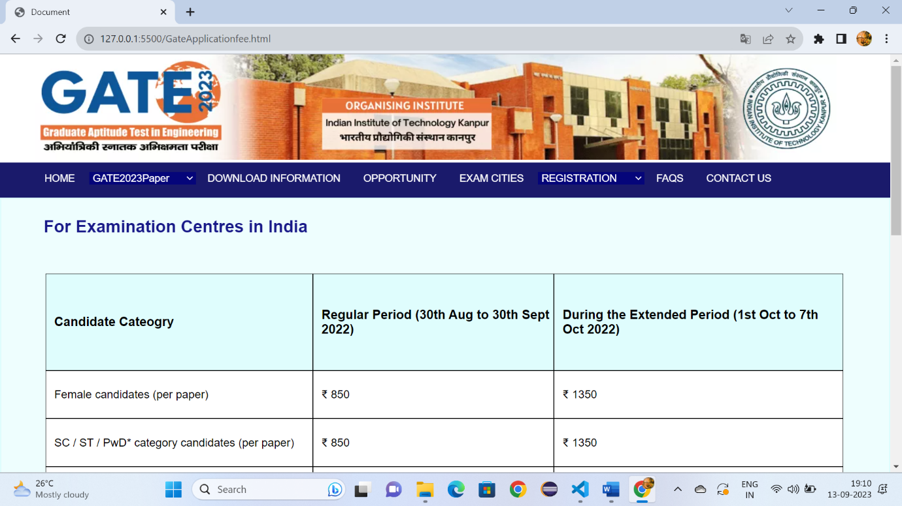

Fig:14.1

**Conclusion**

The GATE 2023 official website is not merely a digital platform but a gateway to a world of opportunities and academic excellence. We embarked on this journey with a clear mission: to provide a user-centric, informative, and accessible resource for all aspiring engineers.

Throughout your visit, we have strived to offer an array of features and services that streamline the GATE application process, empower you with comprehensive exam information, and facilitate your preparation journey.